

**Sri Lanka Institute of Information Technology**

Web Application Security Audit

**Project Report**

Web Security Project 2020[IE2062]

**Submitted By :-**

**Registration Number – IT19107738**

**Name – Senthuran.N**

**Declaration**

I declare that the this project report or part of it was not a copy of a document done by any organization, university any other institute or a previous student project group at SLIIT and was not copied from the Internet or other sources.

**Abstract**

The project titled Web Application Security Audit is the most ideal approach to guarantee your application is secure before you discharge it and to forestall hacks, harm to notoriety and critical misfortunes to your main concern for application designers.

Find out a web application registered in hackerone/Bugcrowd and analyzed their vulnerabilities by penetration testing tools. Security testing software’ primary function is to perform functional testing of a web application under observance and find as many security issues as possible that could potentially lead to hacking. All of this is done without the need to access the source code. Here some security testing tools used to analyzed the vulnerabilities such as **Netsparker -** web application security**, Sublist3r** - python tool designed to enumerate subdomains of websites using OSINT, **OWASP ZAP -** an open source web application security scanner, **Paros** - Java based HTTP/HTTPS proxy for assessing web application vulnerability, **Golismero** - an open source framework built in Python that can be used for security testing.

This project report will help to decrease the vulnerabilities and get out from the theft of sensitive data in this global technologized world. Many security tests have been carried on, and they are attached and discussed in this document.

**Acknowledgement**

The completion of this project undertaking could not have been possible without the participation and assistance of so many people those who provided this opportunity and support to complete this project. Their contributions are sincerely appreciated and gratefully acknowledged. However, the group would like to express their deep appreciation and indebtedness particularly to the following:

Ms. Chethana Liyanapathirana, Ms. Lanessha Rukgahakotuwa Ms. Chathu Udagedara, Dr. Lakmal Rupasinghe for their endless support and understanding spirit during the project development.

Lastly, I would like to thank my parents, friends and seniors for providing us their full support to complete this project successfully.

Table of Contents

**Declaration.........................................................................................**

**Abstract..............................................................................................**

**Acknowledgement.............................................................................**

**Table of Contents...........................................................................................**

Assessment Objectives5

Application Credentials and URL5

Softwares used in this assessment 6

methodology7

focused vulnerabilities7

key findings 9

vulnerability details and solution11

steps followed in the assessment 16

scan results of all subdomains 19-78

Assessment Objectives

The security analyses of the web application http://www.trivago.com/ was done for educational purpose. The application is meant for booking hotels all over the world and planning trips.

The purpose of this assessment is to discover the vulnerabilities in web application and to

indicate the subsequent risk level associated with the vulnerabilities.

Application Credentials and URL

The security assessment was done on the following URL/s:

* www.trivago.com. (Root/main domain)

Found 157 subdomains but around 40 were active. I have analyzed each and every active subdomains.

* [www.admin.trivago.com](http://www.admin.trivago.com)
* [www.tech.trivago.com](http://www.tech.trivago.com)
* [www.newbiecheckin.trivago.com](http://www.newbiecheckin.trivago.com)
* [www.ar.trivago.com](http://www.ar.trivago.com)
* [www.businessblog.trivago.com](http://www.businessblog.trivago.com)
* [www.career.trivago.com](http://www.career.trivago.com)
* [www.click.hotelmanager.trivago.com](http://www.click.hotelmanager.trivago.com)
* [www.developer.trivago.com](http://www.developer.trivago.com)
* [www.discover.trivago.com](http://www.discover.trivago.com)
* [www.dus.trivago.com](http://www.dus.trivago.com)
* [www.express.trivago.com](http://www.express.trivago.com)
* [www.express-api.trivago.com](http://www.express-api.trivago.com)
* [www.express-dus.trivago.com](http://www.express-dus.trivago.com)
* [www.image.email.trivago.com](http://www.image.email.trivago.com)
* [www.knowledge.trivago.com](http://www.knowledge.trivago.com)
* [www.legacy-intelligence.trivago.com](http://www.legacy-intelligence.trivago.com)
* [www.life.trivago.com](http://www.life.trivago.com)
* [www.lyncapp.trivago.com](http://www.lyncapp.trivago.com)
* [www.magacine.tri.com](http://www.magacine.tri.com)
* [www.media-room5.trivago.com](http://www.media-room5.trivago.com)
* [www.meet.trivago.com](http://www.meet.trivago.com)
* [www.support.trivago.com](http://www.support.trivago.com)
* [www.techcamp.trivago.com](http://www.techcamp.trivago.com)
* [www.travel.trivago.com](http://www.travel.trivago.com)
* [www.view.email.trivago.com](http://www.view.email.trivago.com)
* [www.apua.trivago.com](http://www.apua.trivago.com)
* [www.accounts.trivago.com](http://www.accounts.trivago.com)
* [www.captain-compliance.trivago.com](http://www.captain-compliance.trivago.com)
* [www.compare.trivago.com](http://www.compare.trivago.com)
* [www.discussions.engage.trivago.com](http://www.discussions.engage.trivago.com)
* [www.help.trivago.com](http://www.help.trivago.com)
* [www.media-magazine.trivago.com](http://www.media-magazine.trivago.com)
* [www.mta.email.trivago.com](http://www.mta.email.trivago.com)
* [www.press.trivago.com](http://www.press.trivago.com)
* [www.room5.trivago.com](http://www.room5.trivago.com)
* [www.click.hotelmanager.trivago.com](http://www.click.hotelmanager.trivago.com)
* [www.discussions.engage.trivago.com](http://www.discussions.engage.trivago.com)

programs and softwares used for this assessment

1. Sublist3r (from lazyrecon)
2. OWASP Zed attack proxy(zap)
3. Paros penetration tool
4. Netsparker security scanner
5. Golismero software testing framework
6. Nikto web server scanner
7. Nmmapper (online subdomain finder)

Assessment Methodology

**First, I have reviewed the scope.** then **reconnaissance to find valid targets. Find sub-domains through various tools.** I have used various tools to analyse and discover the wide range of vulnerabilities and bugs**. Select one target then scan against discovered targets to gather additional information like Check CMS, Server.** then I **Reviewed all of the services, ports and applications.** then **Fuzzed for errors and to expose vulnerabilities**

**Diagram of the approach of the assessment.**

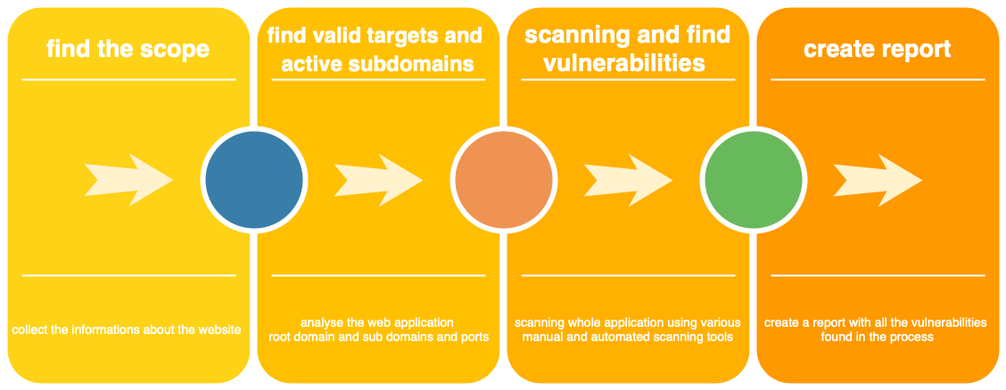

Mainly Focused vulnerabilities in the assessment (OWASP top vulnerabilities)

1. Injections

these vulnerabilities allow hackers or attackers to inject malicious code in a or many systems. XPath Injection, SQL Injection, LDAP Injection, XML Injection, and Command Injection are some of the common injection vulnerabilities.

1. Broken Authentication

This vulnerability is related to session management and authentication management. Using this vulnerability attackers can compromise passwords, session tokens and keys. Attackers can gain access through manual or automatic methods. This vulnerability allows to do credential stuffing and brute force attacks.

1. Sensitive data exposure

Customers and employees Passwords, Credit card numbers, tax IDs, medical information, and other personal information should be protected by the web application. If attackers gain the access of the web application, they can steal and compromise the data

1. XML External Entity attacks (XXE)

If there is a vulnerable XML processor then Attackers can upload malicious xml or malicious content with XML file. Vulnerable code, Dependencies, integrations allows attackers to do XXE attacks.

1. Cross Site Scripting (XSS)

XSS attacks means injecting malicious client-side scripts into a web application and using the website as a propagation method. It allows the attacker to inject malicious script into a website and modify how it is displayed, forcing a end user browser to execute the code provided by the attacker while loading the page.

1. Security misconfigurations

Unpatched flaws, Default configurations, Unused pages, Unprotected files and directories, and Unnecessary services leads to security misconfigurations

1. Broken Access control

Access control implements strategy with the end goal that clients can't act outside of their planned authorizations. Disappointments normally lead to unapproved data divulgence, alteration or pulverization of all information, or playing out a business work outside of the restrictions of the client.

1. Insecure Deserialization

controlled item is infused into the setting of the web application. In the event that the application is helpless, the item is deserialized and executed, which can bring about SQL Injection, Path Traversal, Application Denial of Service and Remote Code Execution.

1. Using Components with known vulnerabilities

Parts, such as, libraries, structures, and other programming modules, quite often run with full benefits. In the event that a powerless part is misused, such an assault can encourage genuine information misfortune or worker takeover. Applications utilizing parts with realised weaknesses may subvert application safeguards furthermore, empower a scope of potential assaults and effects.

1. Insufficient logging and monitoring

Hackers depend on the absence of checking and opportune reaction to accomplish their objectives without being identified.

Key findings

|  |  |  |  |
| --- | --- | --- | --- |
| no | vulnerability | Risk level | status |
| 1 | Remote file inclusion | high | open |
| 2 | Out-of-date Version (Nginx) | high | open |
| 3 | HTTP Strict Transport Security (HSTS) Policy Not Enabled | medium | open |
| 4 | Out-of-date Version (PHP) | medium | open |
| 5 | Invalid SSL Certificate | medium | open |
| 6 | Weak Ciphers Enable | medium | open |
| 7 | **Web Browser XSS Protection Not Enabled** | low | Open |
| 8 | **X-Content-Type-Options Header Missing** | low | open |
| 9 | **Cross-Domain JavaScript Source File Inclusion** | low | open |
| 10 | **Incomplete or No Cache-control and Pragma HTTP Header Set** | low | open |
| 11 | **Cookie Without Secure Flag** | low | open |
| 12 | **Cross-Domain JavaScript Source File Inclusion** | low | open |
| 13 | Cookie Not Marked as HttpOnly | low | open |
| 14 | Insecure Transportation Security Protocol Supported (TLS 1.0) | low | open |
| 15 | **Cookie No HttpOnly Flag** | low | open |
| 16 | **Incomplete or No Cache-control and Pragma HTTP Header Set** | low | open |
| 17 | **Incomplete or No Cache-control and Pragma HTTP Header Set** | low | open |
| 18 | **Private IP Disclosure** | low | open |

Vulnerability details

**1.Remote File Inclusion(high)**

Remote File Include (RFI) is an attack technique used to exploit "dynamic file include" mechanisms in web applications. When web applications take user input (URL, parameter value, etc.) and pass them into file include commands, the web application might be tricked into including remote files with malicious code.

Almost all web application frameworks support file inclusion. File inclusion is mainly used for packaging common code into separate files that are later referenced by main application modules. When a web application references an include file, the code in this file may be executed implicitly or explicitly by calling specific procedures. If the choice of module to load is based on elements from the HTTP request, the web application might be vulnerable to RFI.

|  |  |
| --- | --- |
| URL | http://tech.trivago.com?query=http%3A%2F%2Fwww.google.com%2Fsearch%3Fq%3DOWASP%2520ZAP |

**Solution**

Phase: Architecture and Design

When the set of acceptable objects, such as filenames or URLs, is limited or known, create a mapping from a set of fixed input values (such as numeric IDs) to the actual filenames or URLs, and reject all other inputs.

For example, ID 1 could map to "inbox.txt" and ID 2 could map to "profile.txt". Features such as the ESAPI AccessReferenceMap provide this capability.

Phases: Architecture and Design; Operation

Run your code in a "jail" or similar sandbox environment that enforces strict boundaries between the process and the operating system. This may effectively restrict which files can be accessed in a particular directory or which commands can be executed by your software.

OS-level examples include the Unix chroot jail, AppArmor, and SELinux. In general, managed code may provide some protection. For example, java.io.FilePermission in the Java SecurityManager allows you to specify restrictions on file operations.

This may not be a feasible solution, and it only limits the impact to the operating system; the rest of your application may still be subject to compromise.

Be careful to avoid CWE-243 and other weaknesses related to jails.

For PHP, the interpreter offers restrictions such as open basedir or safe mode which can make it more difficult for an attacker to escape out of the application. Also consider Suhosin, a hardened PHP extension, which includes various options that disable some of the more dangerous PHP features.

Phase: Implementation

Assume all input is malicious. Use an "accept known good" input validation strategy, i.e., use a whitelist of acceptable inputs that strictly conform to specifications. Reject any input that does not strictly conform to specifications, or transform it into something that does. Do not rely exclusively on looking for malicious or malformed inputs (i.e., do not rely on a blacklist). However, blacklists can be useful for detecting potential attacks or determining which inputs are so malformed that they should be rejected outright.

When performing input validation, consider all potentially relevant properties, including length, type of input, the full range of acceptable values, missing or extra inputs, syntax, consistency across related fields, and conformance to business rules. As an example of business rule logic, "boat" may be syntactically valid because it only contains alphanumeric characters, but it is not valid if you are expecting colors such as "red" or "blue."

For filenames, use stringent whitelists that limit the character set to be used. If feasible, only allow a single "." character in the filename to avoid weaknesses such as CWE-23, and exclude directory separators such as "/" to avoid CWE-36. Use a whitelist of allowable file extensions, which will help to avoid CWE-434.

Phases: Architecture and Design; Operation

Store library, include, and utility files outside of the web document root, if possible. Otherwise, store them in a separate directory and use the web server's access control capabilities to prevent attackers from directly requesting them. One common practice is to define a fixed constant in each calling program, then check for the existence of the constant in the library/include file; if the constant does not exist, then the file was directly requested, and it can exit immediately.

This significantly reduces the chance of an attacker being able to bypass any protection mechanisms that are in the base program but not in the include files. It will also reduce your attack surface.

Phases: Architecture and Design; Implementation

Understand all the potential areas where untrusted inputs can enter your software: parameters or arguments, cookies, anything read from the network, environment variables, reverse DNS lookups, query results, request headers, URL components, e-mail, files, databases, and any external systems that provide data to the application. Remember that such inputs may be obtained indirectly through API calls.

Many file inclusion problems occur because the programmer assumed that certain inputs could not be modified, especially for cookies and URL components.

## **2.Out-of-date Version (Nginx)(high)**

Since this is an old version of the software, it may be vulnerable to attacks.

nginx before versions 1.15.6 and 1.14.1 has a vulnerability in the implementation of HTTP/2 that can allow for excessive CPU usage. This issue affects nginx compiled with the ngx_http_v2_module (not compiled by default) if the &#039;http2&#039; option of the &#039;listen&#039; directive is used in a configuration file.

#### NginX Denial of Service (DoS) Vulnerability

The resolver in nginx before 1.8.1 and 1.9.x before 1.9.10 does not properly limit CNAME resolution, which allows remote attackers to cause a denial of service (worker process resource consumption) via vectors related to arbitrary name resolution.

URL- <https://newbiecheckin.trivago.com/>

**Solution**

Please upgrade your installation of Nginx to the latest stable version.

## **3. HTTP Strict Transport Security (HSTS) Policy Not Enabled(medium)**

The target website is being served from not only HTTPS but also HTTP and it lacks of HSTS policy implementation.

HTTP Strict Transport Security (HSTS) is a web security policy mechanism whereby a web server declares that complying user agents (such as a web browser) are to interact with it using only secure (HTTPS) connections. The HSTS Policy is communicated by the server to the user agent via a HTTP response header field named "Strict-Transport-Security". HSTS Policy specifies a period of time during which the user agent shall access the server in only secure fashion.

When a web application issues HSTS Policy to user agents, conformant user agents behave as follows:

* Automatically turn any insecure (HTTP) links referencing the web application into secure (HTTPS) links. (For instance, http://example.com/some/page/ will be modified to https://example.com/some/page/ before accessing the server.)
* If the security of the connection cannot be ensured (e.g. the server's TLS certificate is self-signed), user agents show an error message and do not allow the user to access the web application.

**Solution**

Configure your webserver to redirect HTTP requests to HTTPS

## **4. Out-of-date Version (jQuery)(medium)**

this is an old version of the software, it may be vulnerable to attacks.

#### jquery Cross-Site Scripting (XSS) Vulnerability

jQuery before 3.4.0, as used in Drupal, Backdrop CMS, and other products, mishandles jQuery.extend(true, {}, ...) because of Object.prototype pollution. If an unsanitized source object contained an enumerable __proto__ property, it could extend the native Object.prototype.

**solution**

upgrade your installation of jQuery to the latest stable version.

## **5. Weak Ciphers Enable(medium)**

should allow only strong ciphers on your web server to protect secure communication with your visitors.

Attackers might decrypt SSL traffic between your server and your visitors.

**Solution**

1. For Apache, you should modify the SSLCipherSuite directive in the httpd.conf.

SSLCipherSuite HIGH:MEDIUM:!MD5:!RC4

1. Lighttpd:
2. ssl.honor-cipher-order = "enable"

ssl.cipher-list = "EECDH+AESGCM:EDH+AESGCM"

1. For Microsoft IIS, you should make some changes to the system registry. **Incorrectly editing the registry may severely damage your system. Before making changes to the registry, you should back up any valued data on your computer.**  
     
   **a.**Click Start, click Run, type regedt32or type regedit, and then click OK.  
   **b.**In Registry Editor, locate the following registry key: HKLM\SYSTEM\CurrentControlSet\Control\SecurityProviders  
   **c.**Set "Enabled" DWORD to "0x0" for the following registry keys:

SCHANNEL\Ciphers\DES 56/56  
SCHANNEL\Ciphers\RC4 64/128  
SCHANNEL\Ciphers\RC4 40/128  
SCHANNEL\Ciphers\RC2 56/128  
SCHANNEL\Ciphers\RC2 40/128  
SCHANNEL\Ciphers\NULL   
SCHANNEL\Hashes\MD5

Configure your web server to disallow using weak ciphers.

## **Invalid SSL Certificate**

An SSL certificate can be created and signed by anyone. You should have a valid SSL certificate to make your visitors sure about the secure communication between your website and them. If you have an invalid certificate, your visitors will have trouble distinguishing between your certificate and those of attackers.

Attackers can perform man-in-the-middle attacks and observe the encryption traffic between your website and its visitors.

**Solution**

Fix the problem with your SSL certificate to provide secure communication between your website and its visitors.

**Steps that I followed in this assessment**

1.first, I have found all the subdomains of trivago.com using **sublist3r**

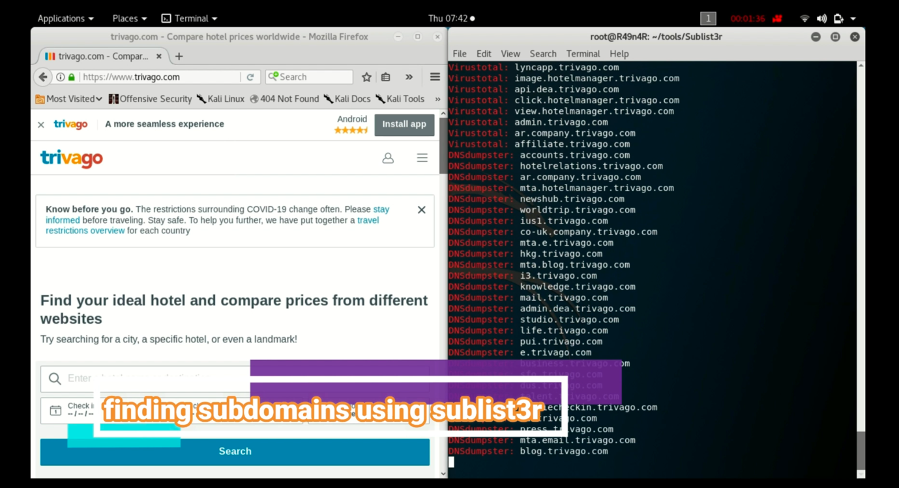

2. then I scanned the root domain [www.trivago.com](http://www.trivago.com) with **paros web application proxy**, **Netsparker vulnerability scanner** and **golismero security testing tool** for finding vulnerability.

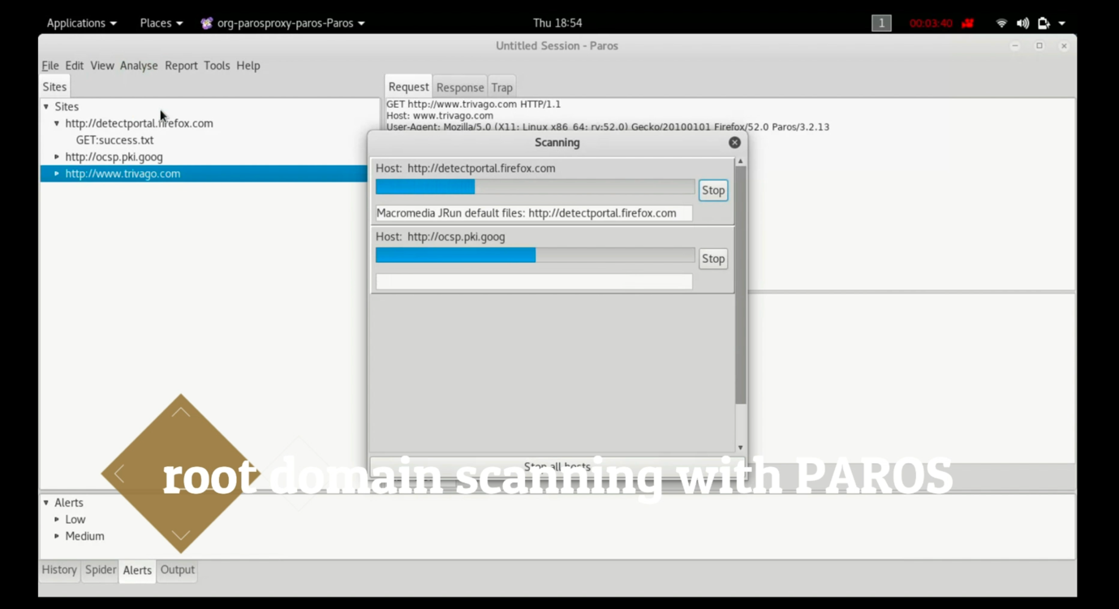

(scanning with paros web application proxy)

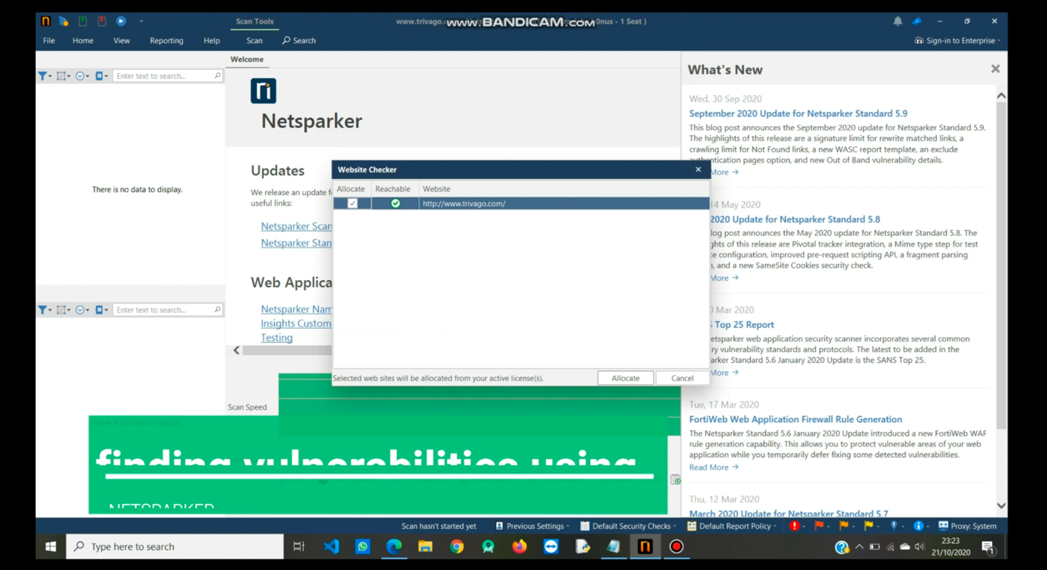

(scanning with netsparker)

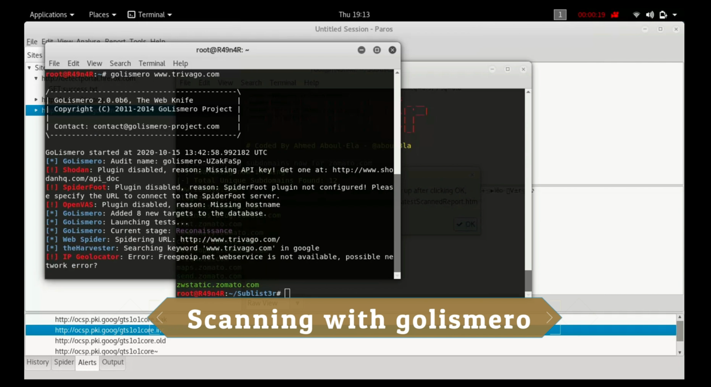

(scanning with golismero)

3.then, I selected all the active subdomains and scanned the with **OWAZP ZAP vulnerability scanning tool** and **Netsparker scanner**

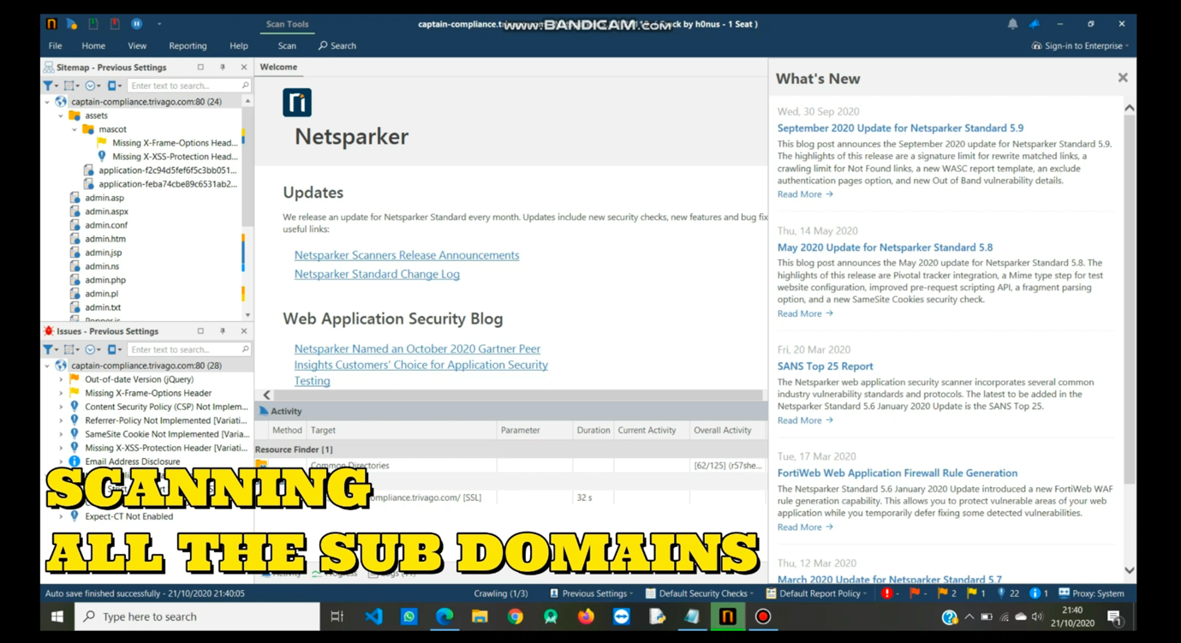

(scanning subdomains with netsparker)

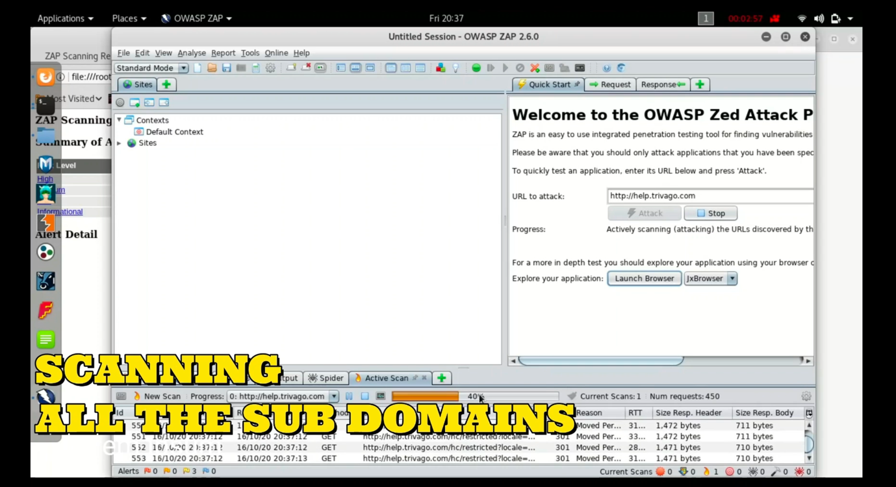

(scanning subdomains with OWASP ZAP)

**Scan results of all subdomains**

1.[www.tech.trivago.com](http://www.tech.trivago.com)

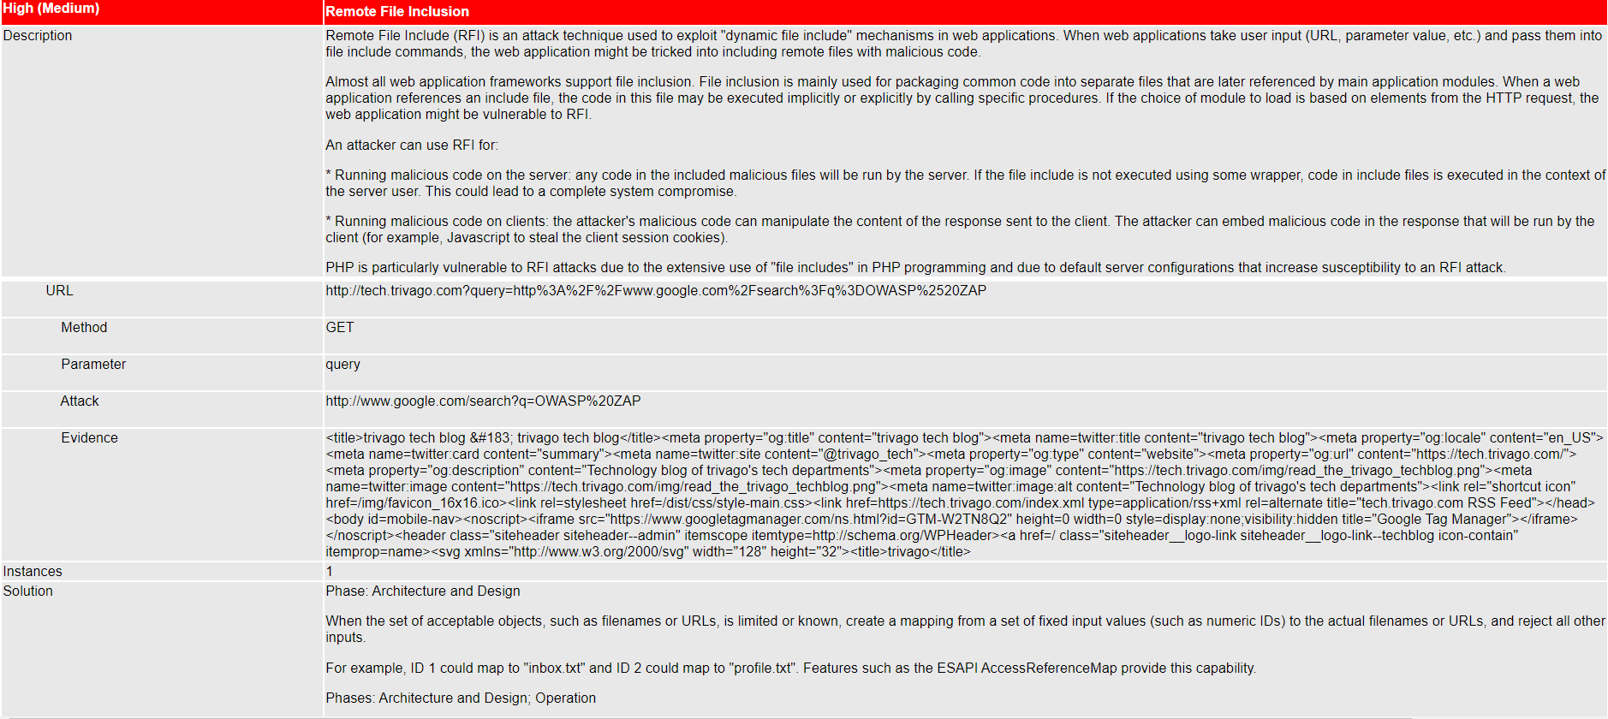

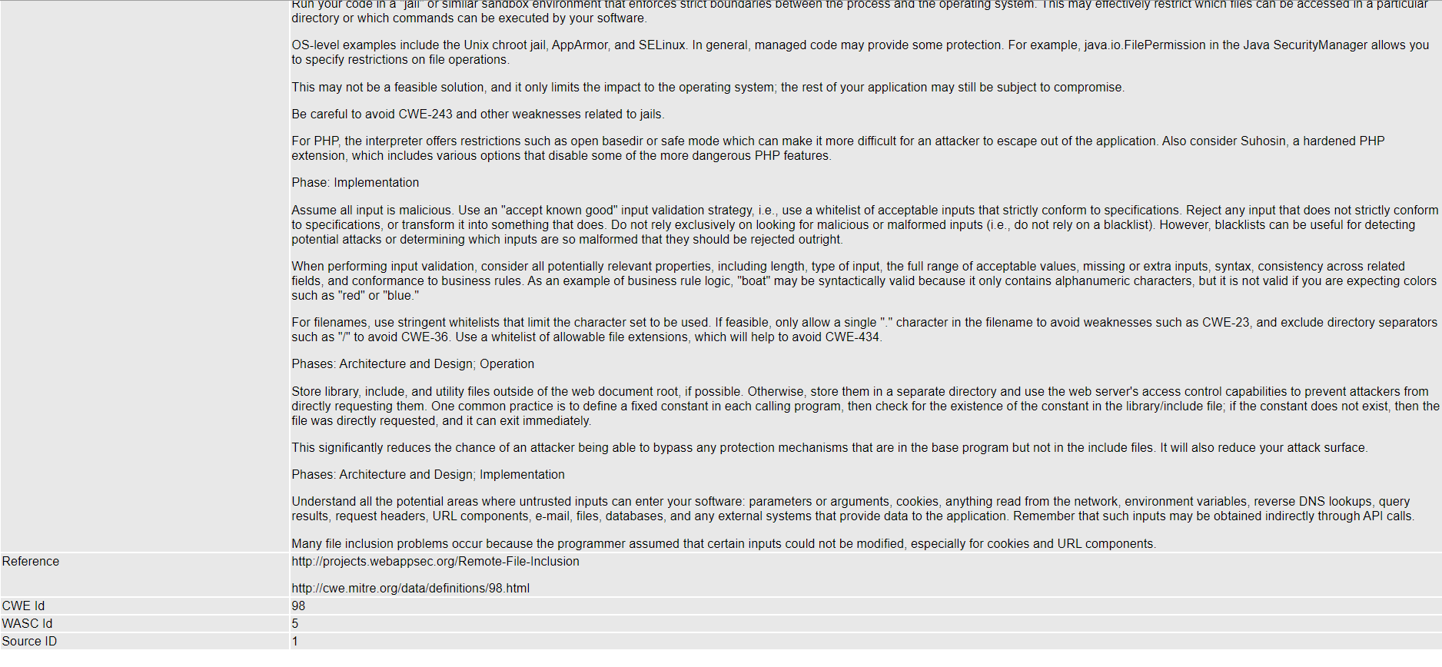

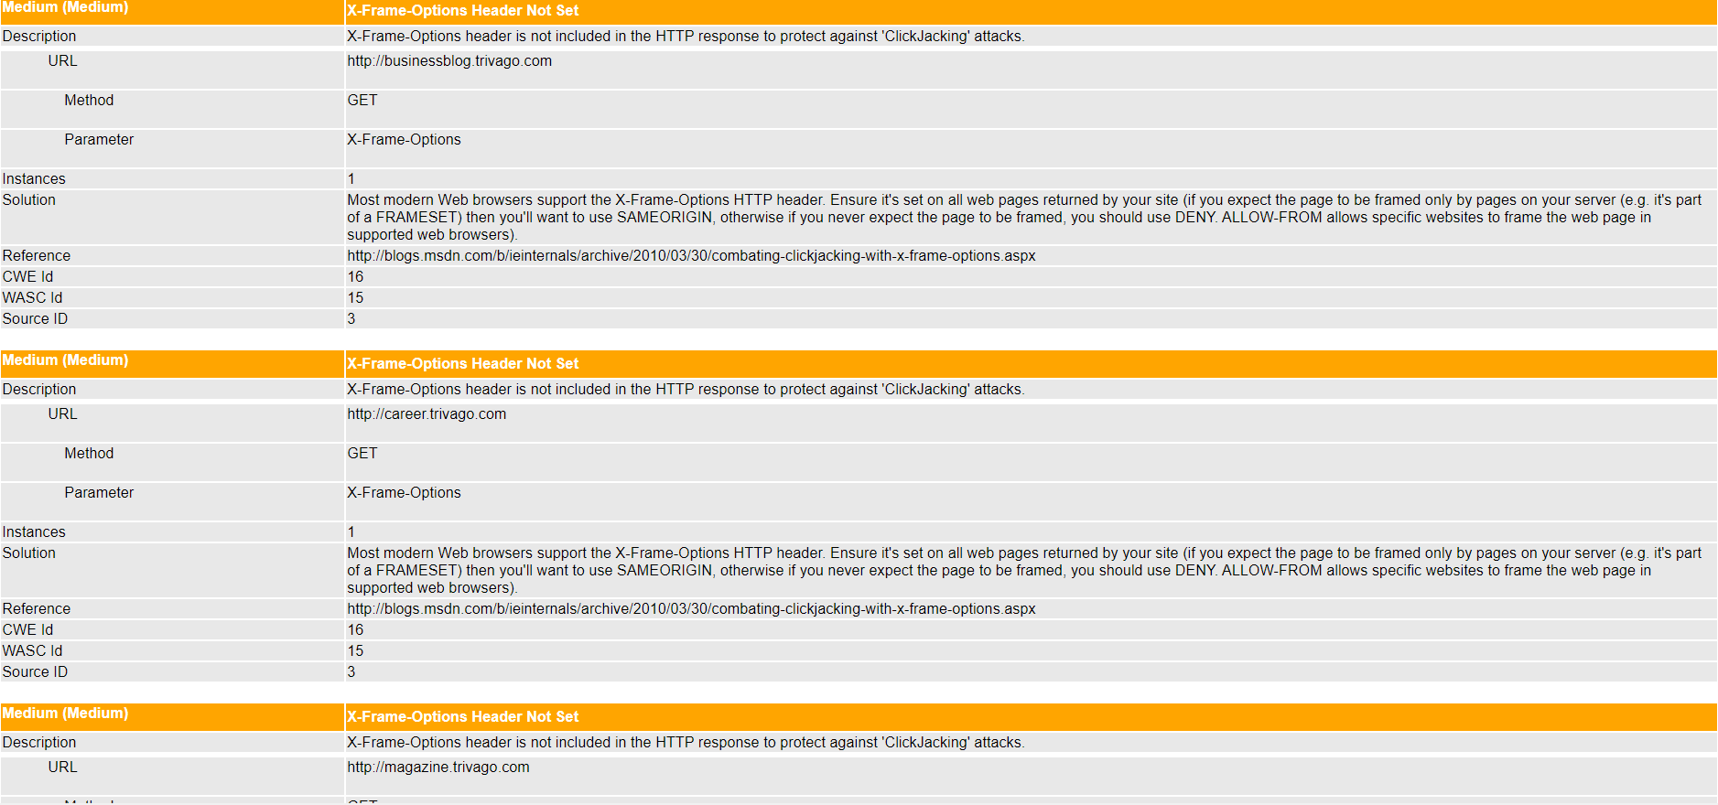

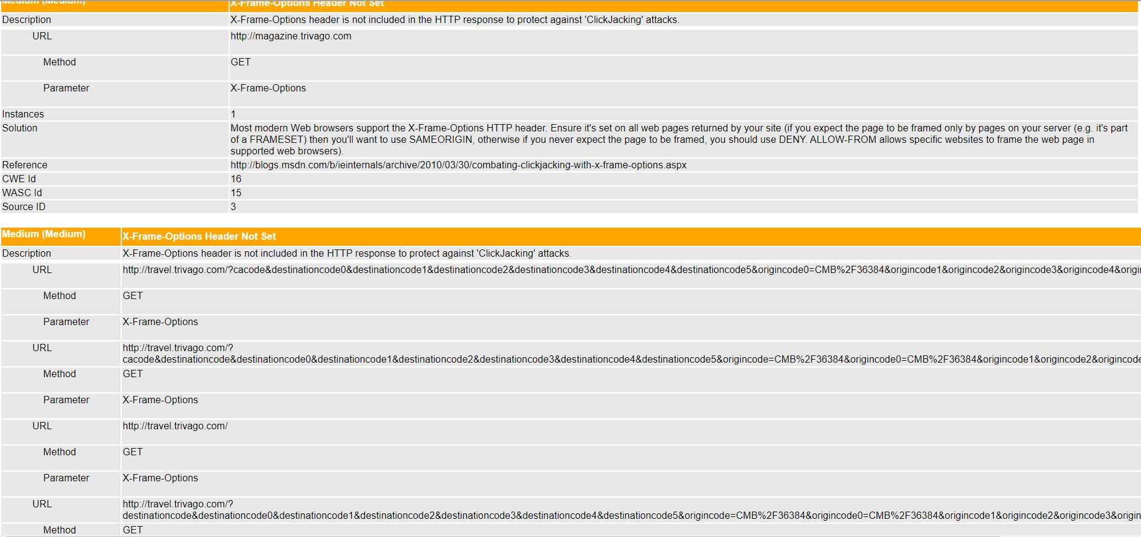

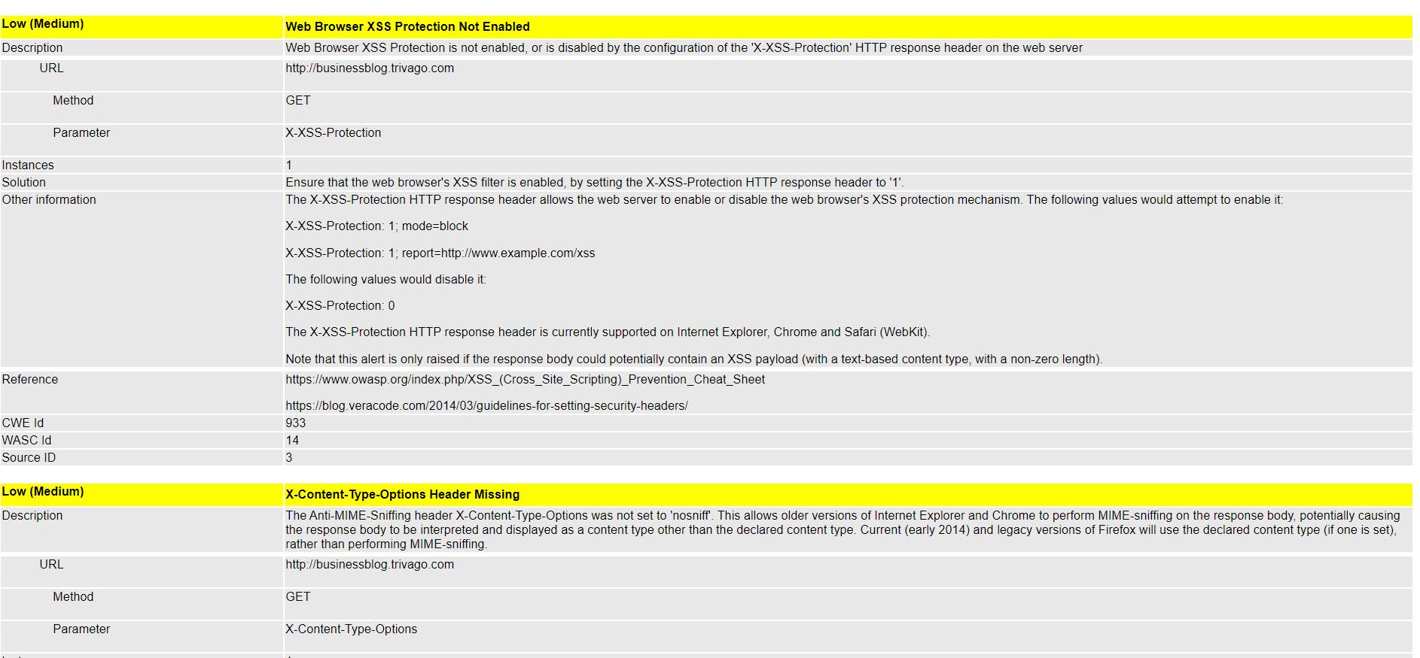

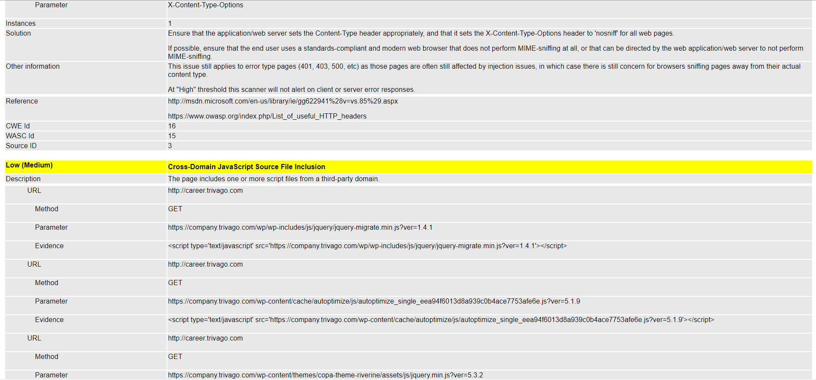

2.[www.newbiecheckin.trivago.com](http://www.newbiecheckin.trivago.com)

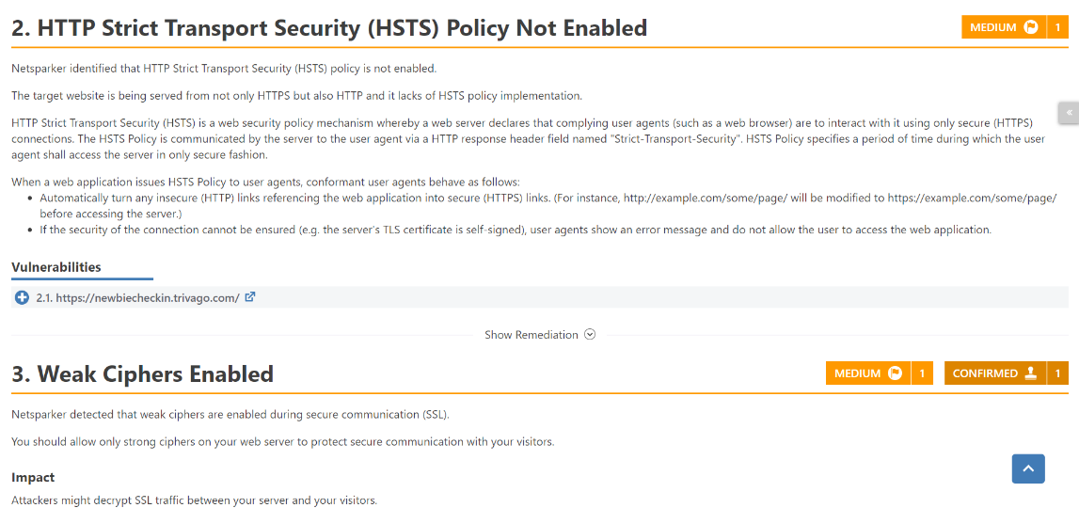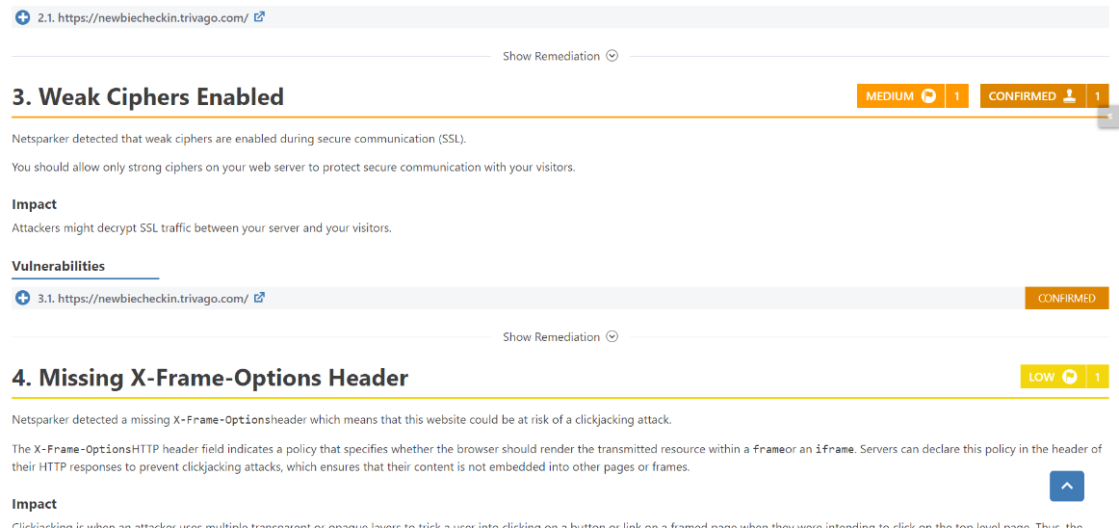

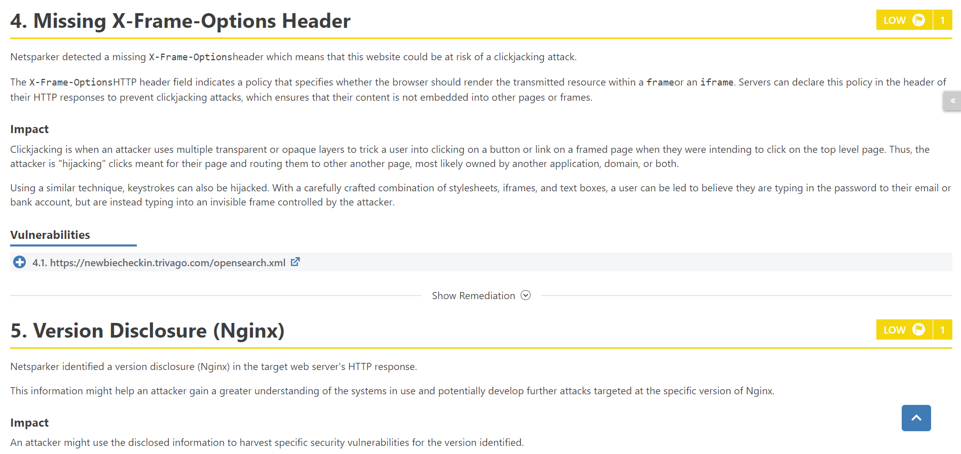

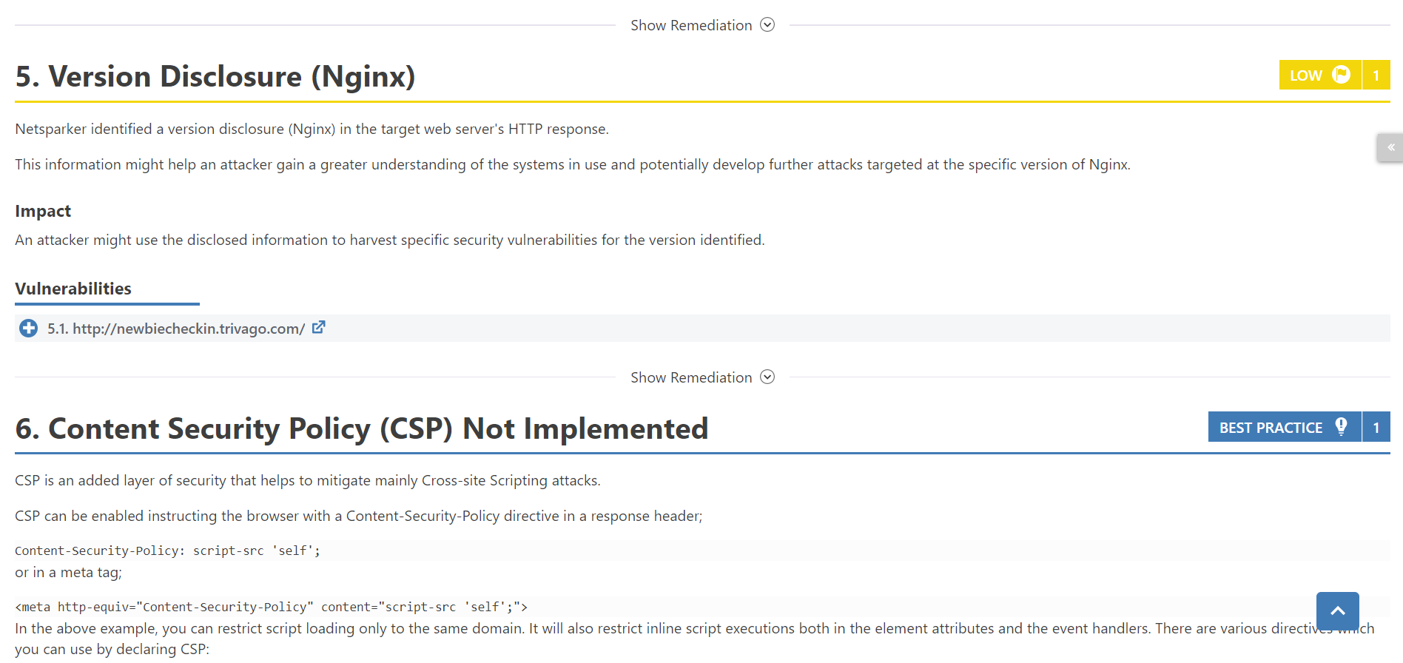

3.[www.ar.trivago.com](http://www.ar.trivago.com)

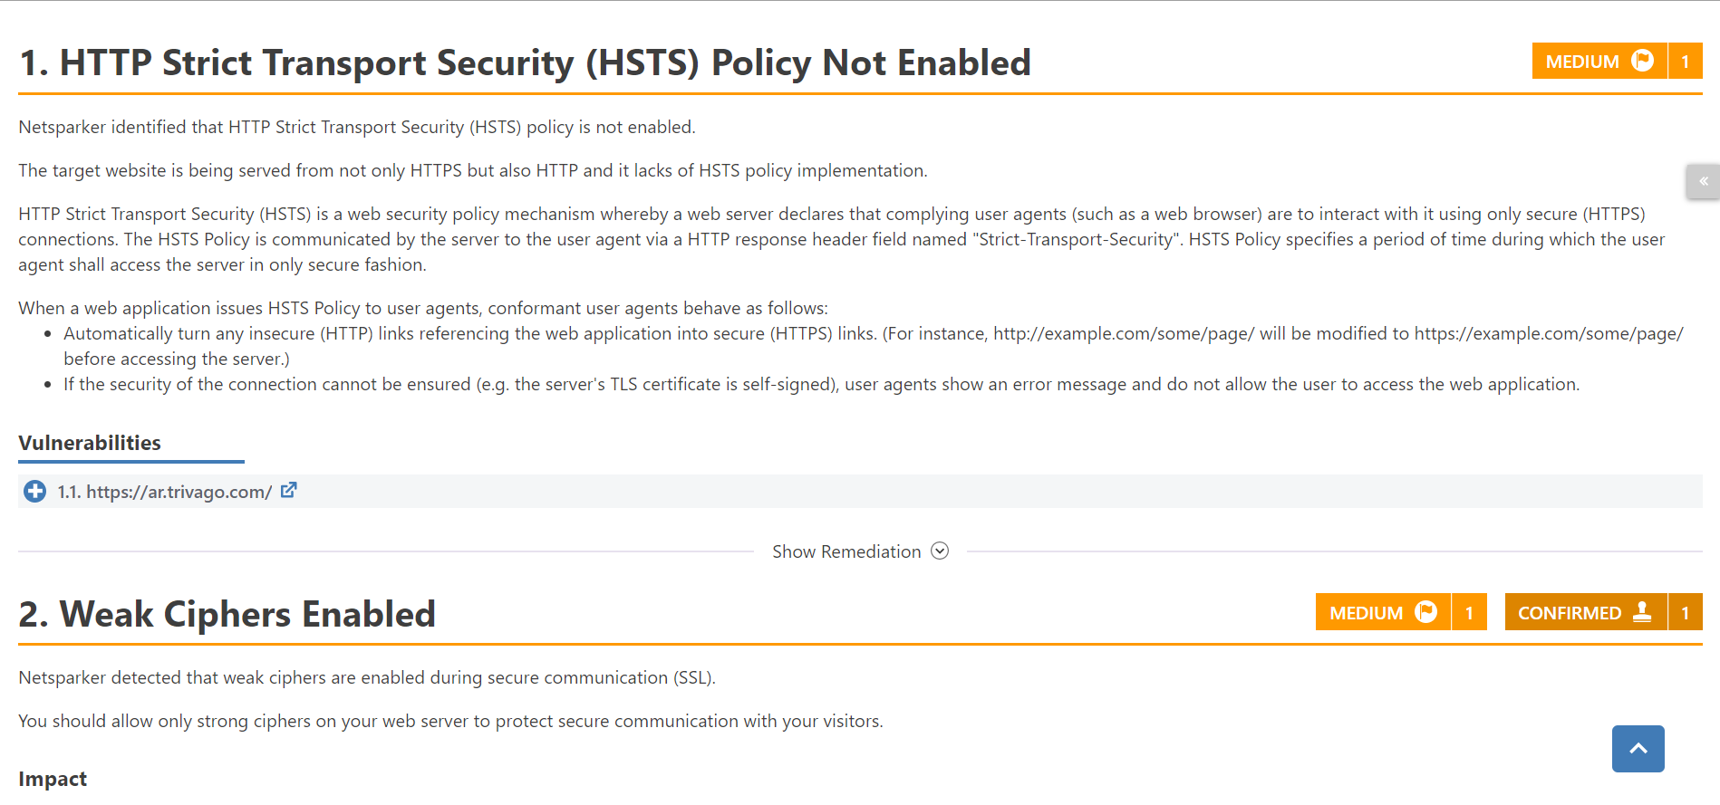

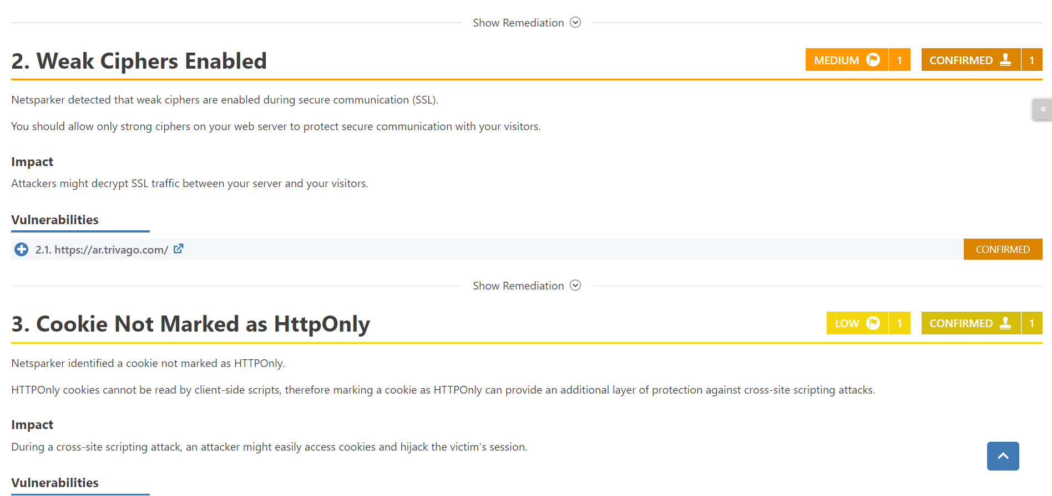

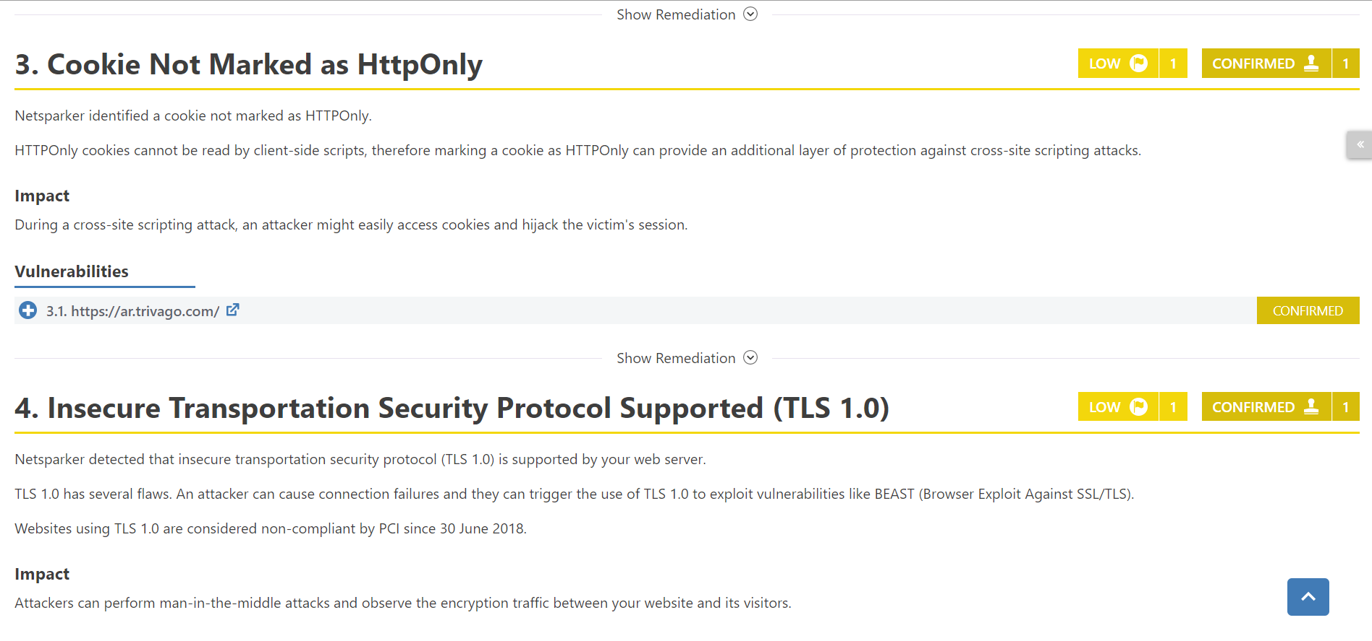

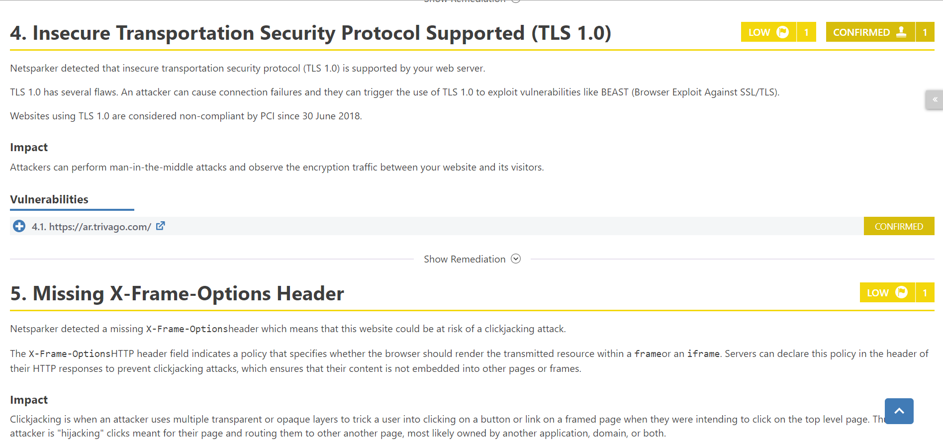

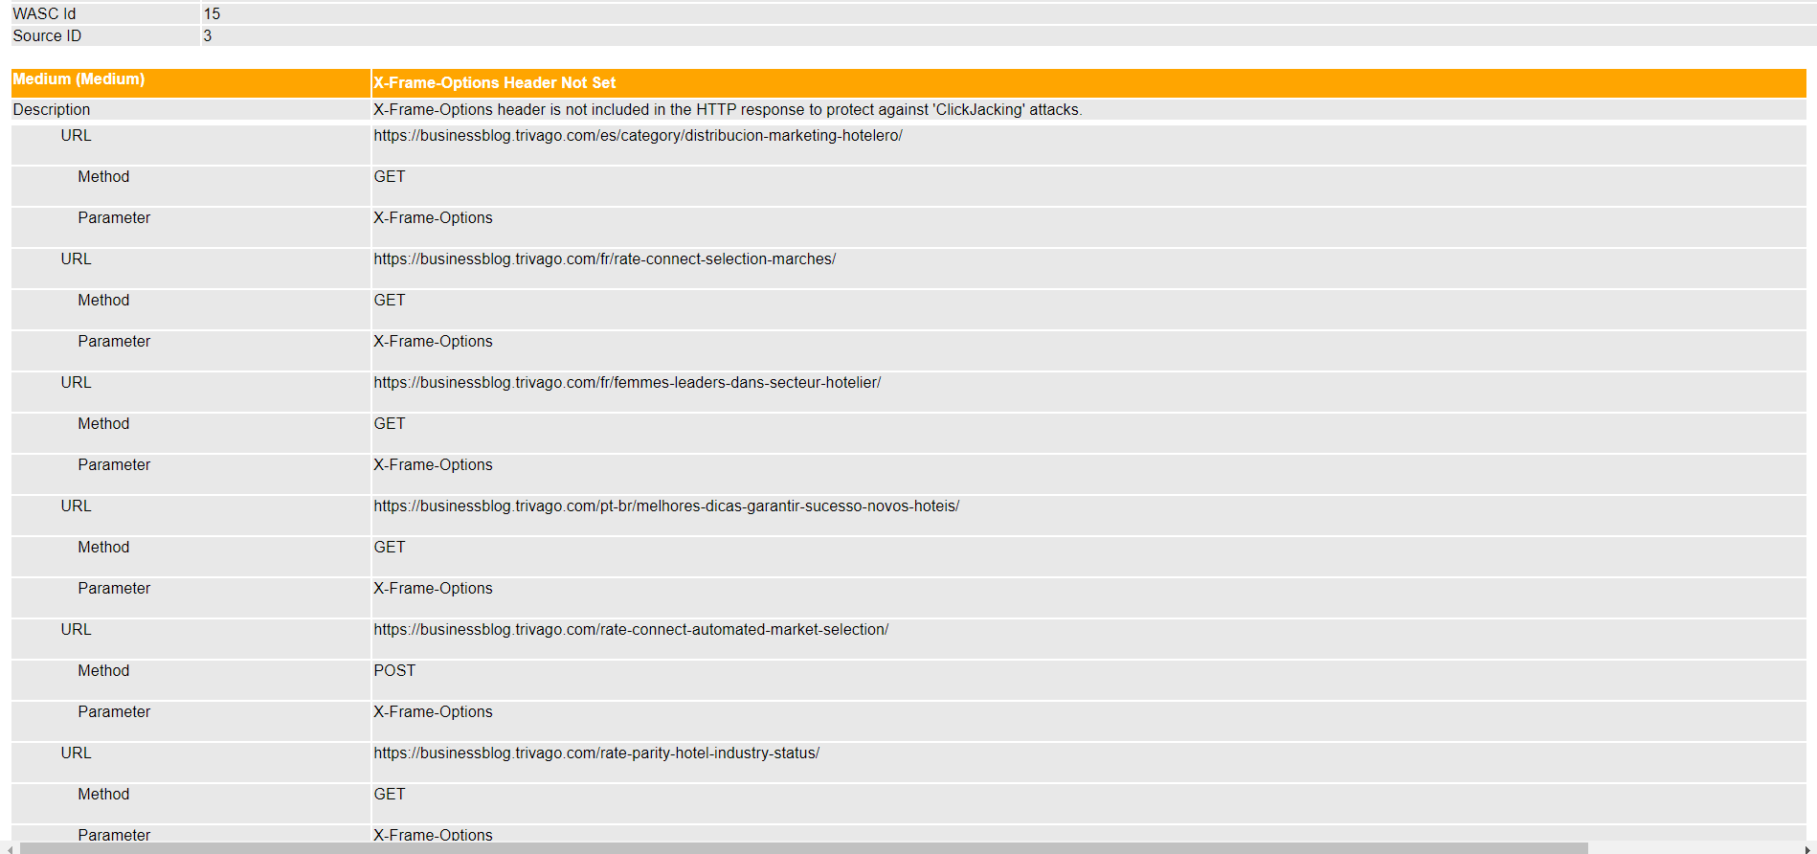[www.businessblog.trivago.com](http://www.businessblog.trivago.com)

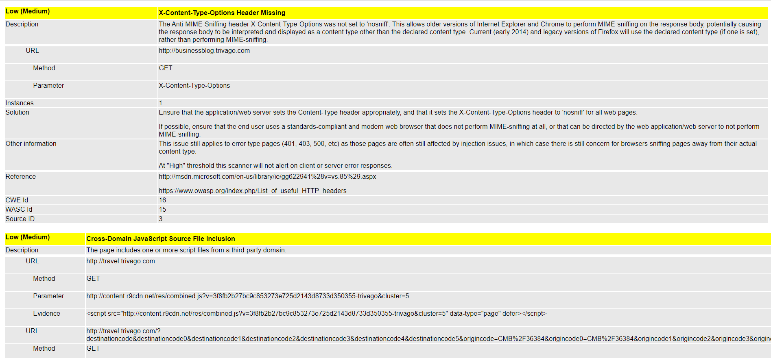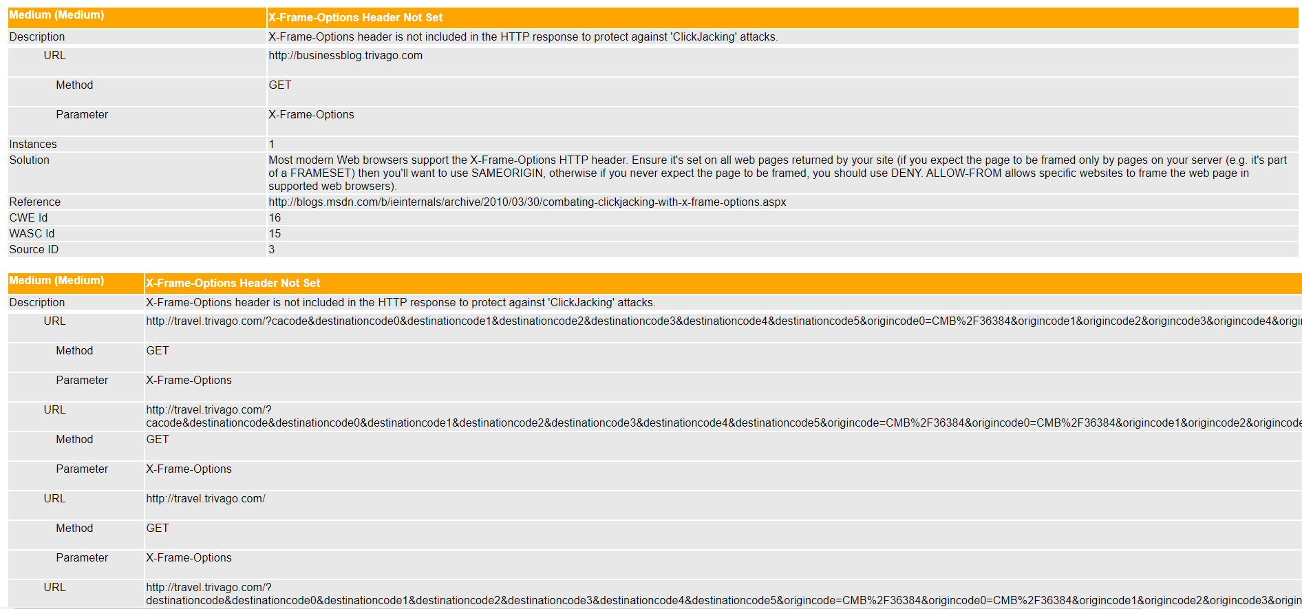

[www.career.trivago.com](http://www.career.trivago.com)

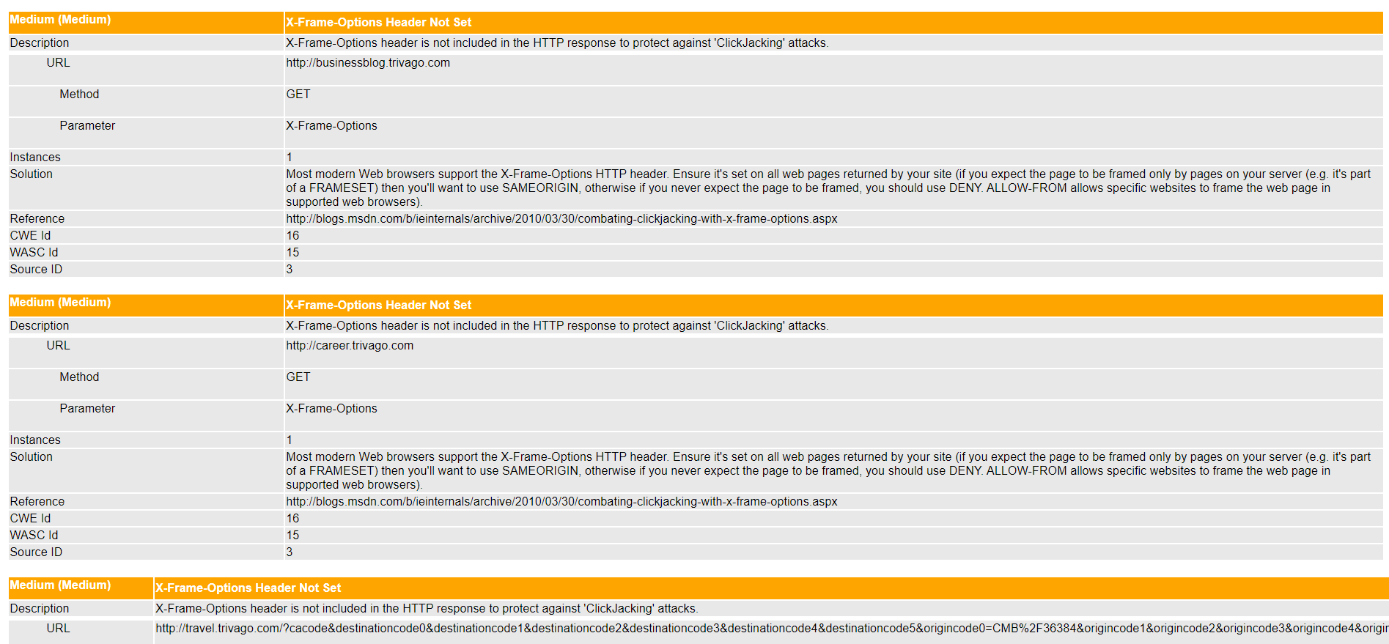

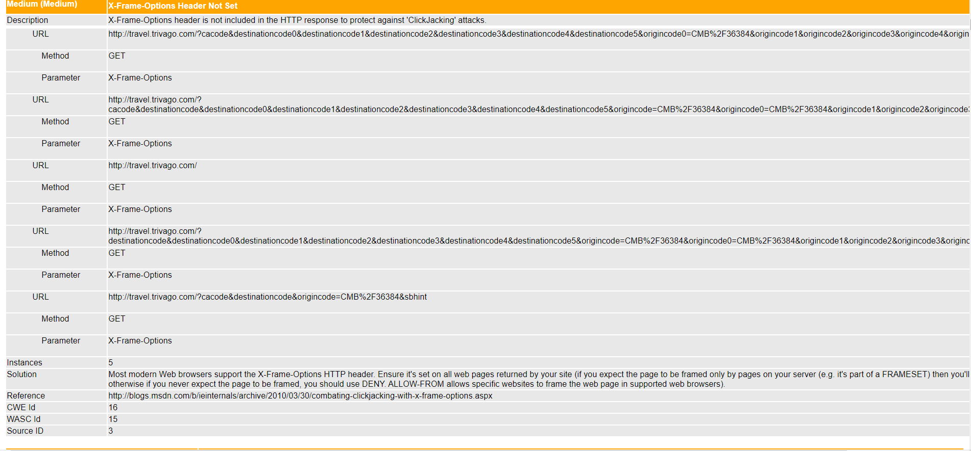

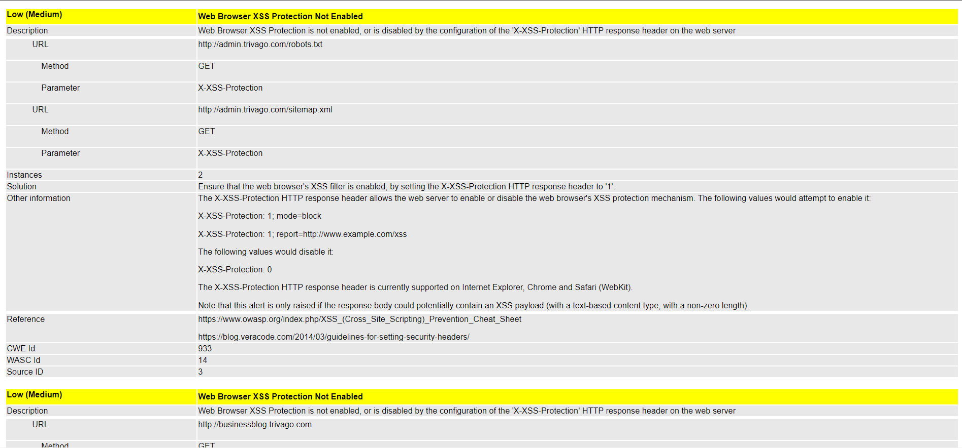

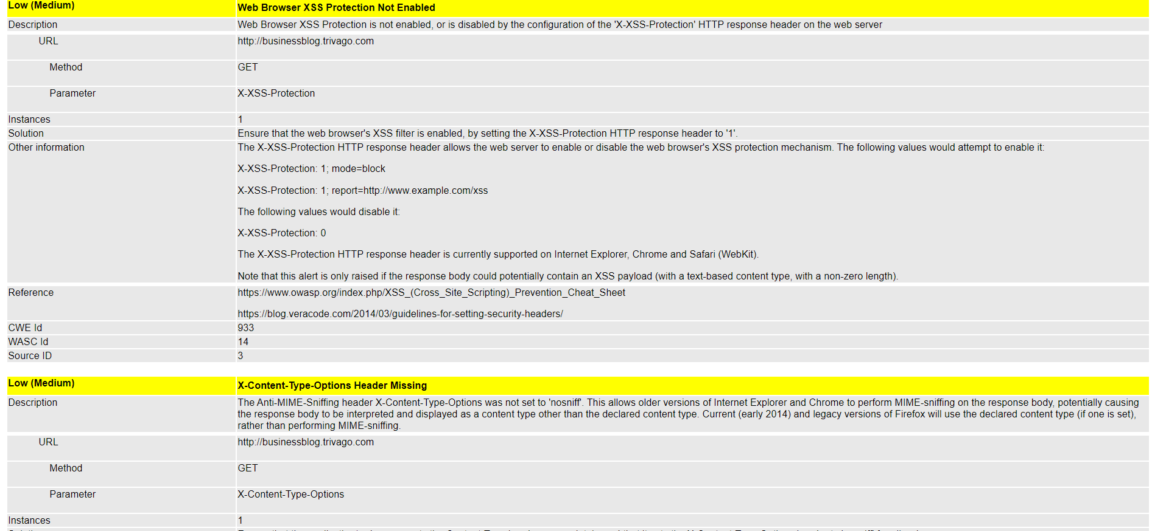

[www.click.hotelmanager.trivago.com](http://www.click.hotelmanager.trivago.com)

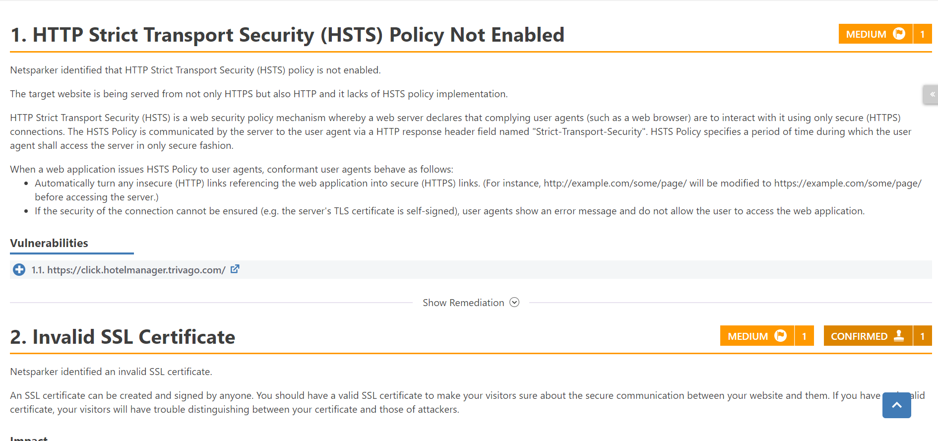

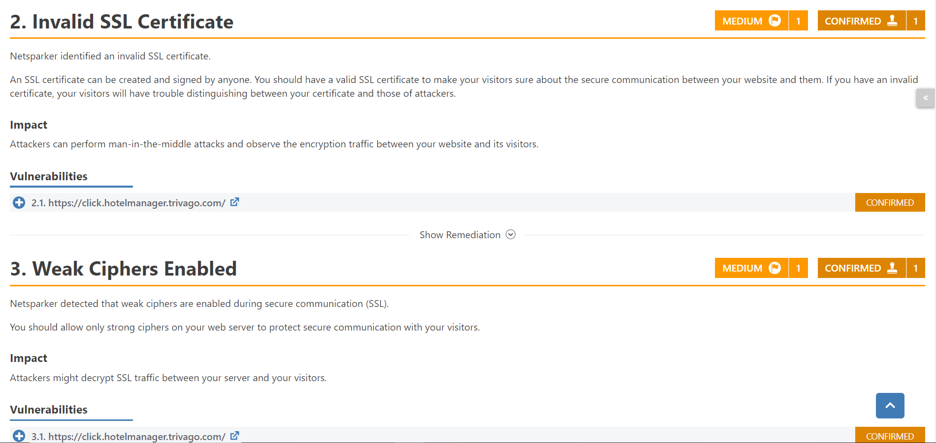

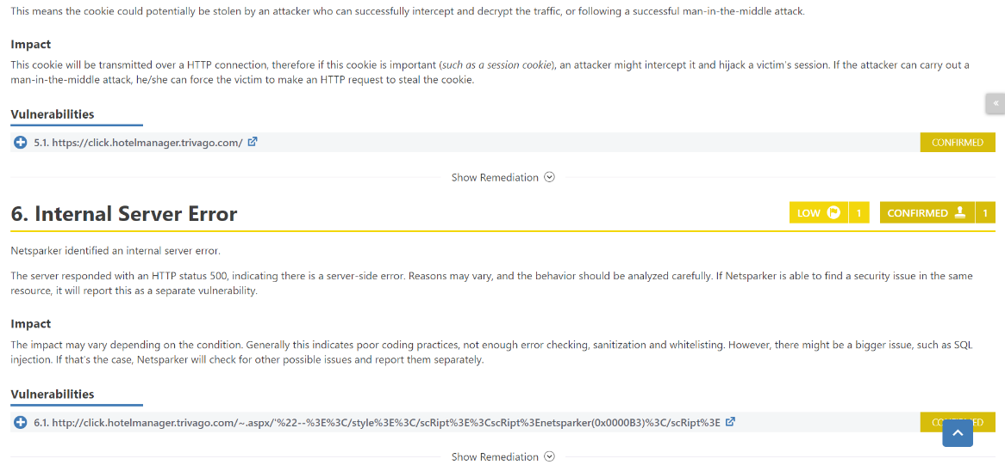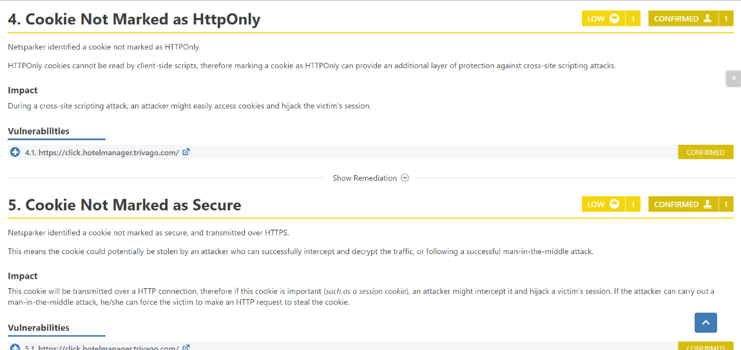

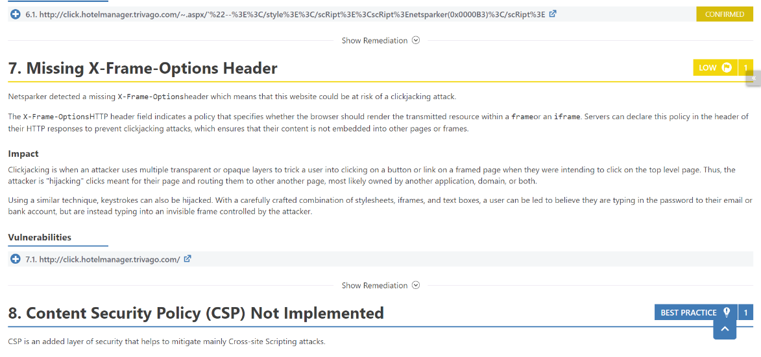

[www.developer.trivago.com](http://www.developer.trivago.com)

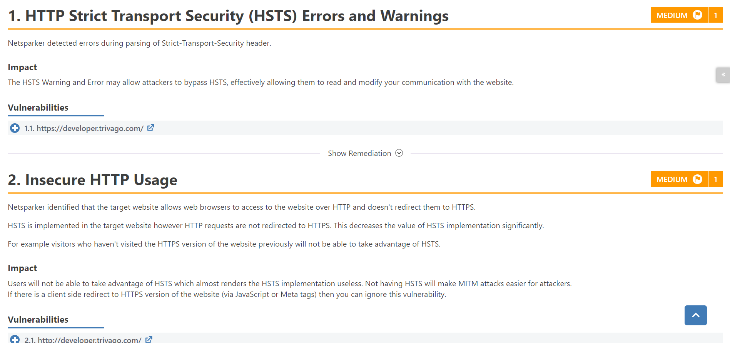

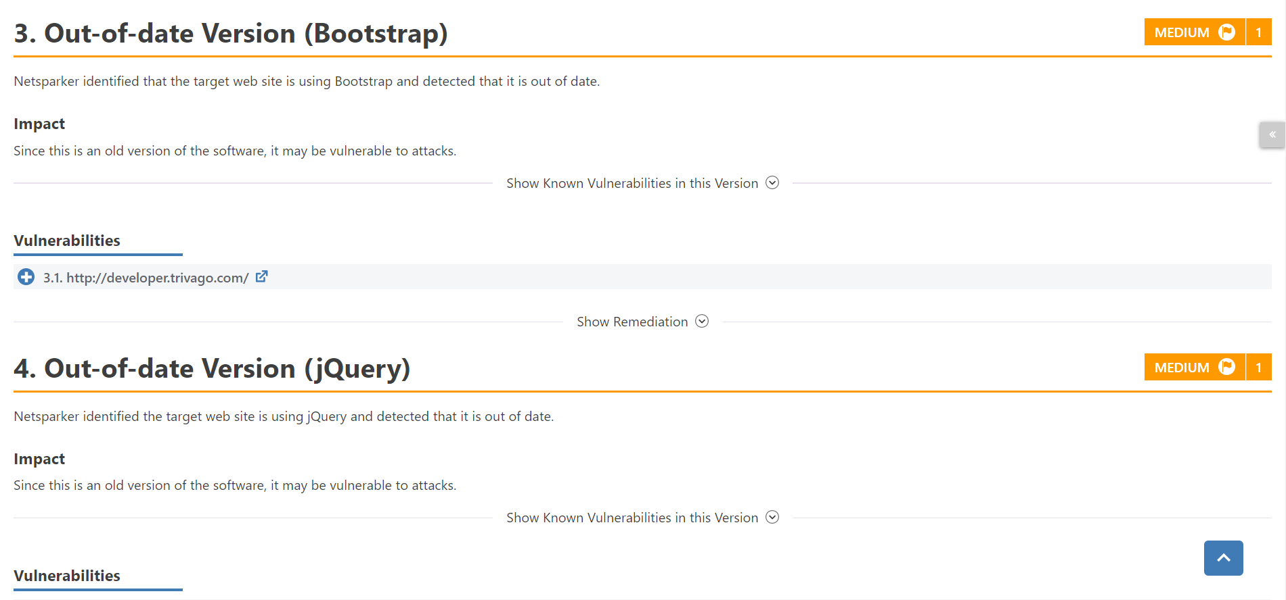

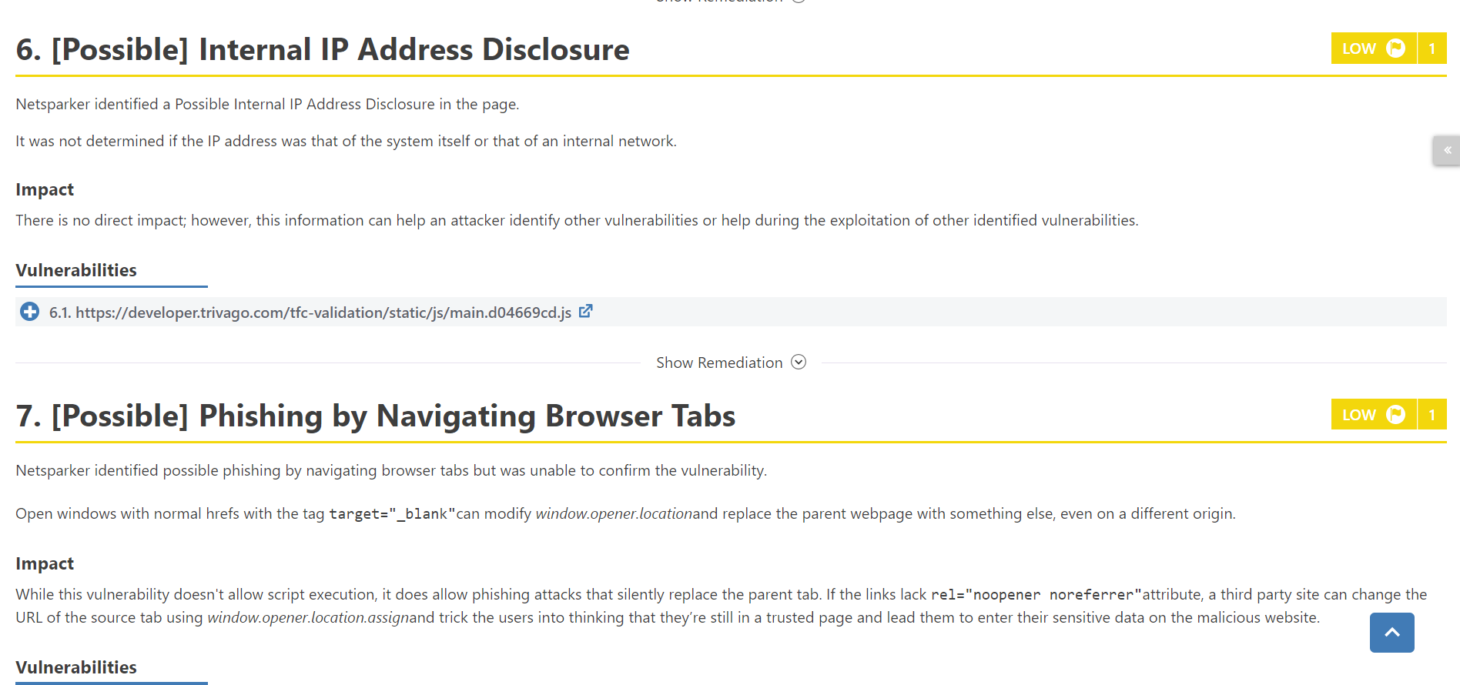

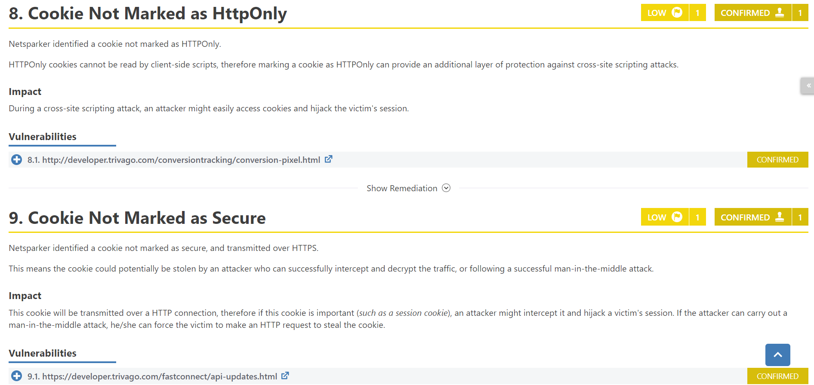

[www.discover.trivago.com](http://www.discover.trivago.com)

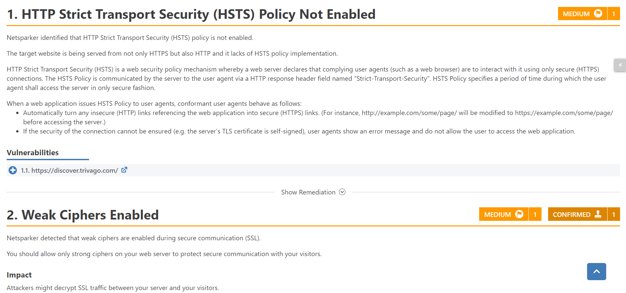

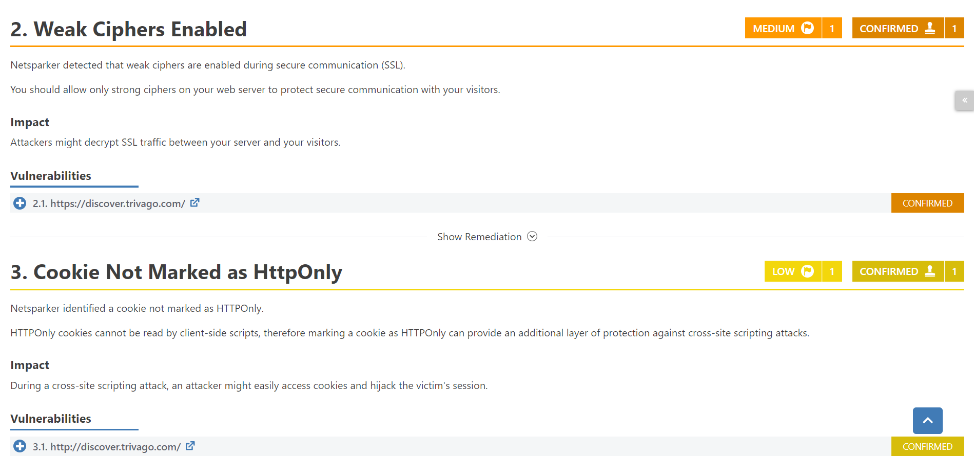

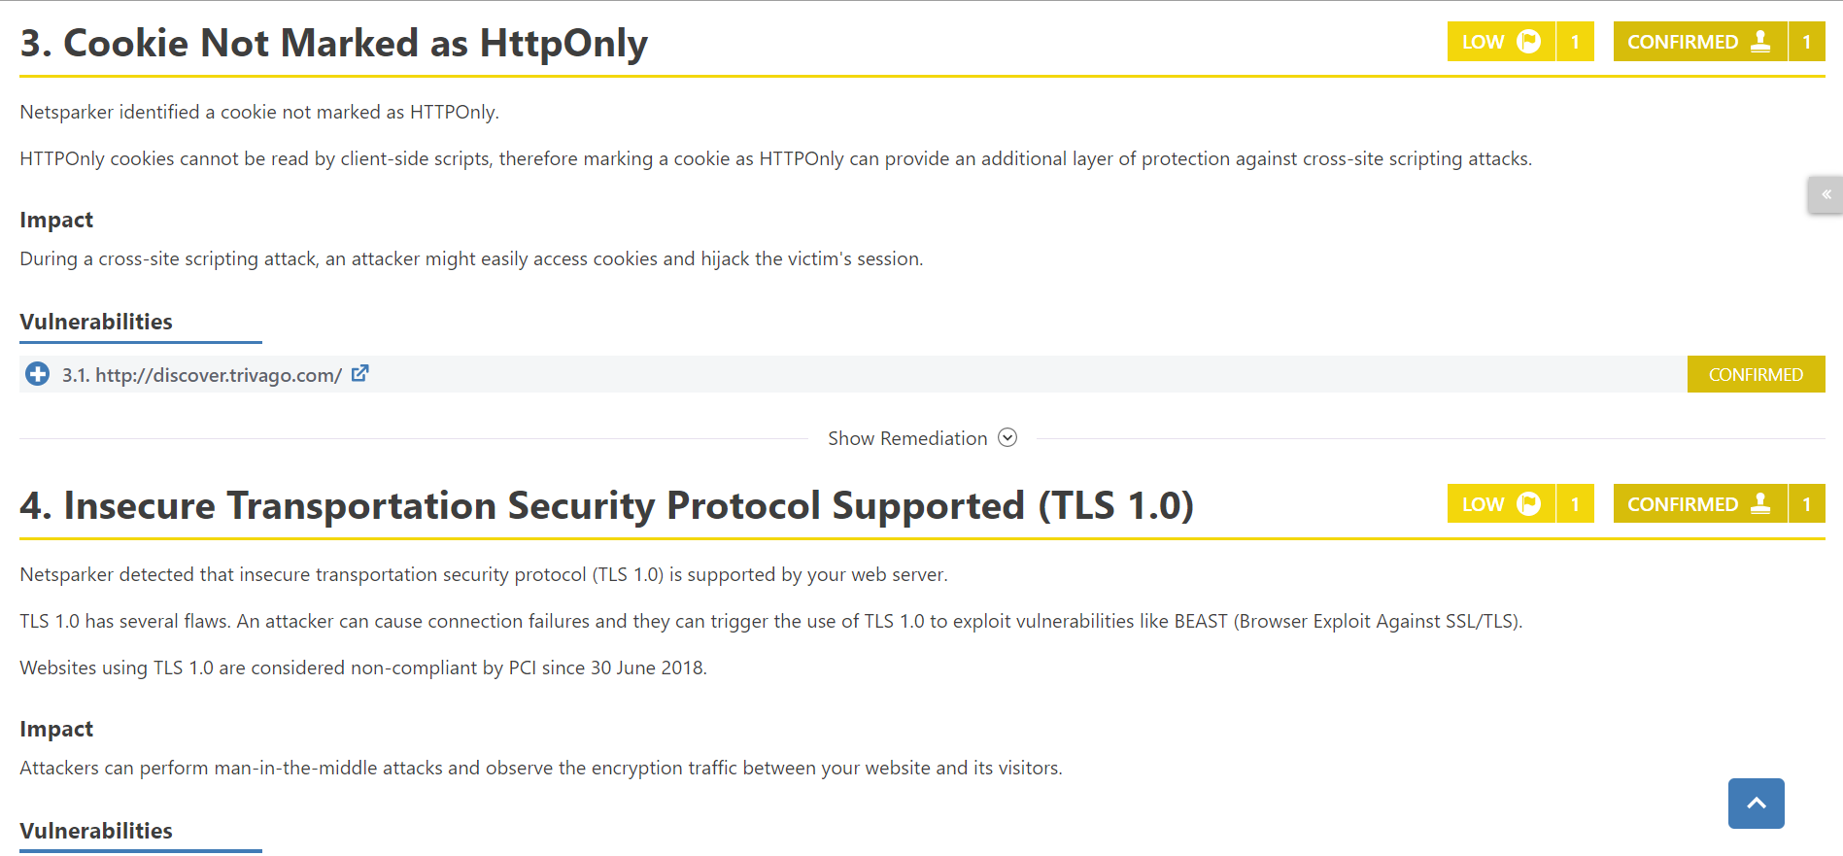

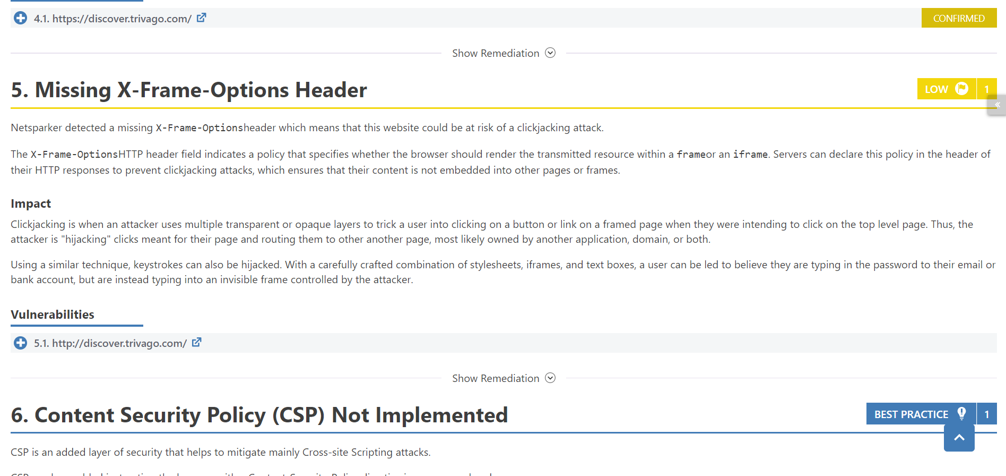

[www.dus.trivago.com](http://www.dus.trivago.com)

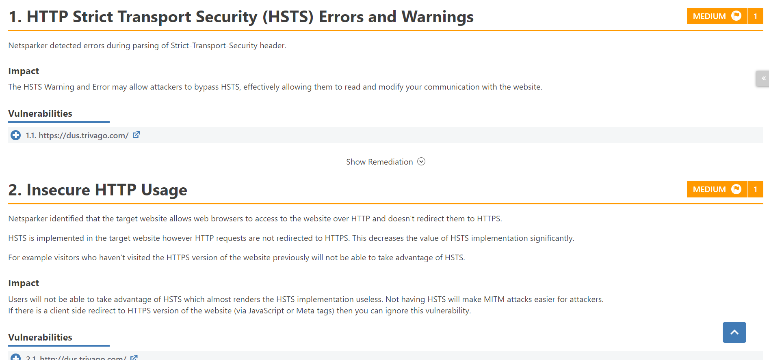

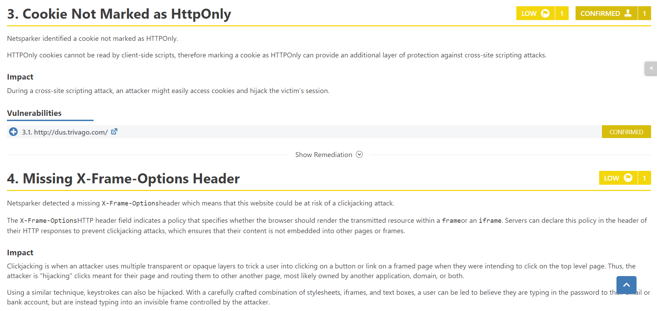

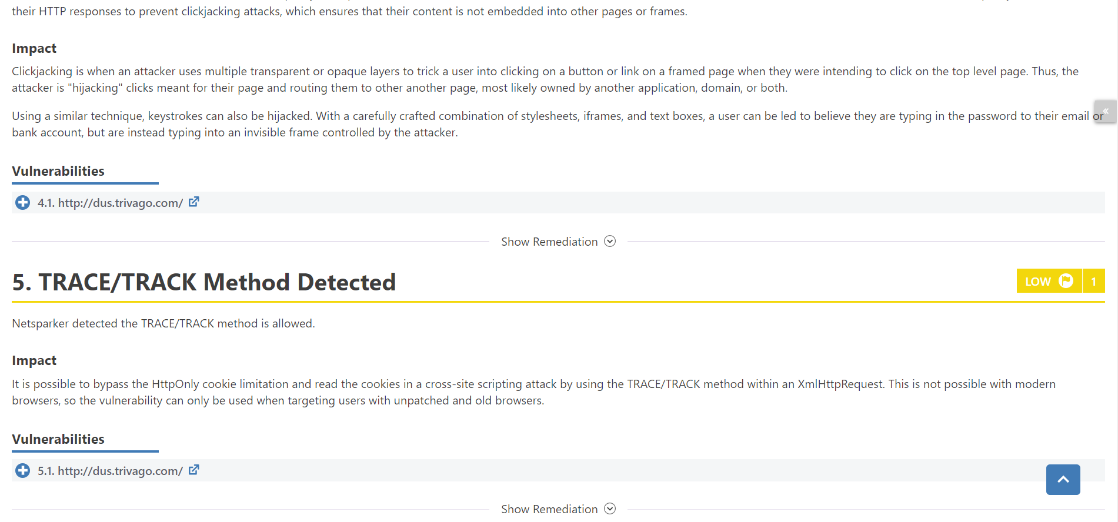

[www.express.trivago.com](http://www.express.trivago.com)

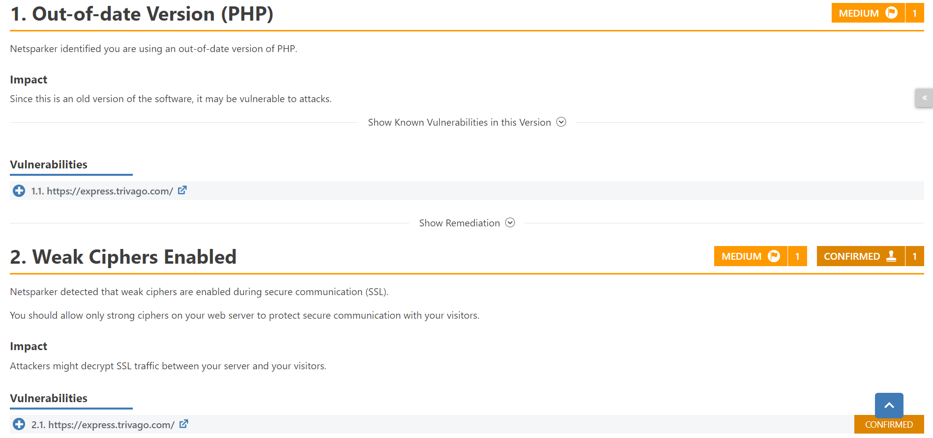

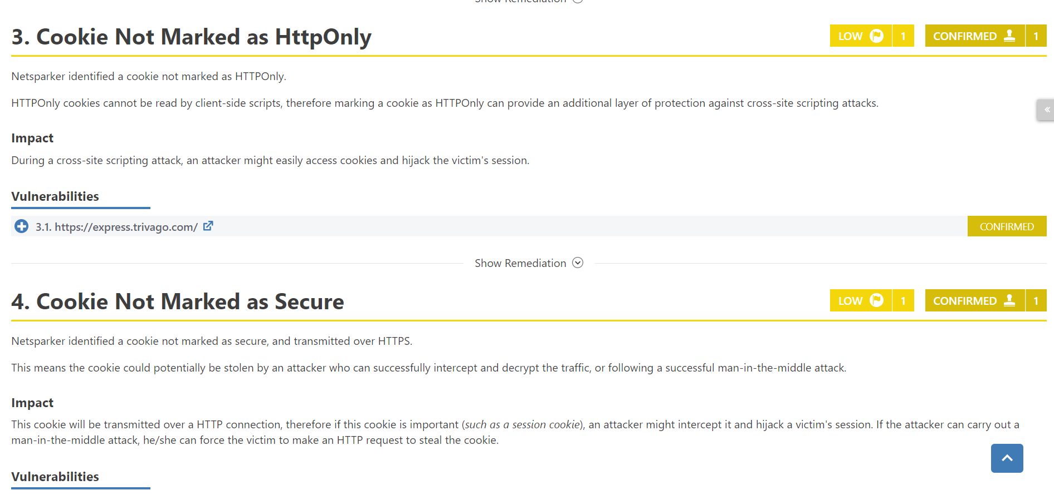

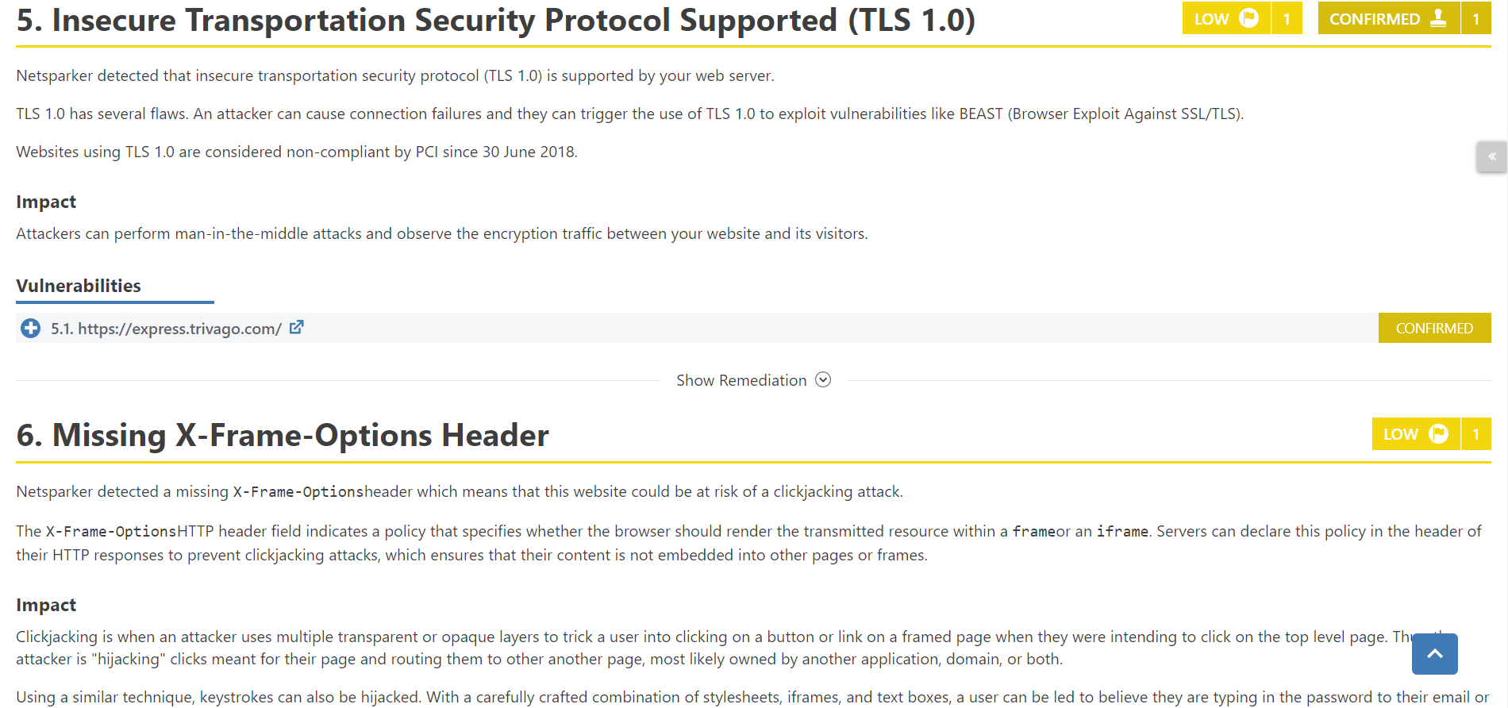

[www.express-api.trivago.com](http://www.express-api.trivago.com)

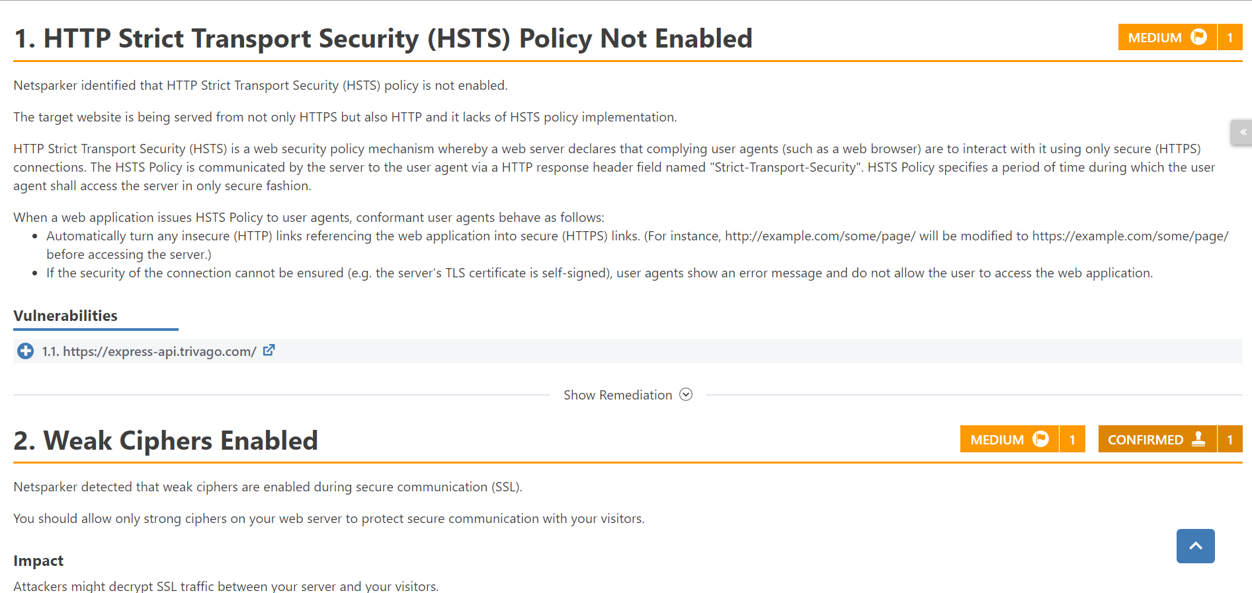

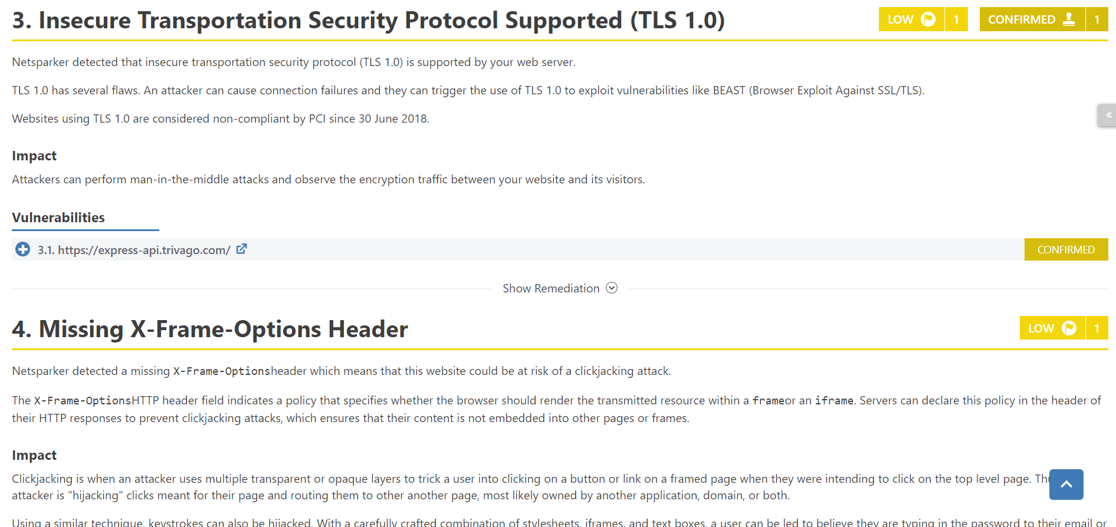

[www.express-dus.trivago.com](http://www.express-dus.trivago.com)

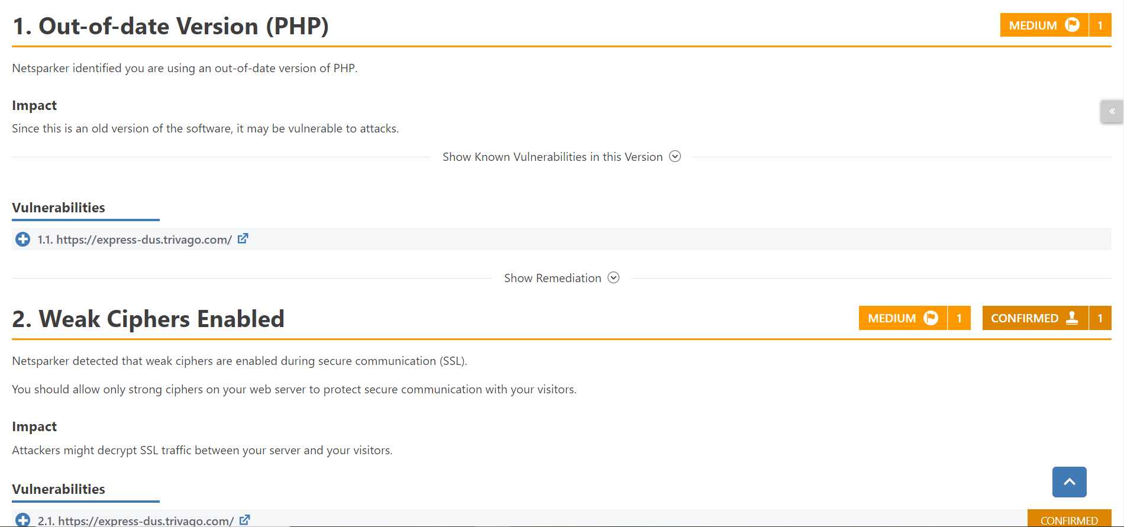

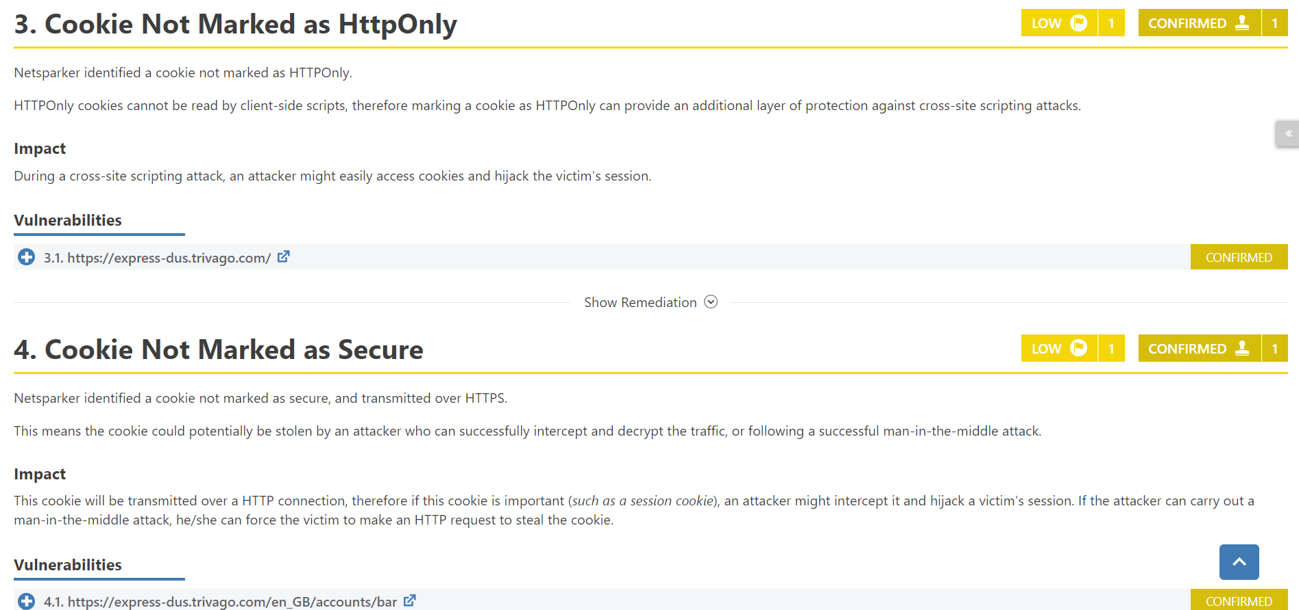

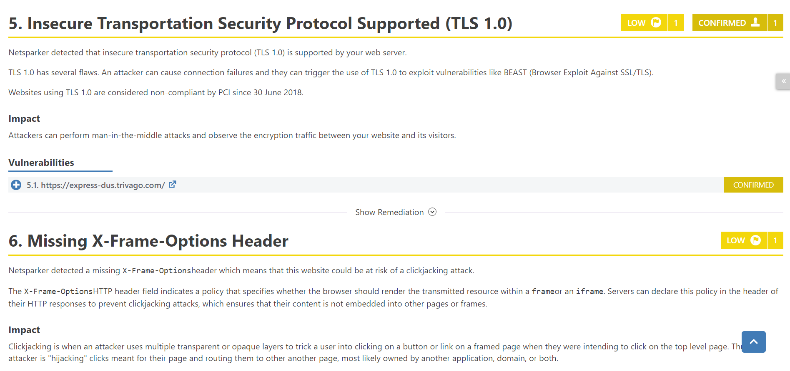

[www.image.email.trivago.com](http://www.image.email.trivago.com)

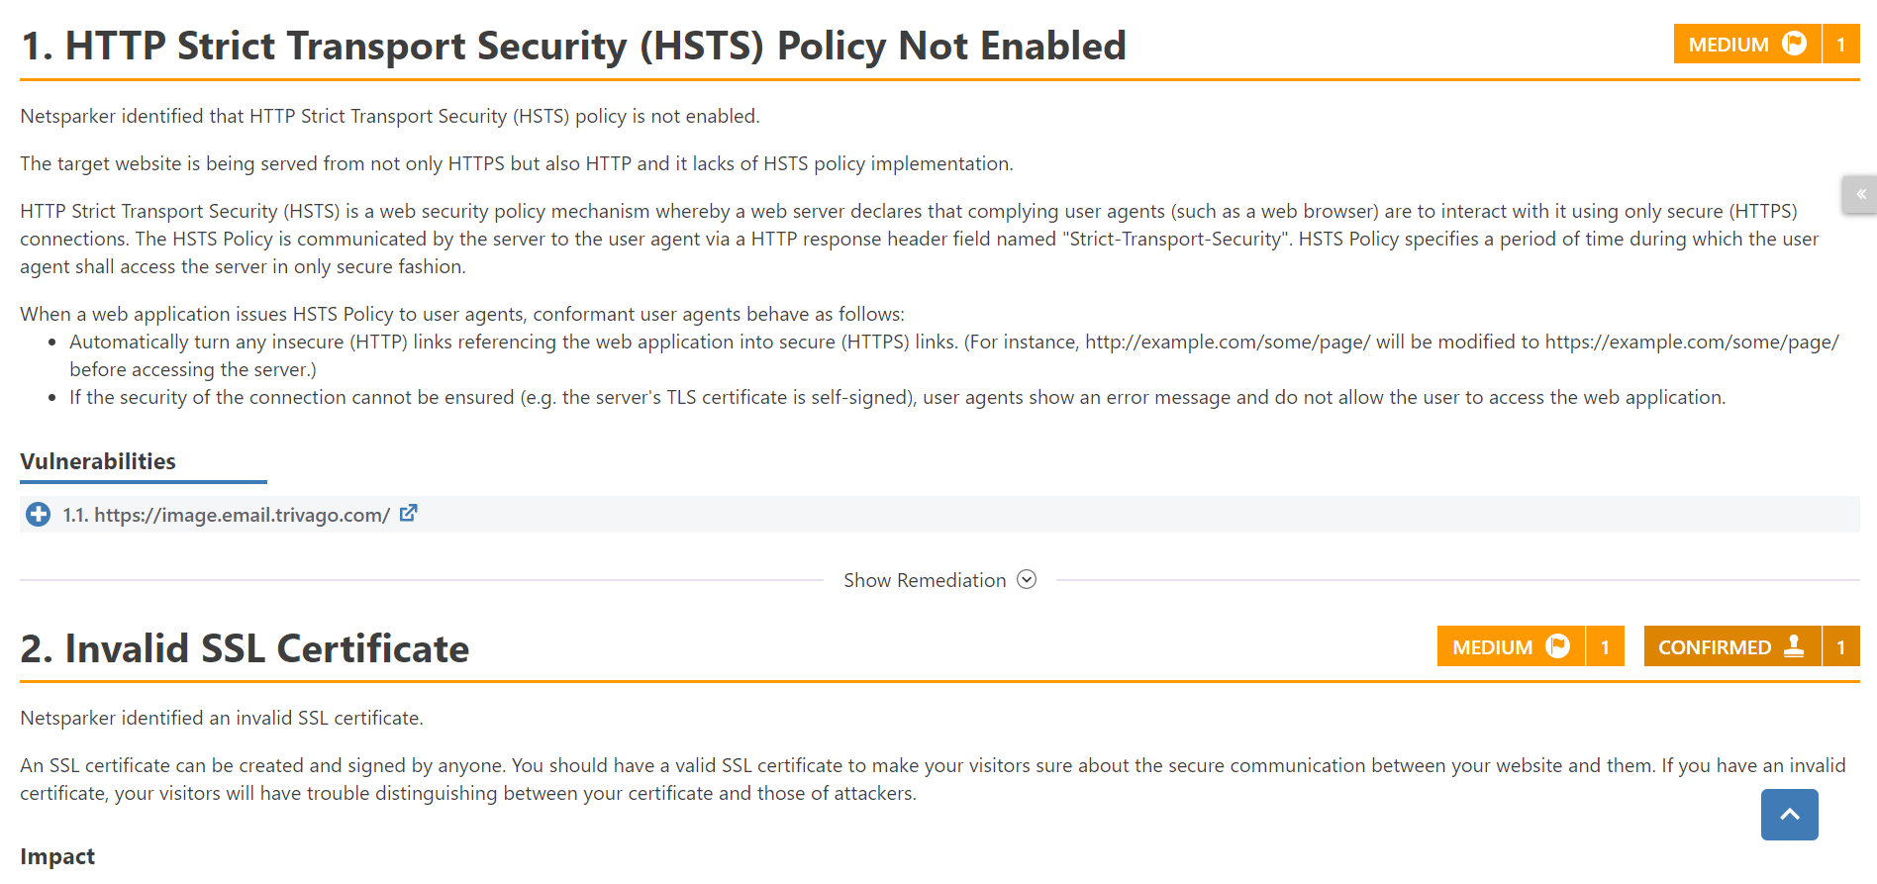

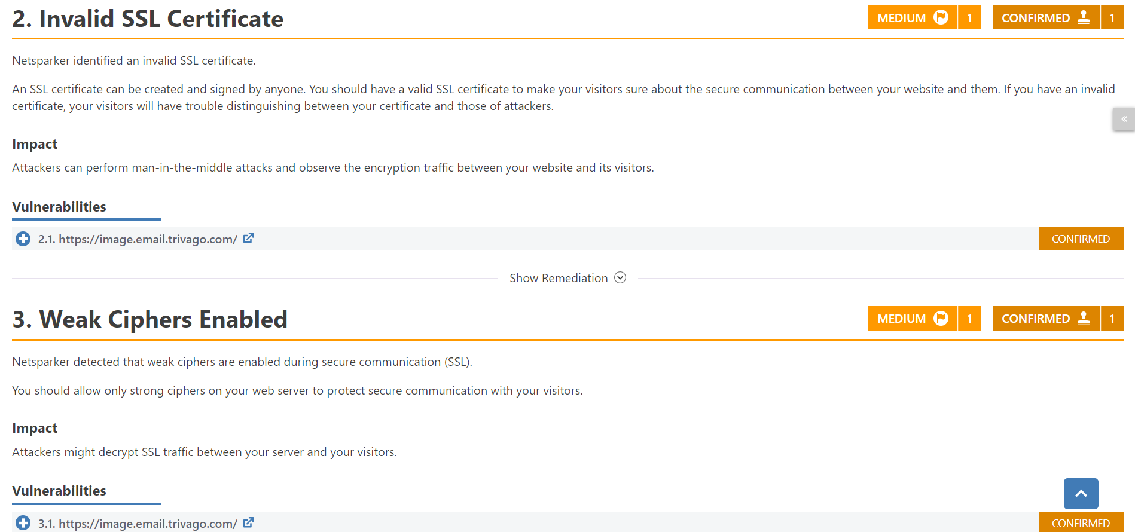

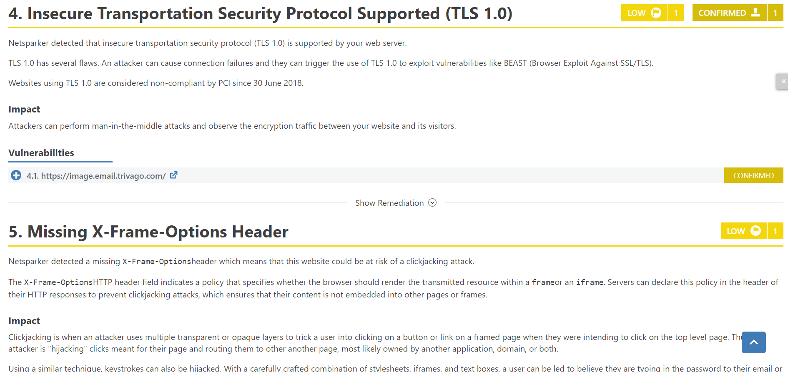

[www.knowledge.trivago.com](http://www.knowledge.trivago.com)

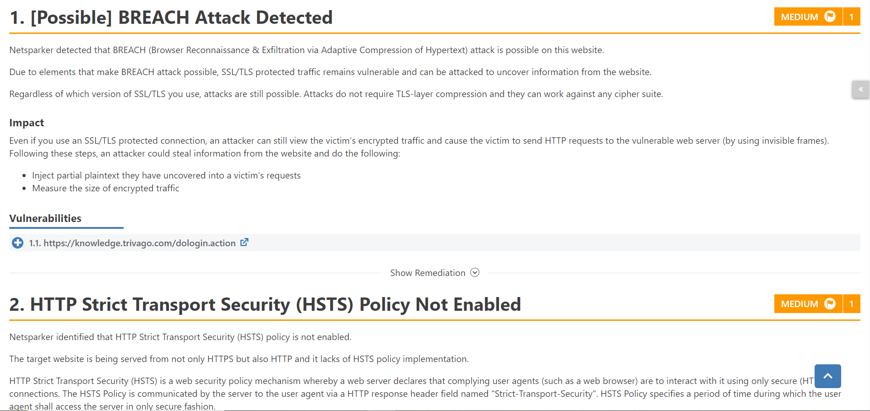

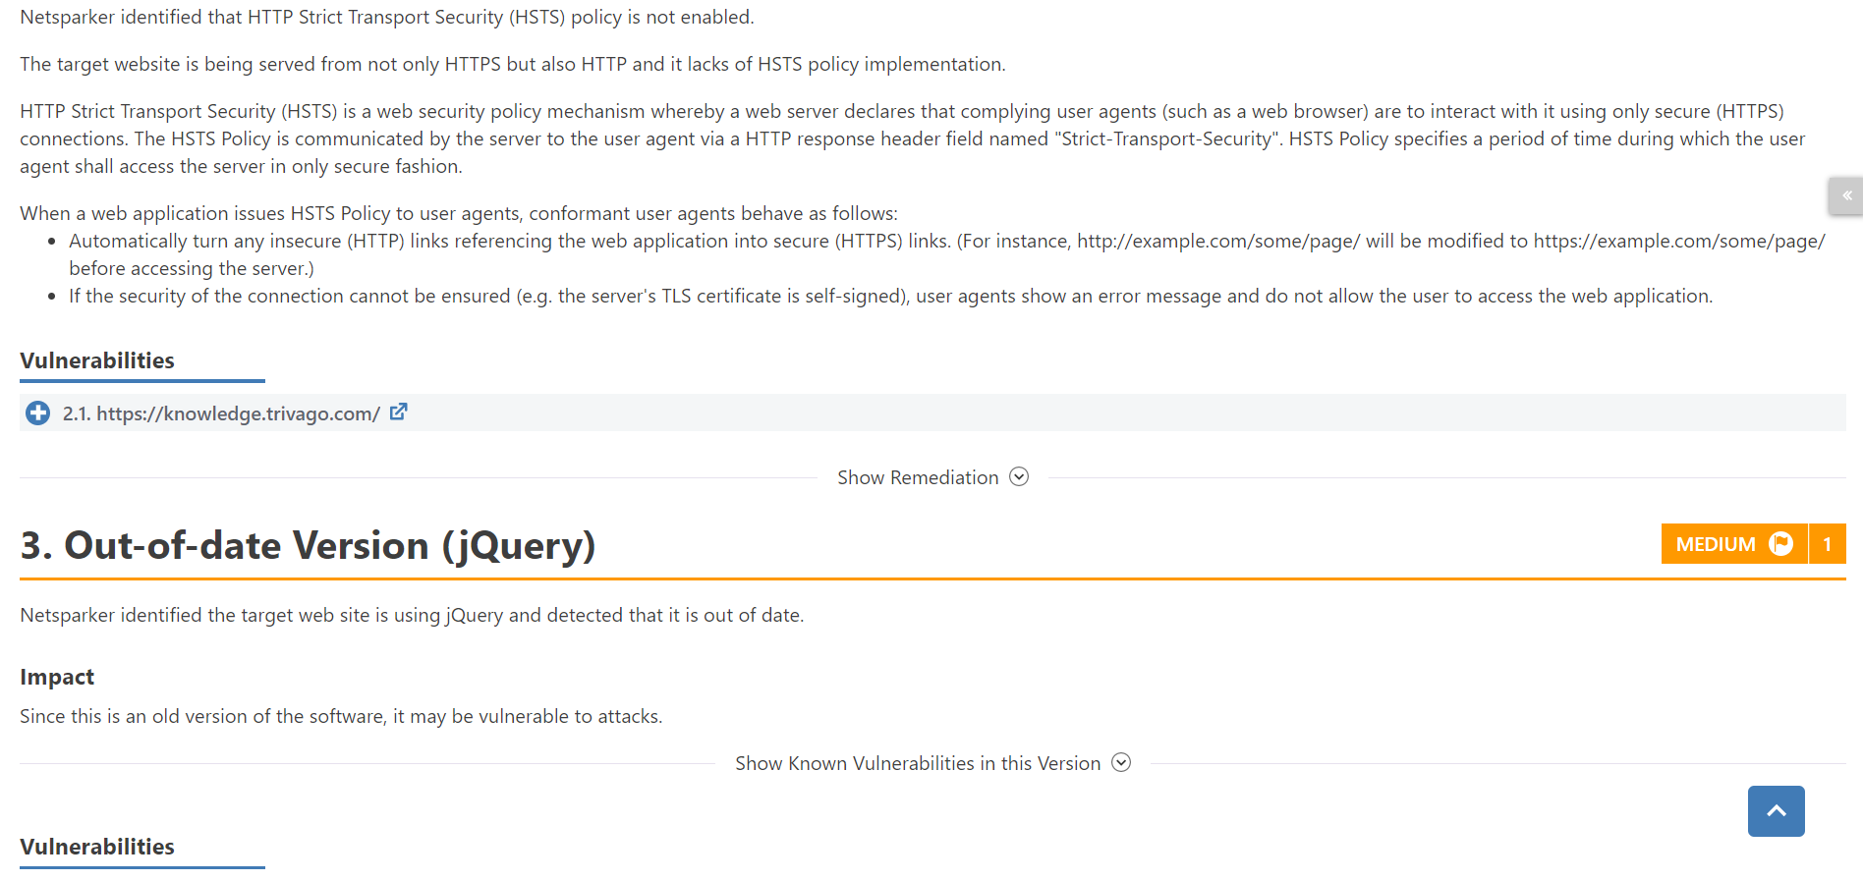

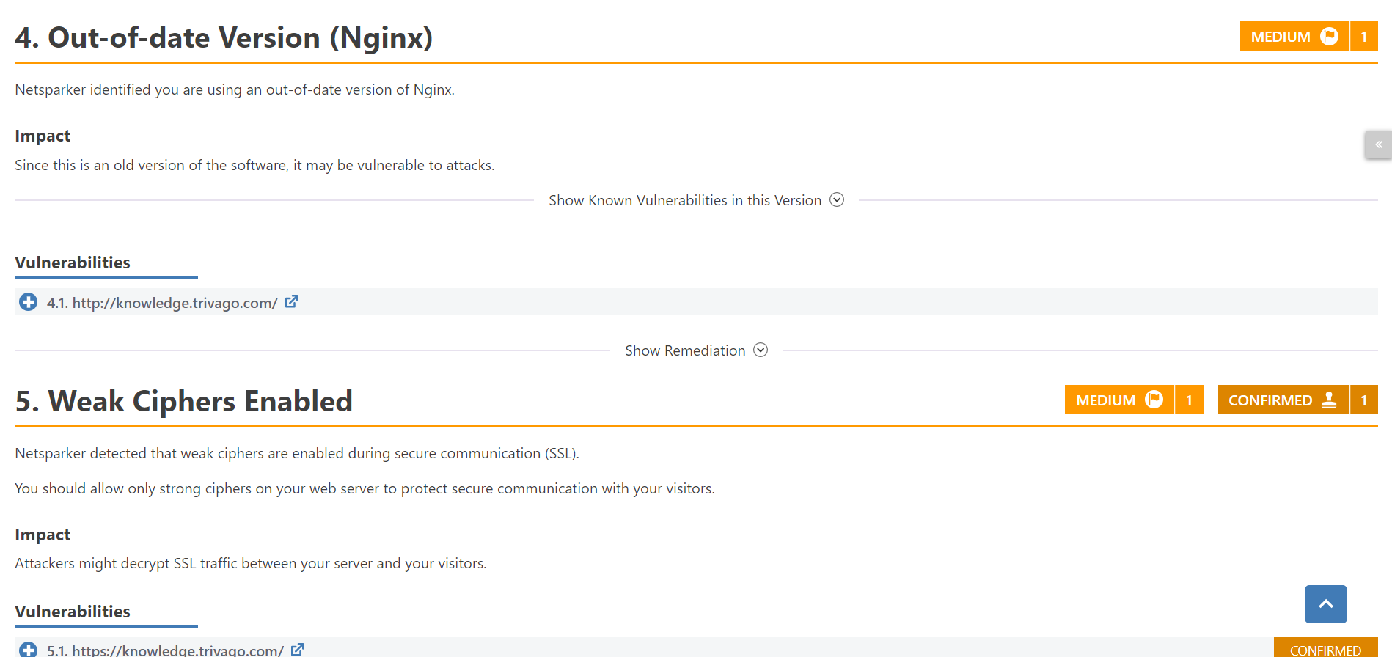

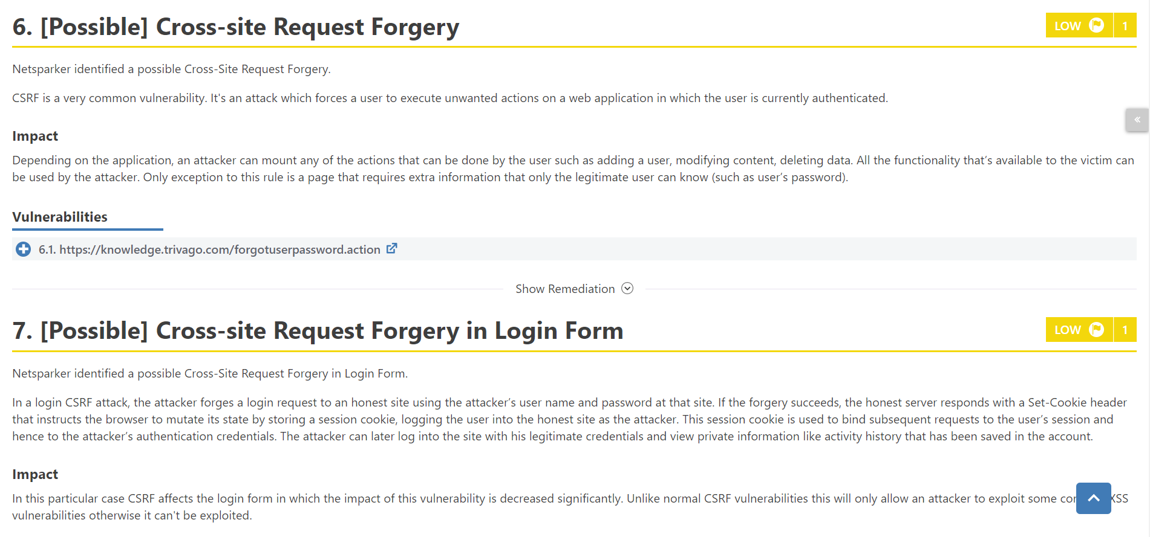

[www.legacy-intelligence.trivago.com](http://www.legacy-intelligence.trivago.com)

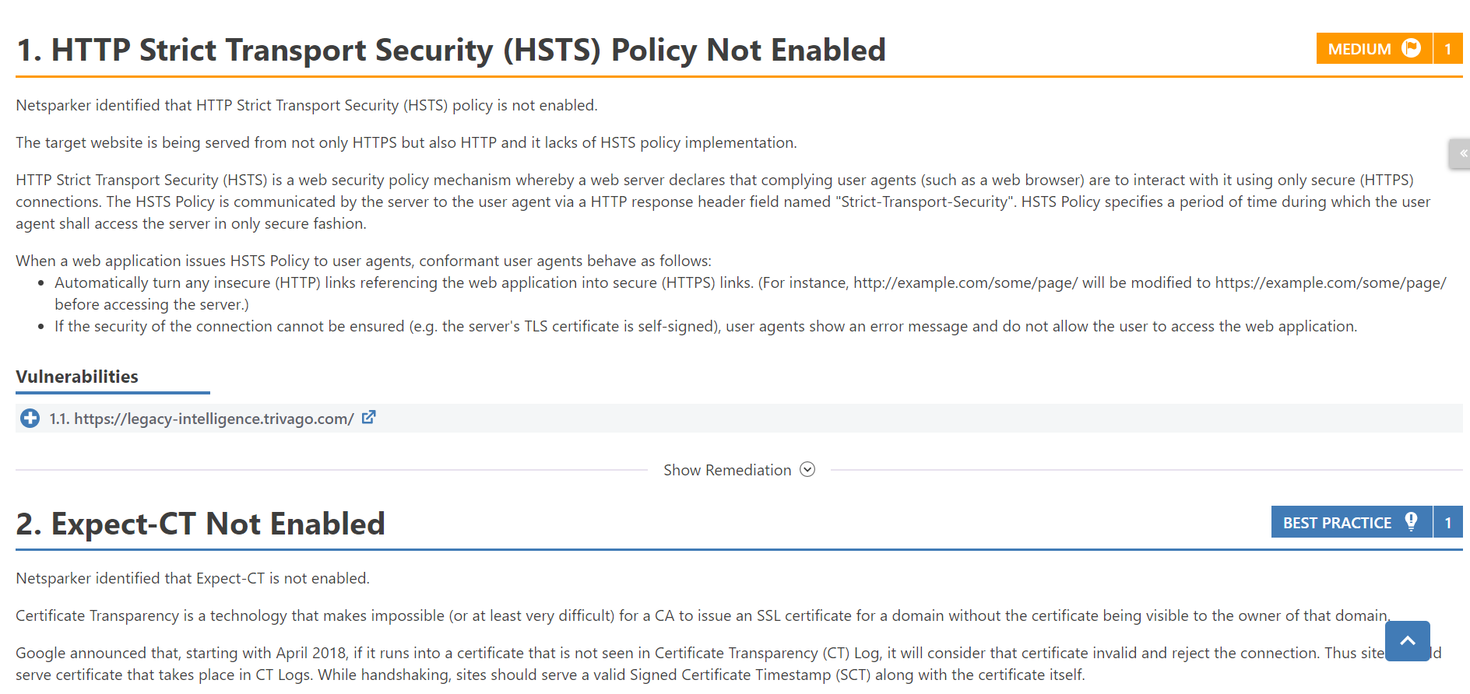

[www.life.trivago.com](http://www.life.trivago.com)

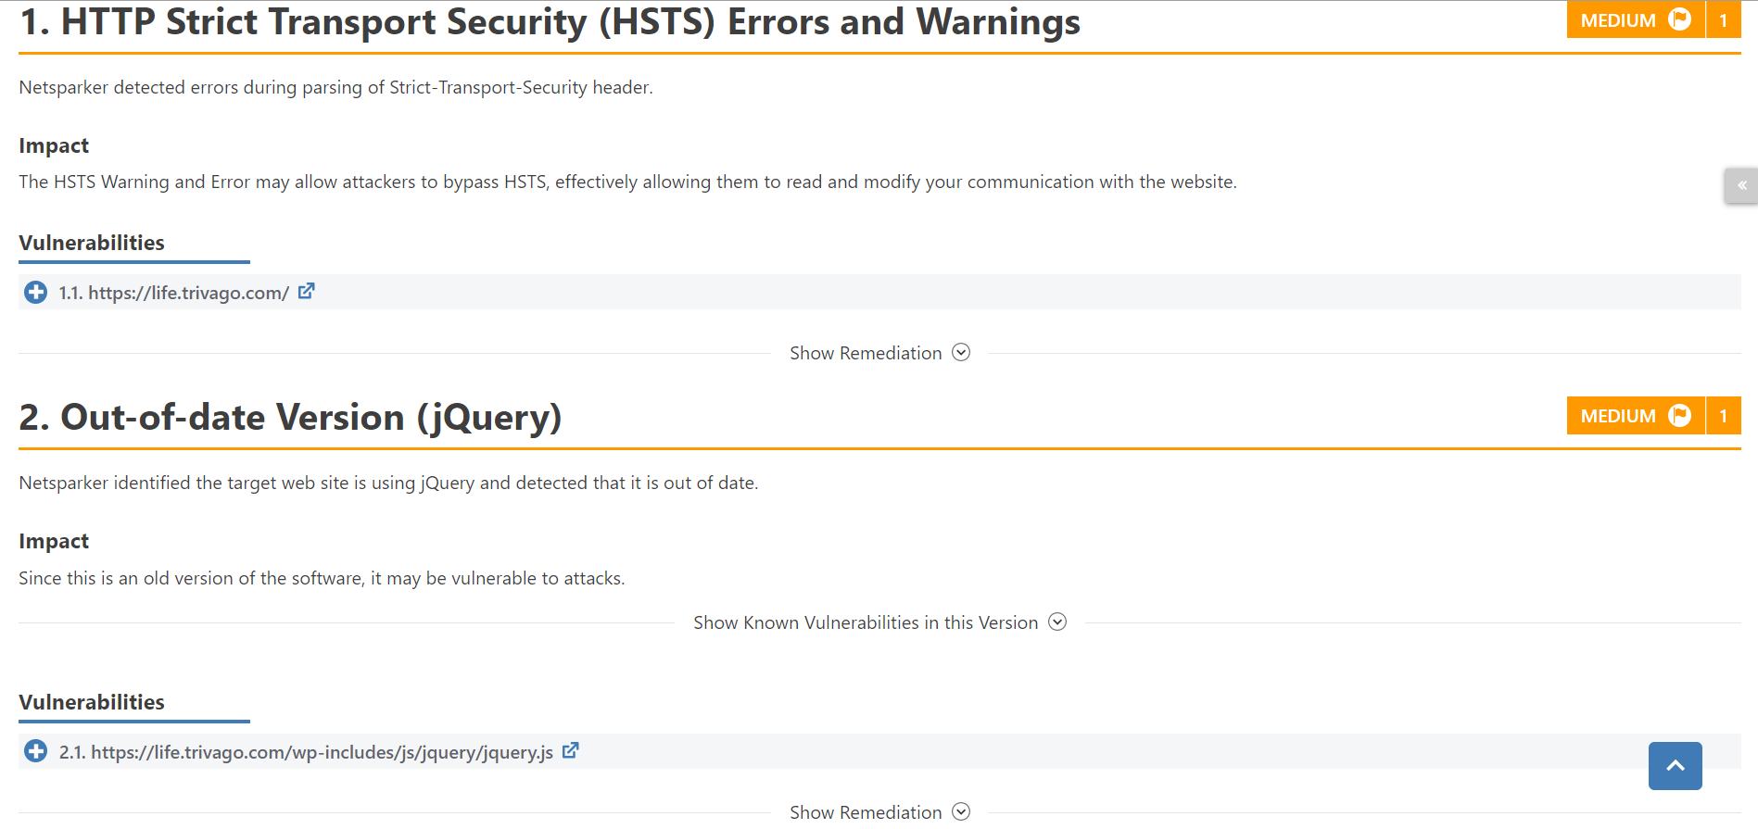

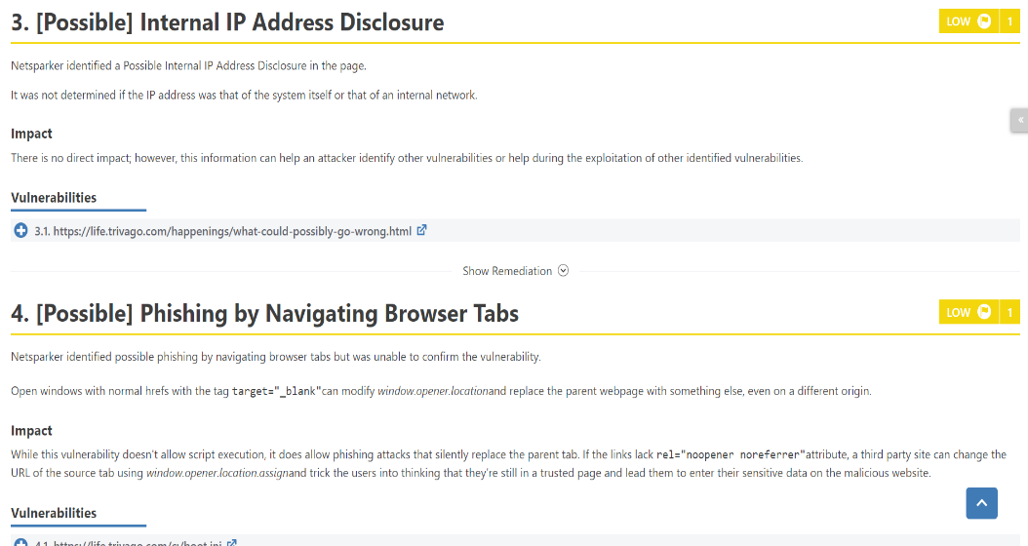

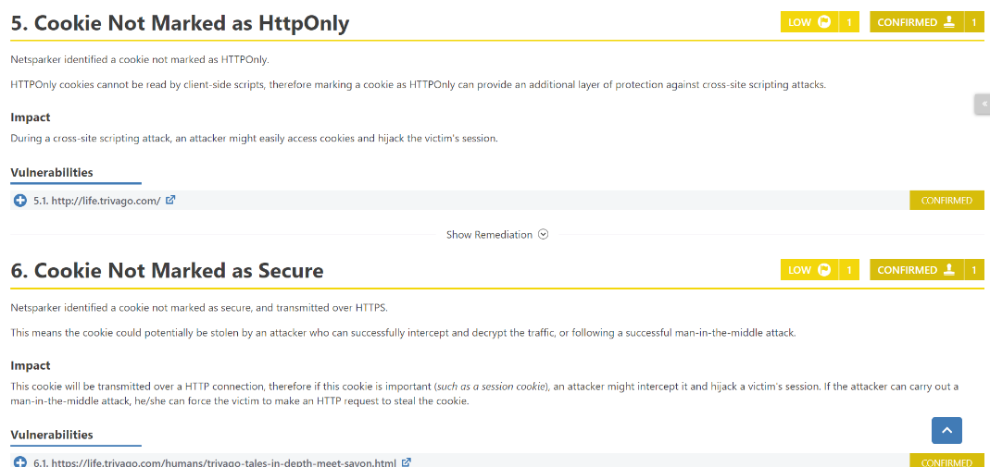

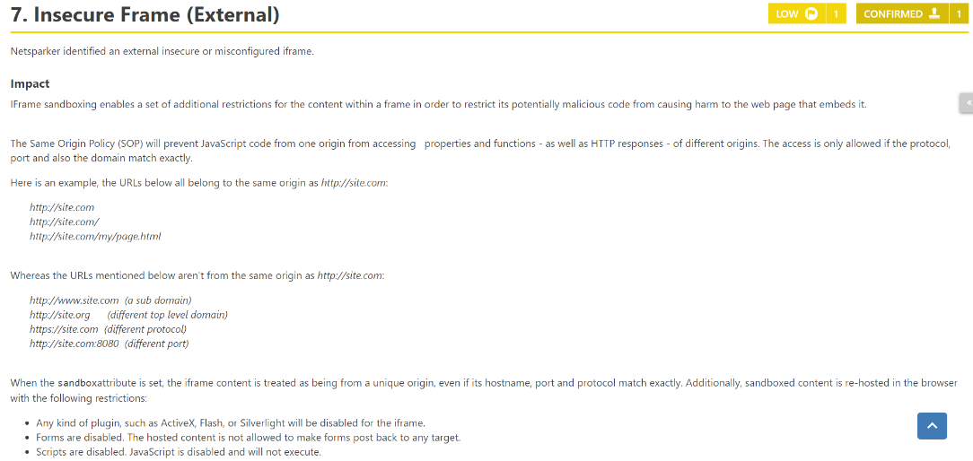

[www.lyncapp.trivago.com](http://www.lyncapp.trivago.com)

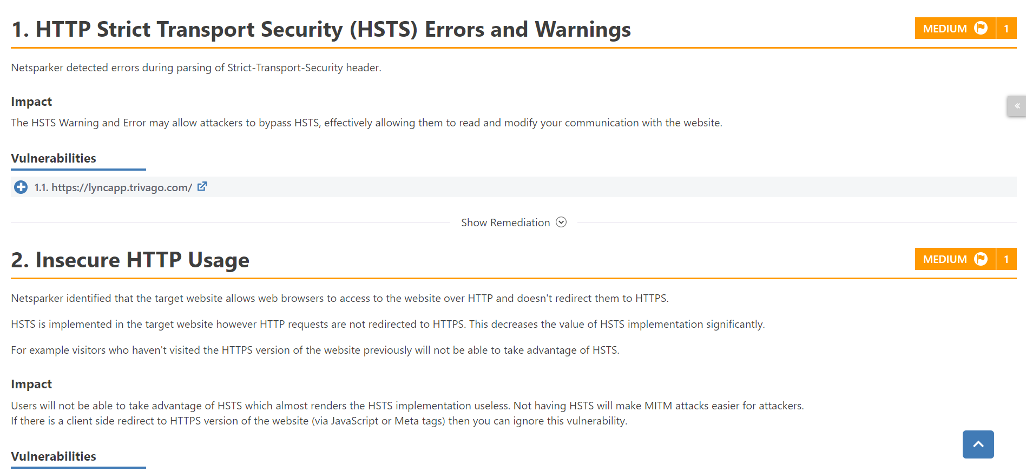

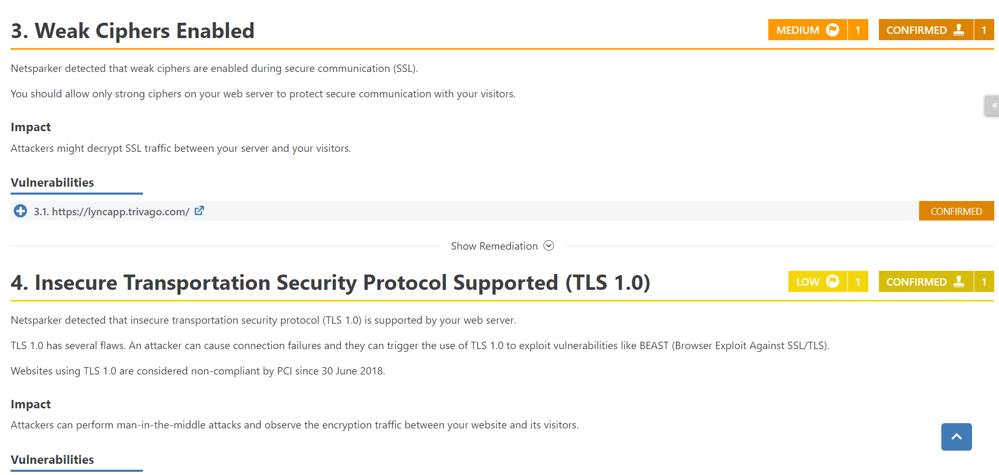

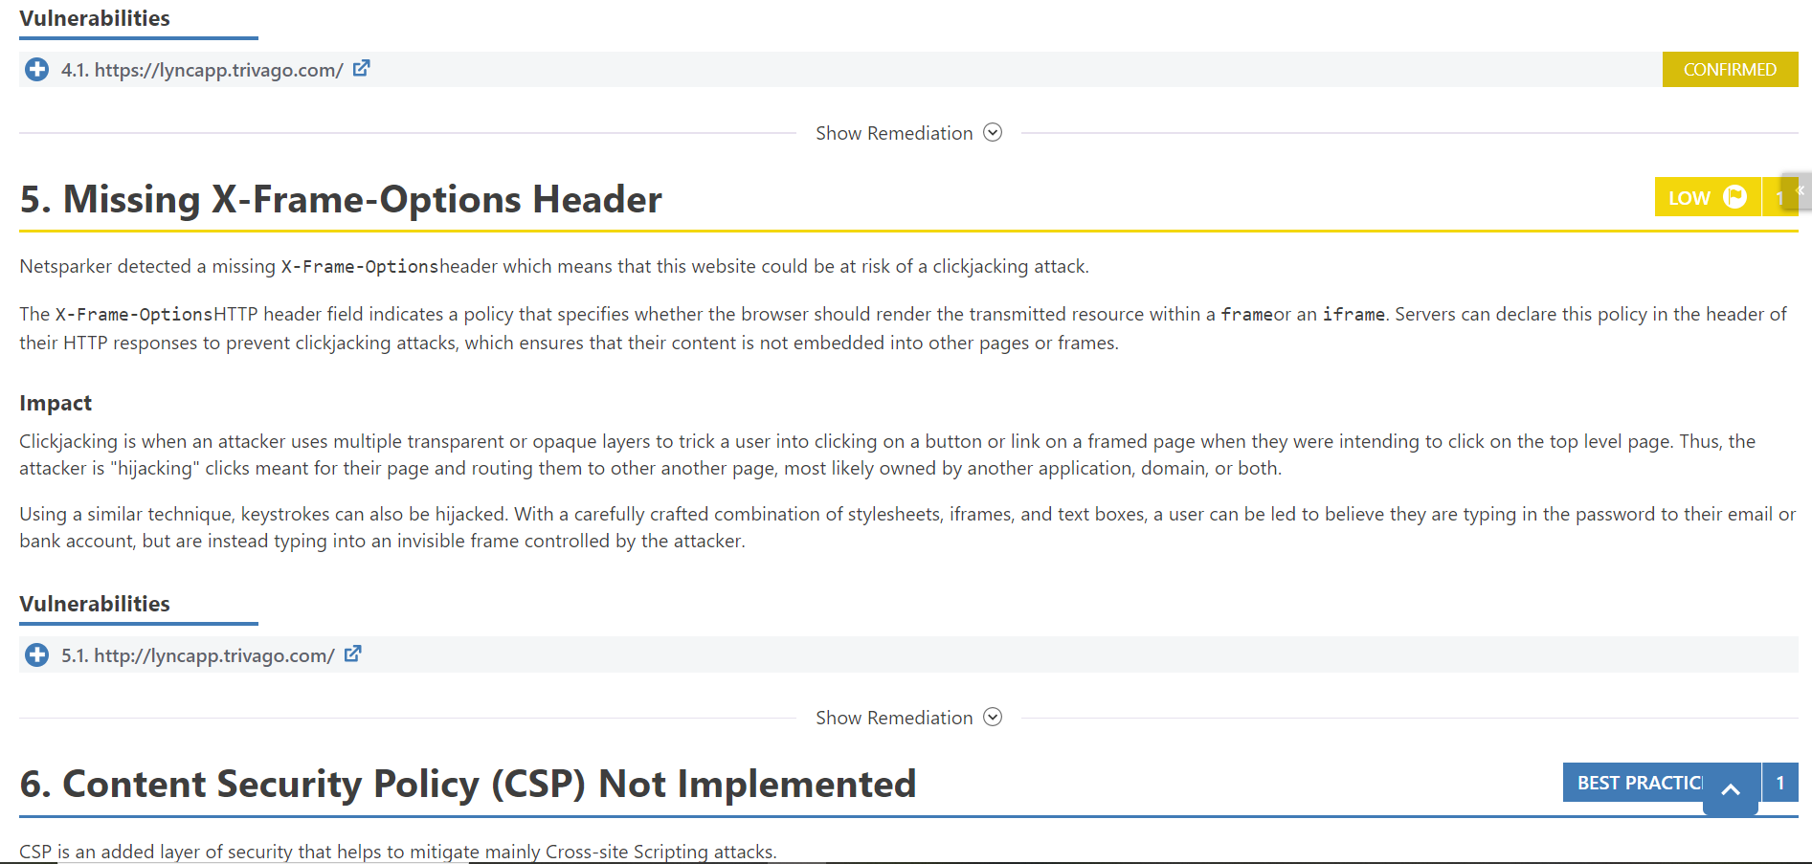

[www.magacine.tri.com](http://www.magacine.tri.com)

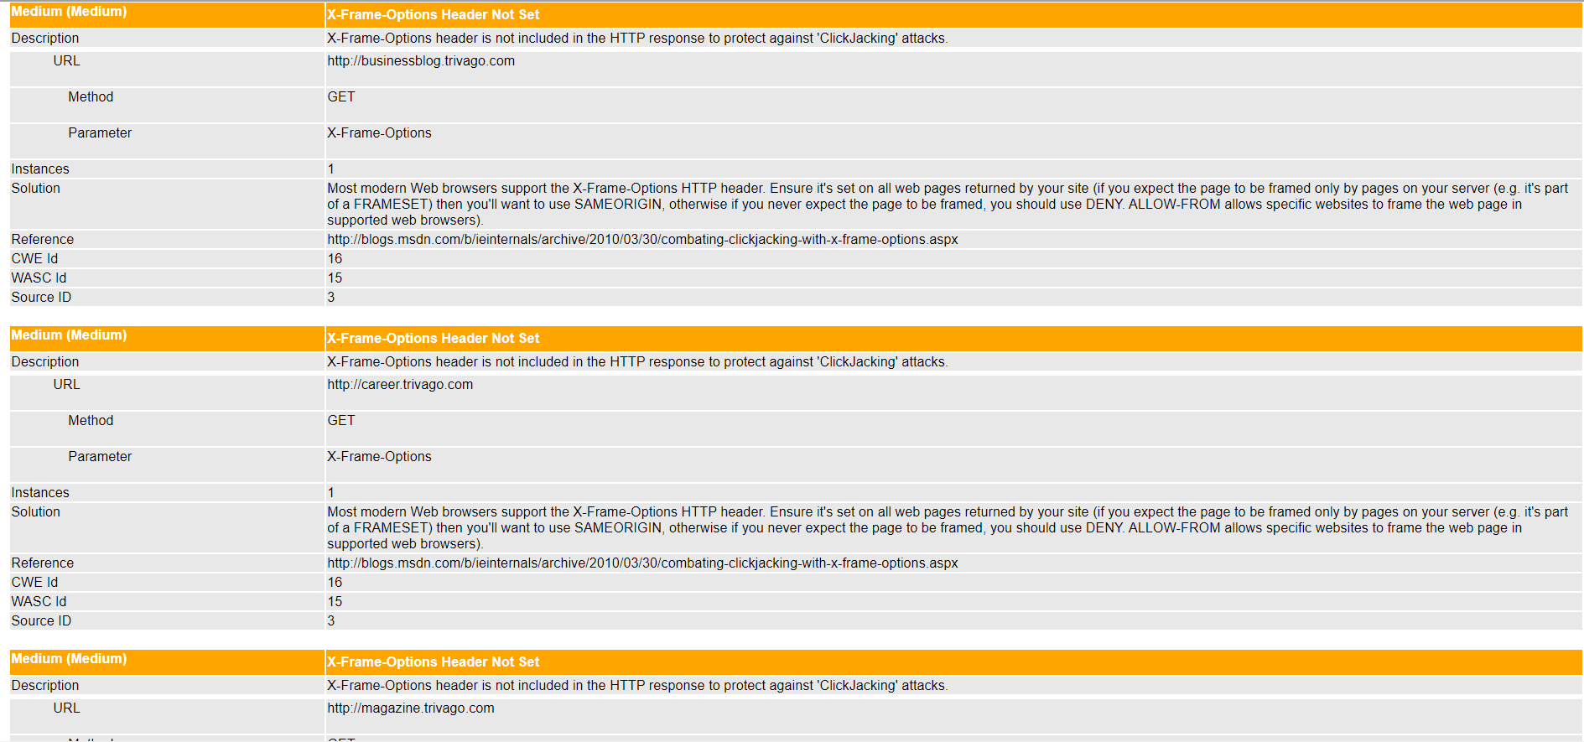

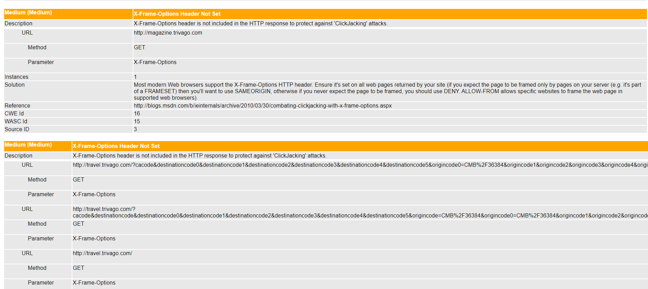

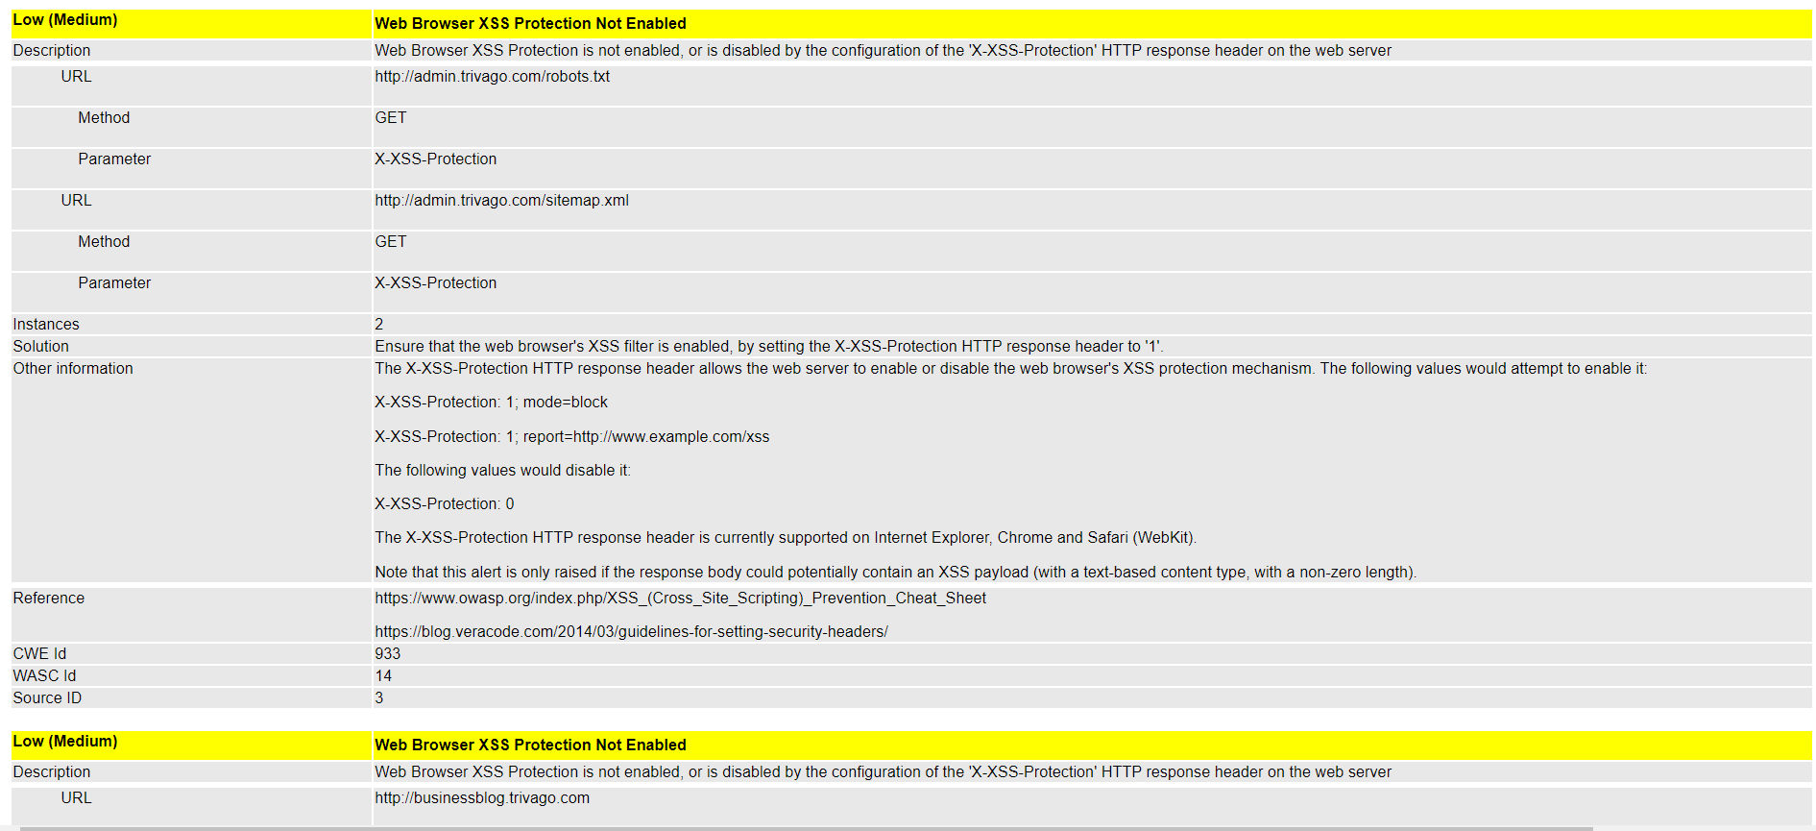

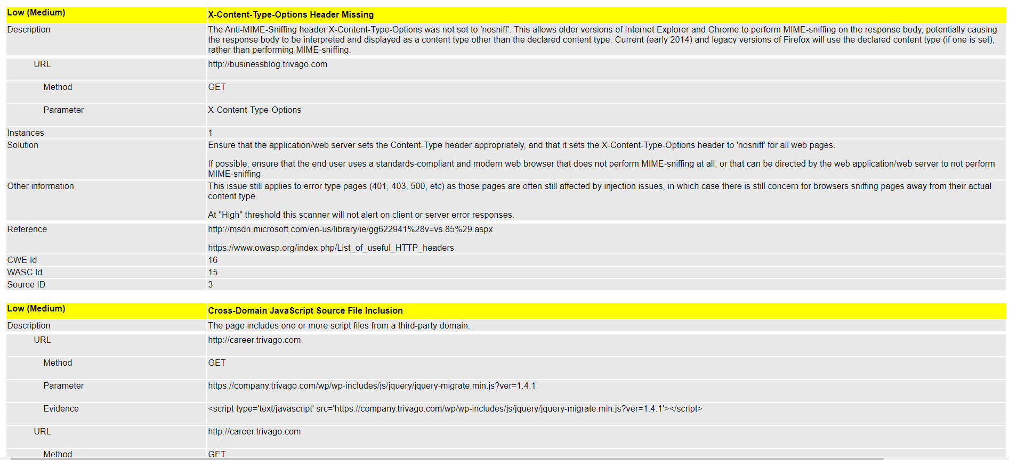

[www.media-room5.trivago.com](http://www.media-room5.trivago.com)

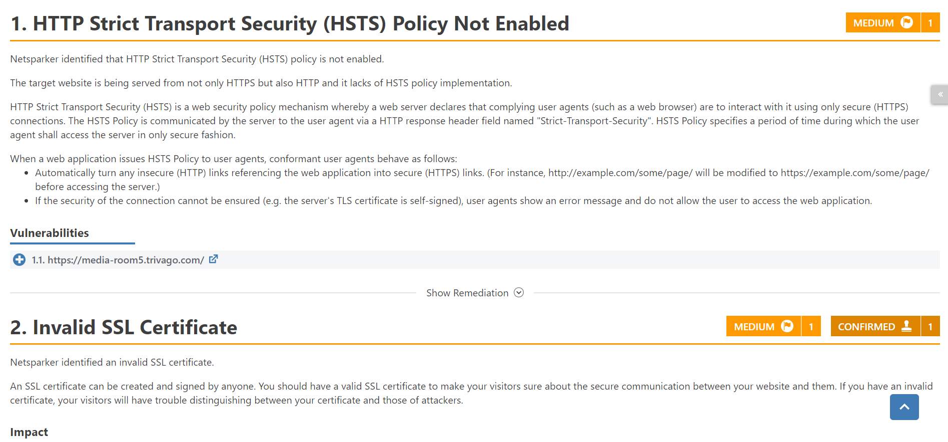

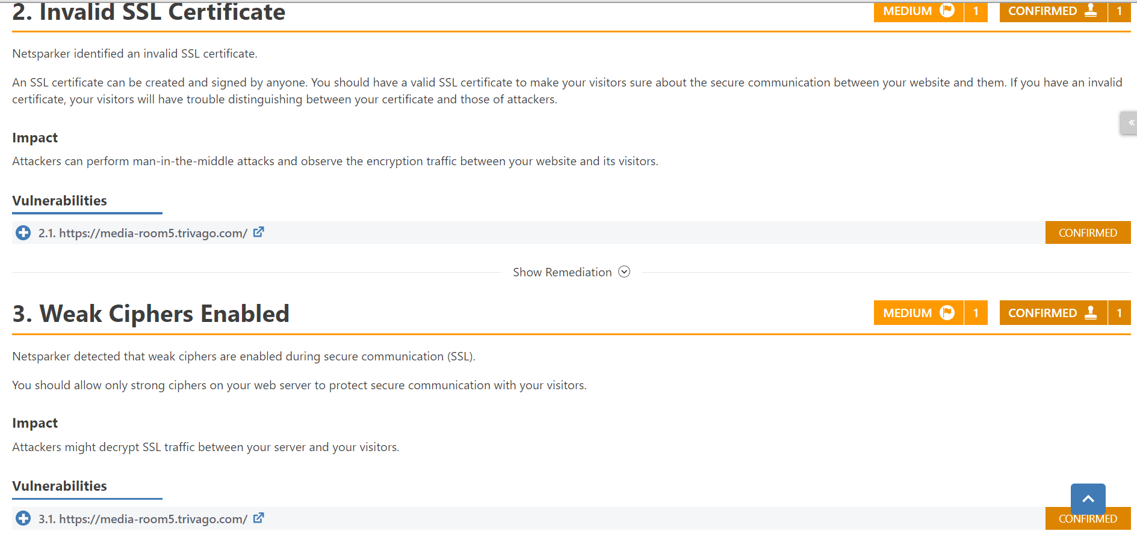

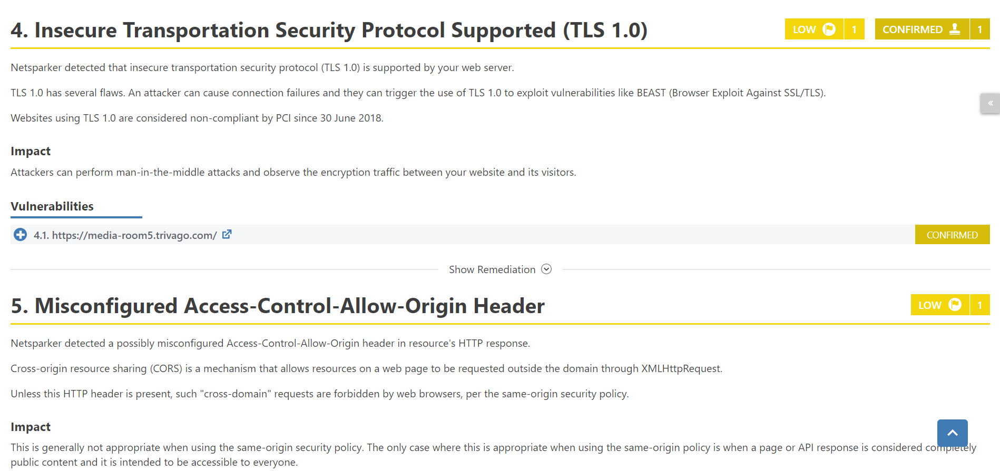

[www.meet.trivago.com](http://www.meet.trivago.com)

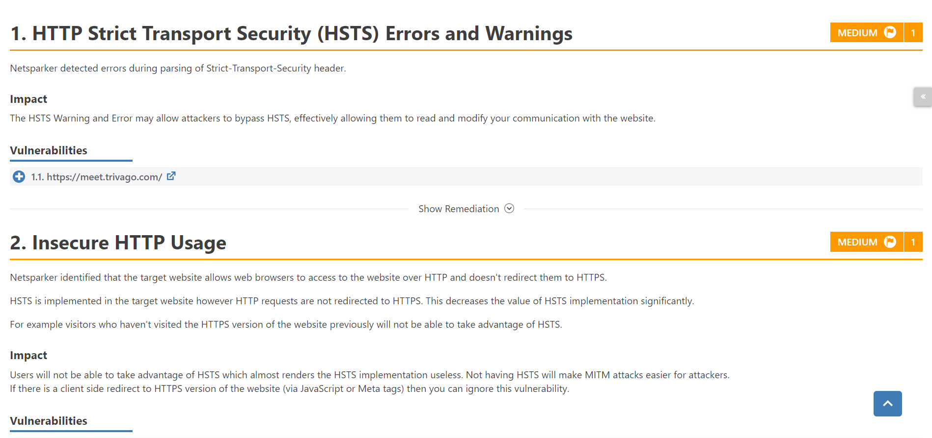

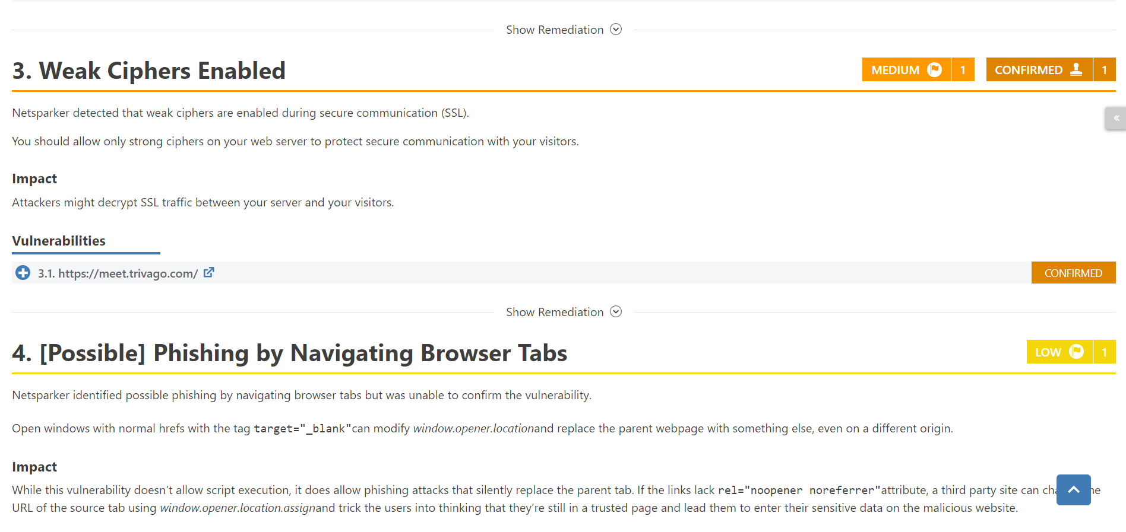

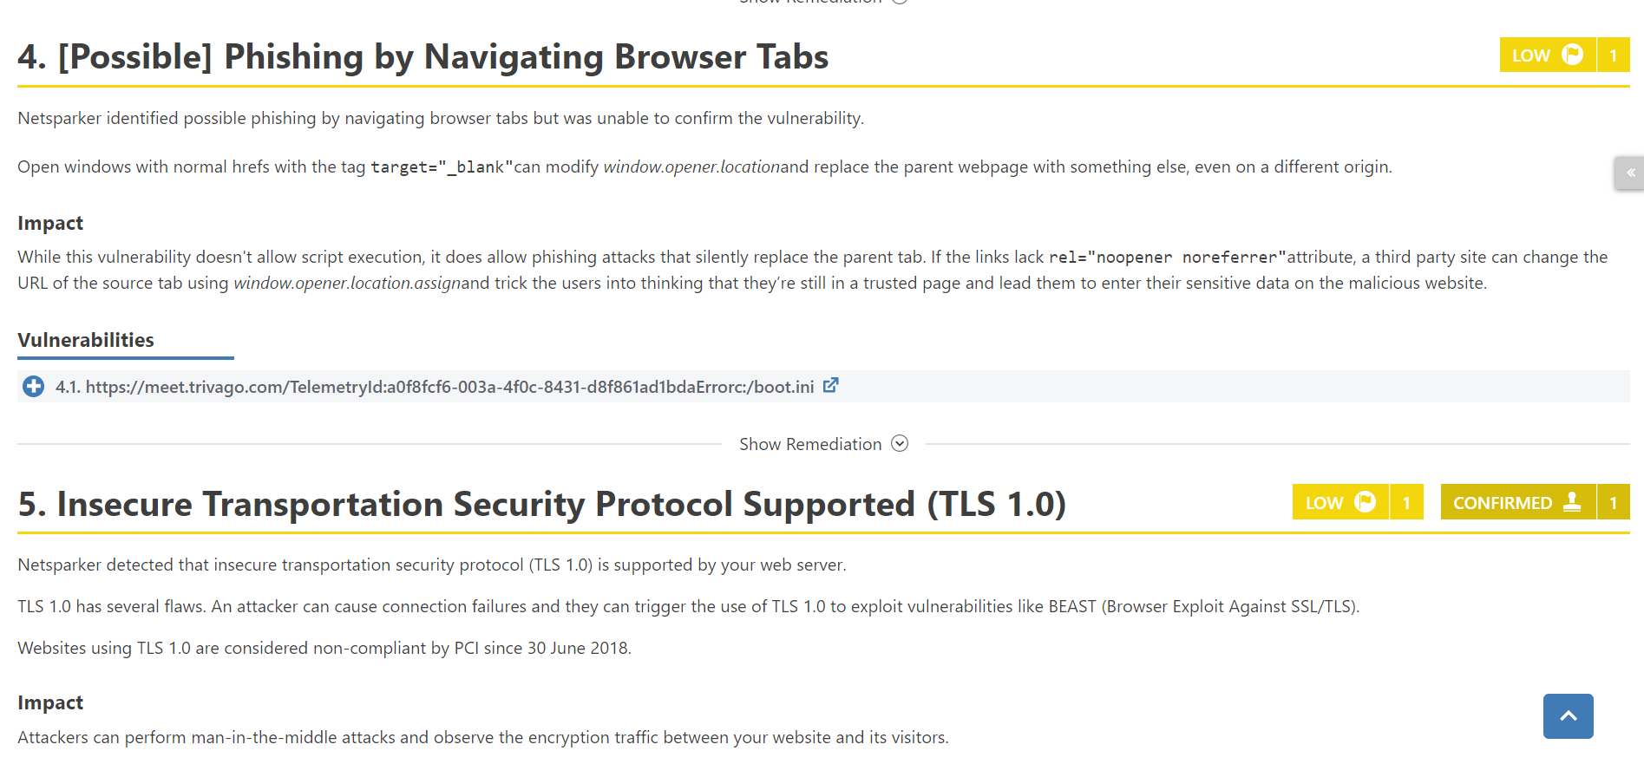

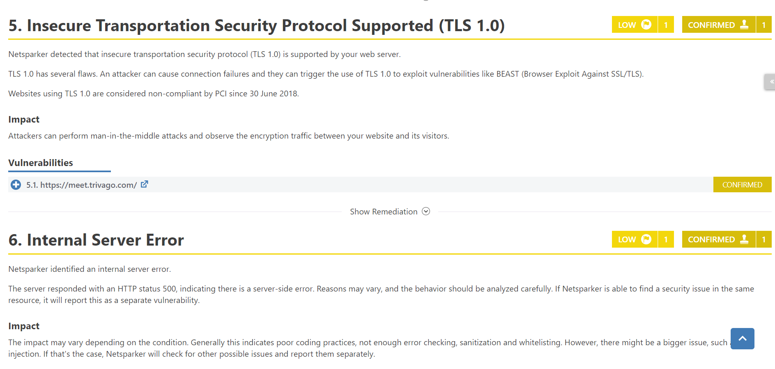

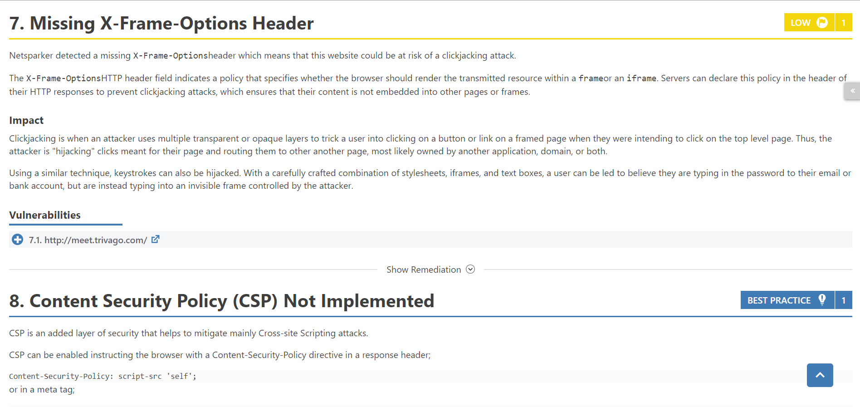

[www.support.trivago.com](http://www.support.trivago.com)

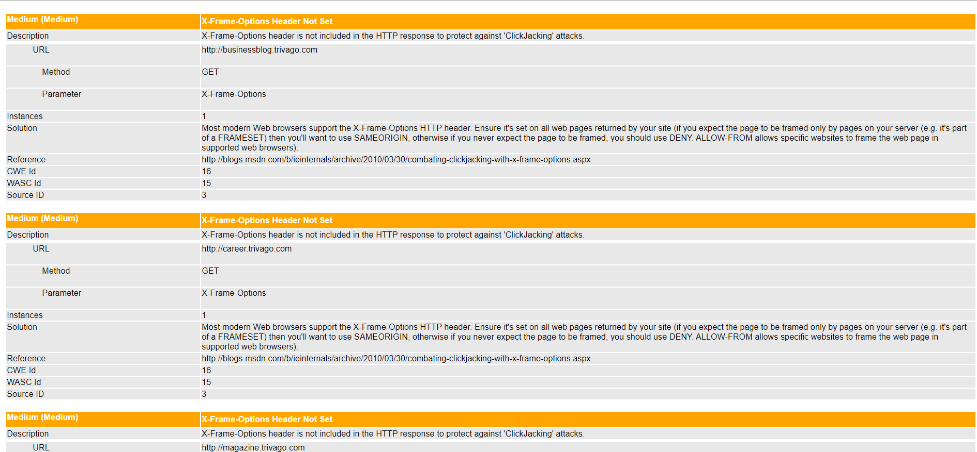

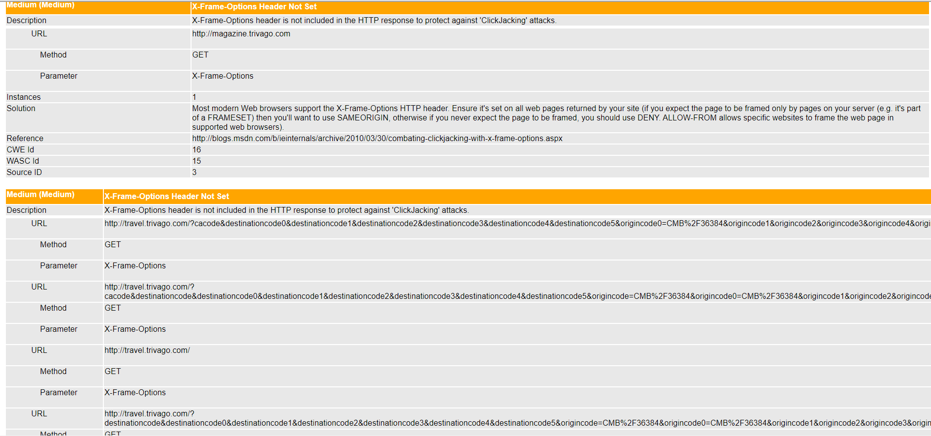

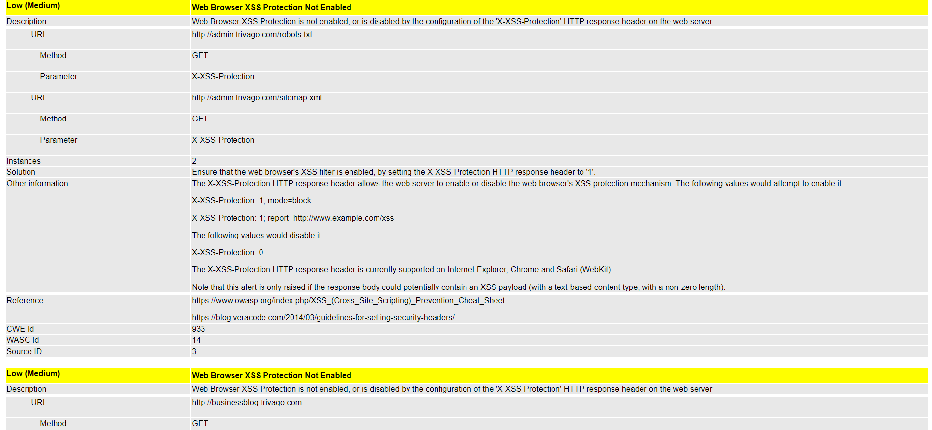

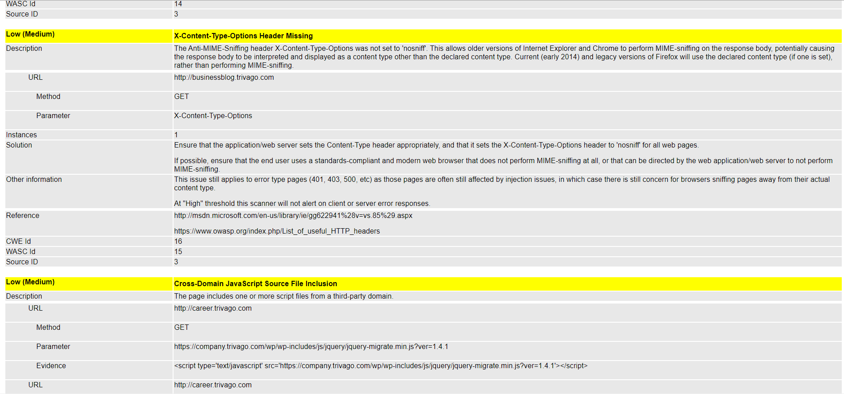

[www.techcamp.trivago.com](http://www.techcamp.trivago.com)

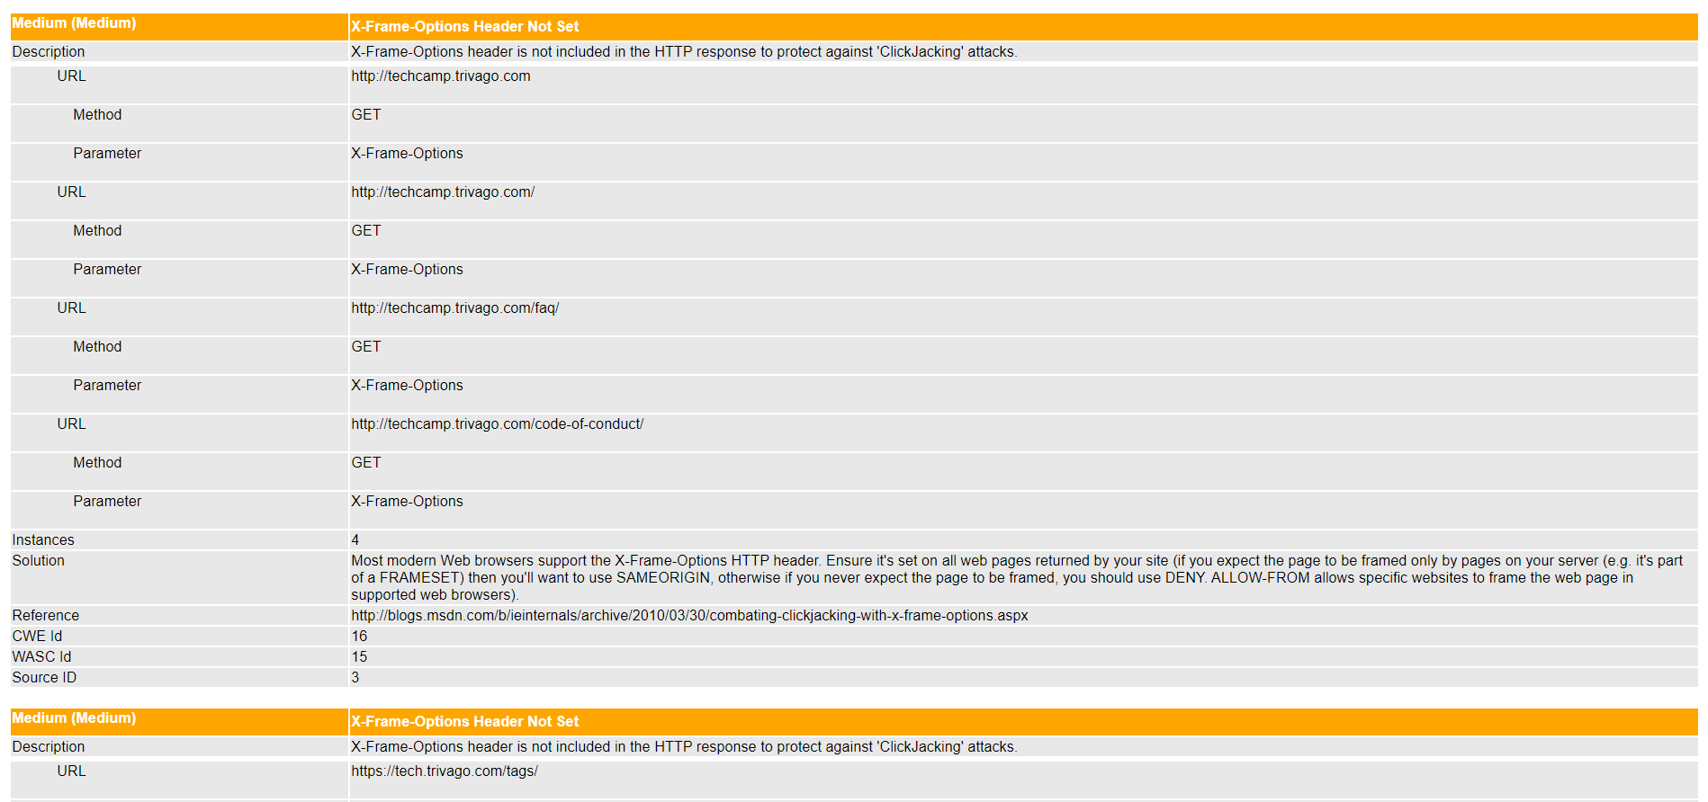

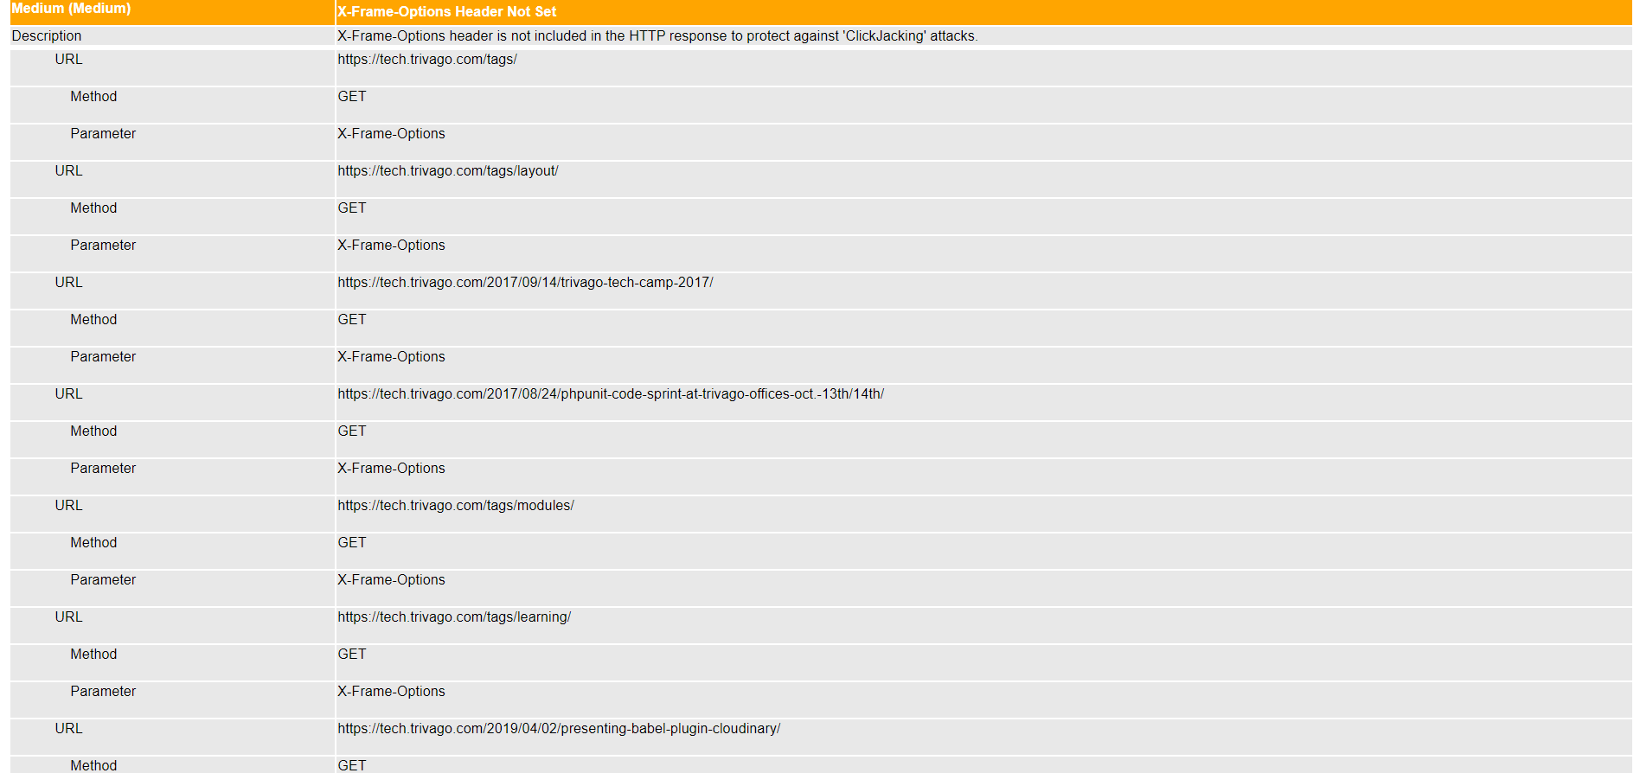

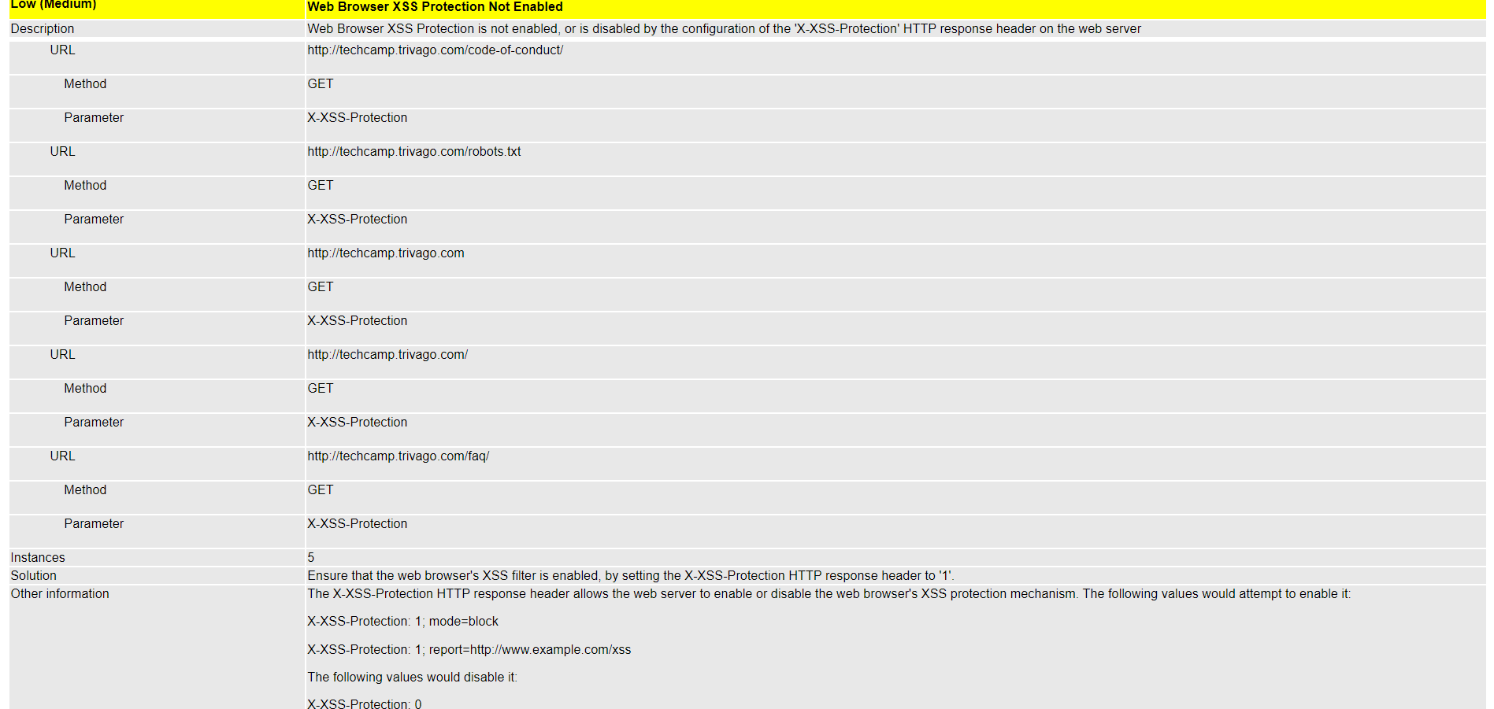

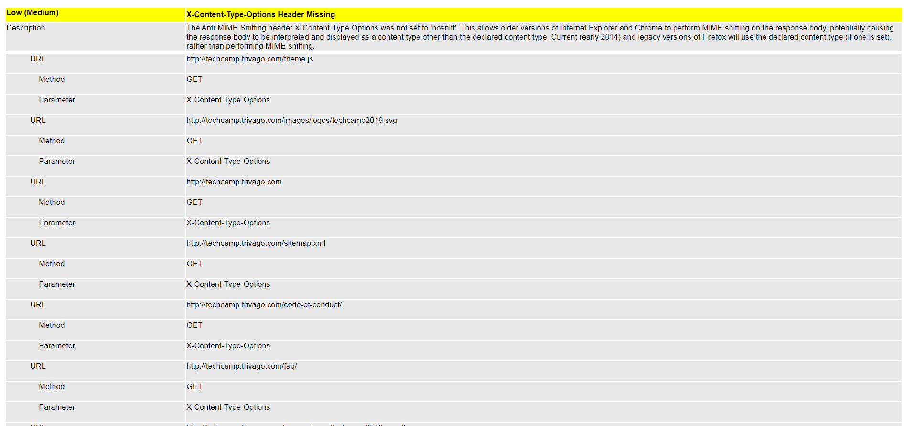

[www.travel.trivago.com](http://www.travel.trivago.com)

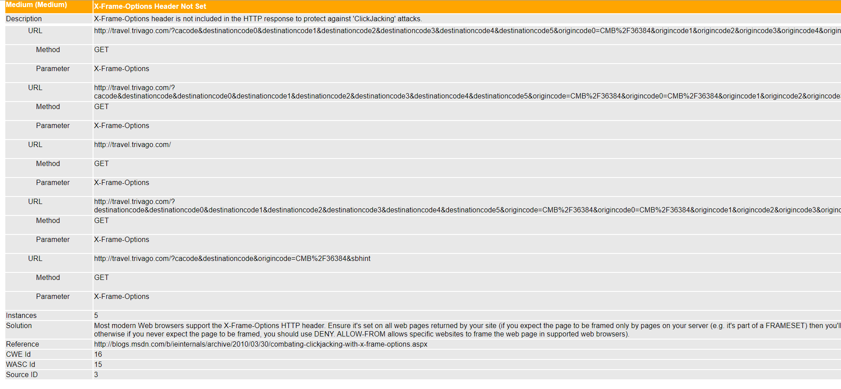

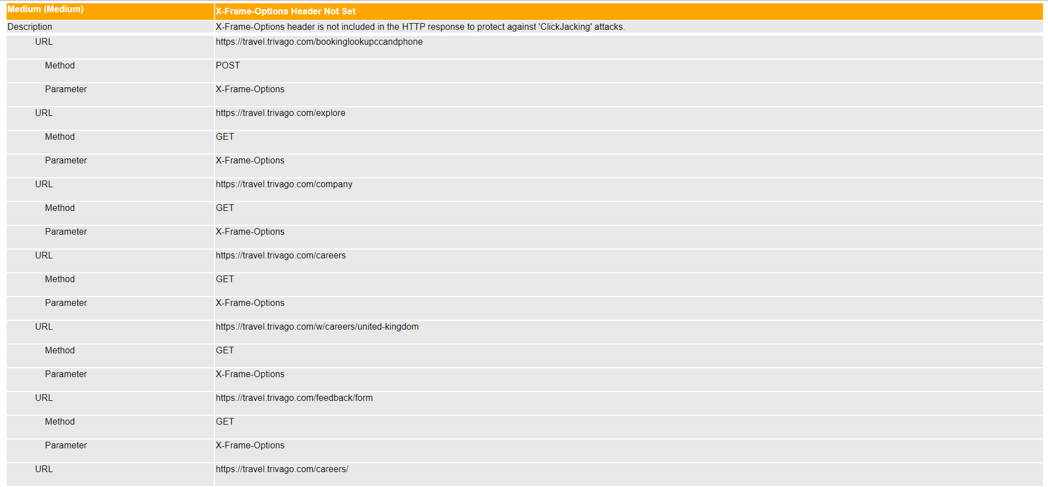

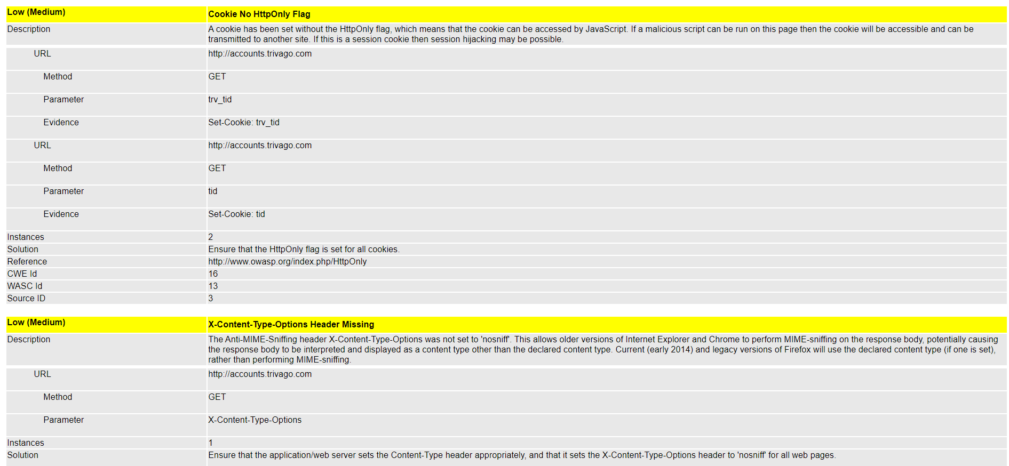

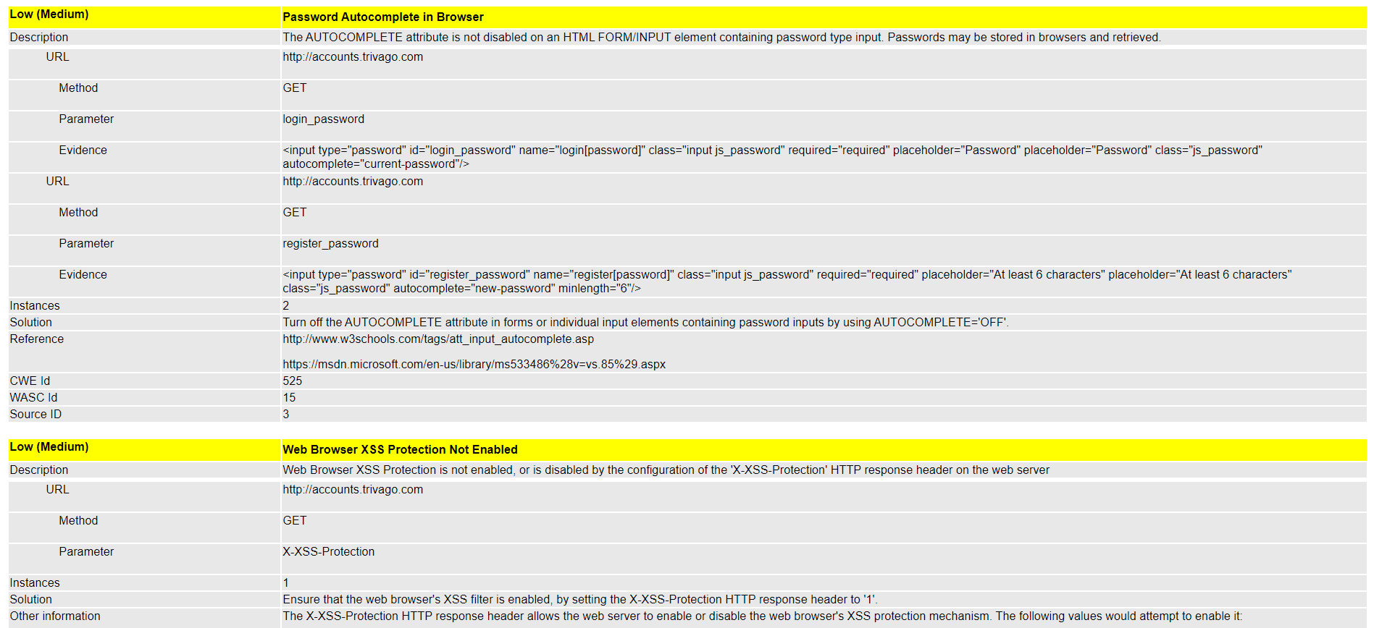

[www.view.email.trivago.com](http://www.view.email.trivago.com)

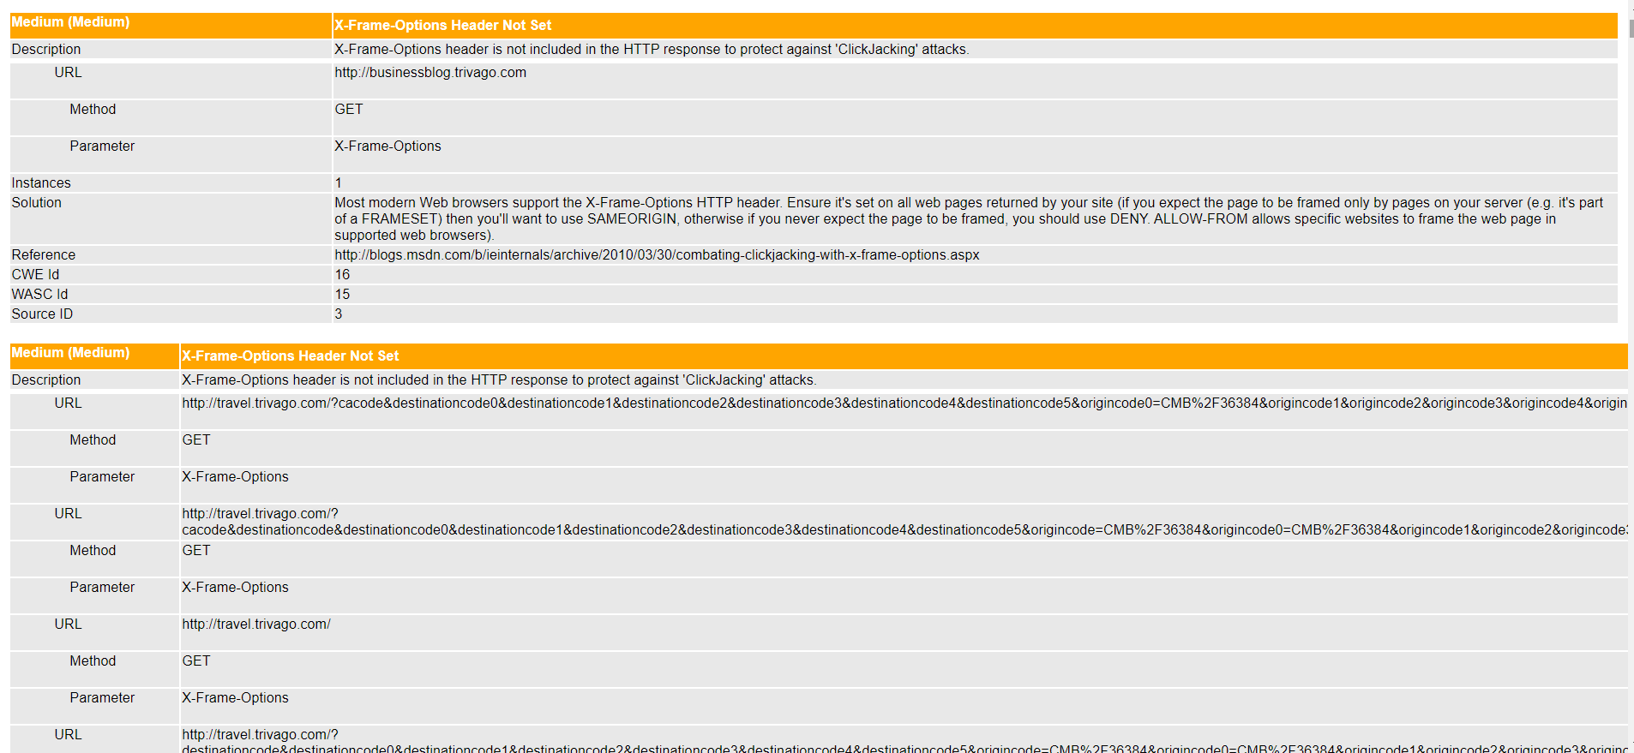

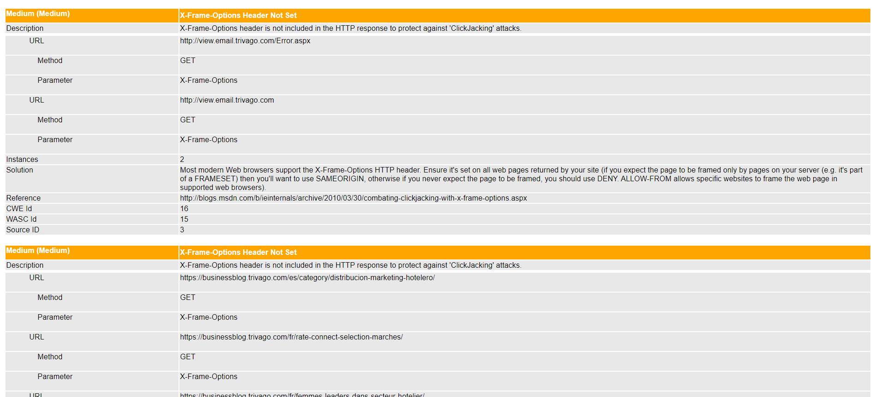

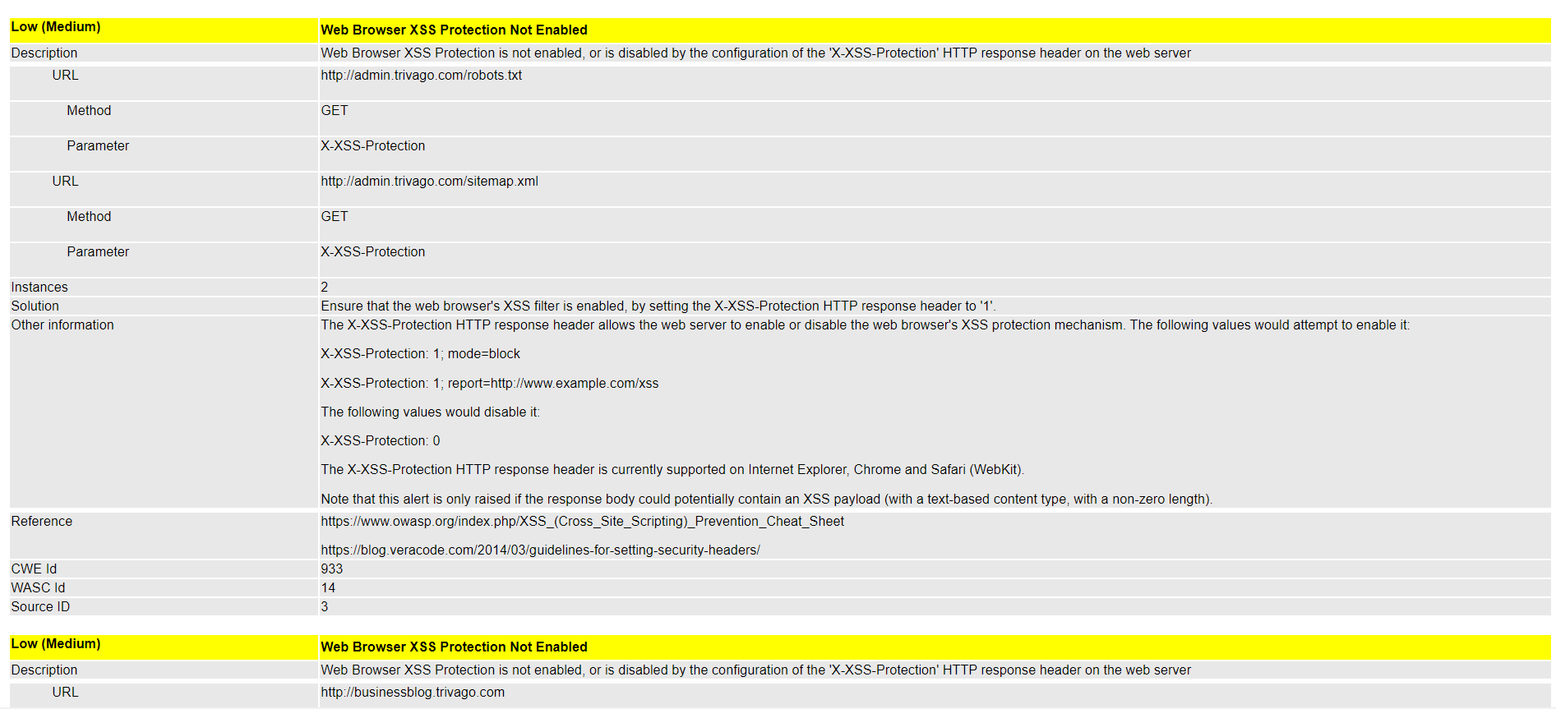

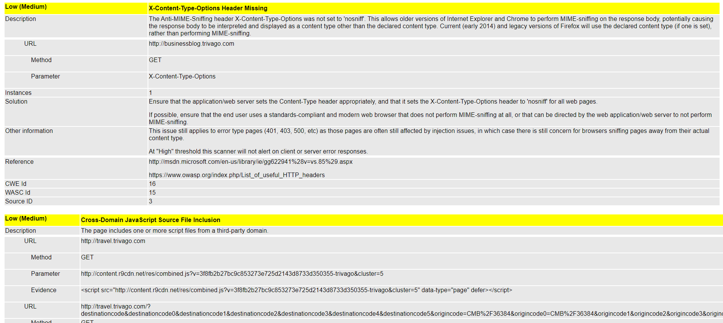

[www.apua.trivago.com](http://www.apua.trivago.com)

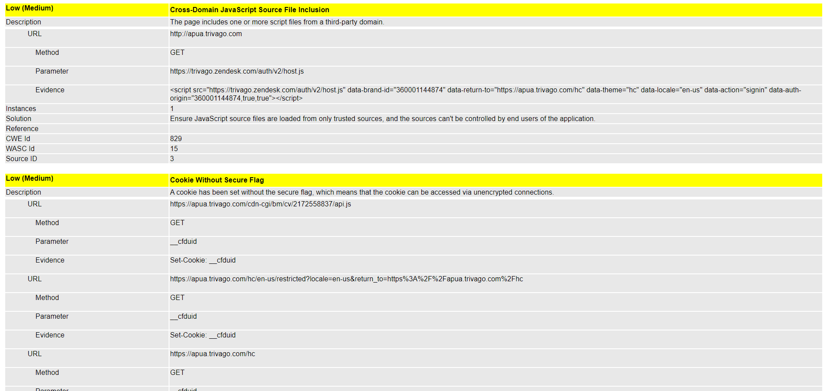

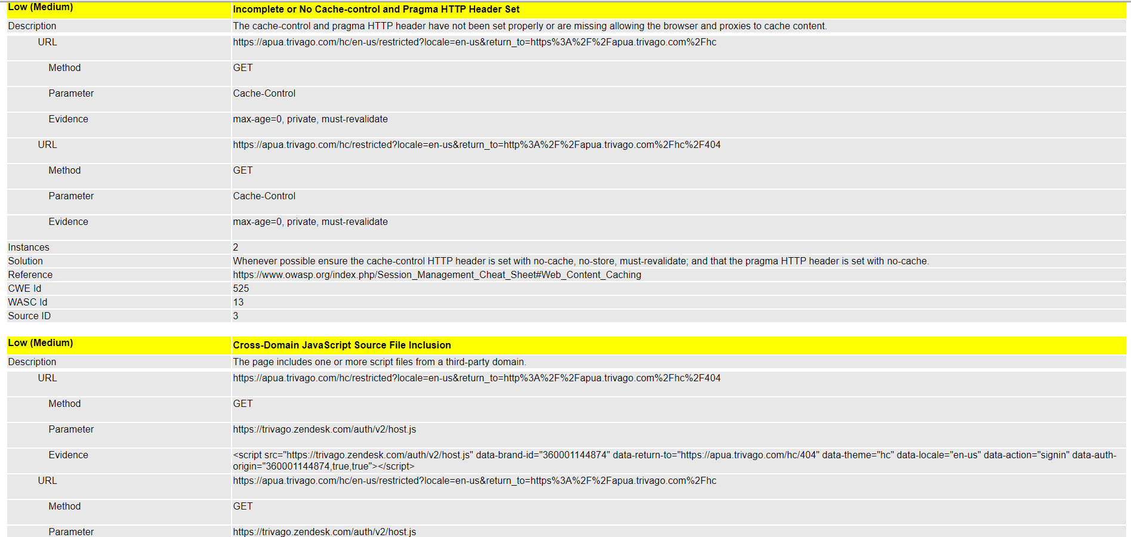

[www.accounts.trivago.com](http://www.accounts.trivago.com)

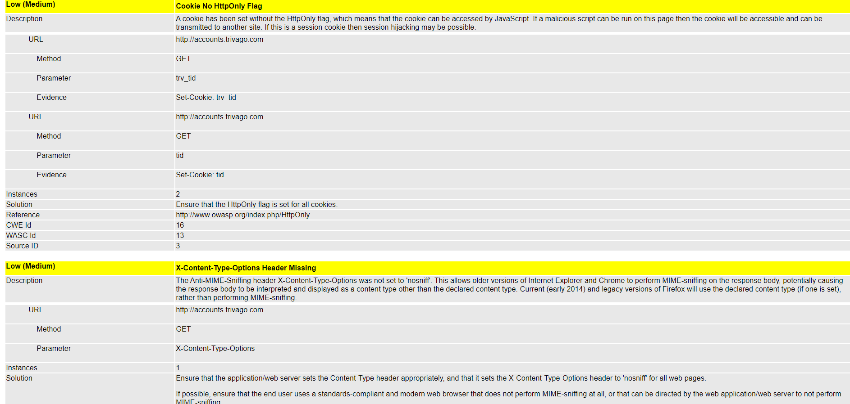

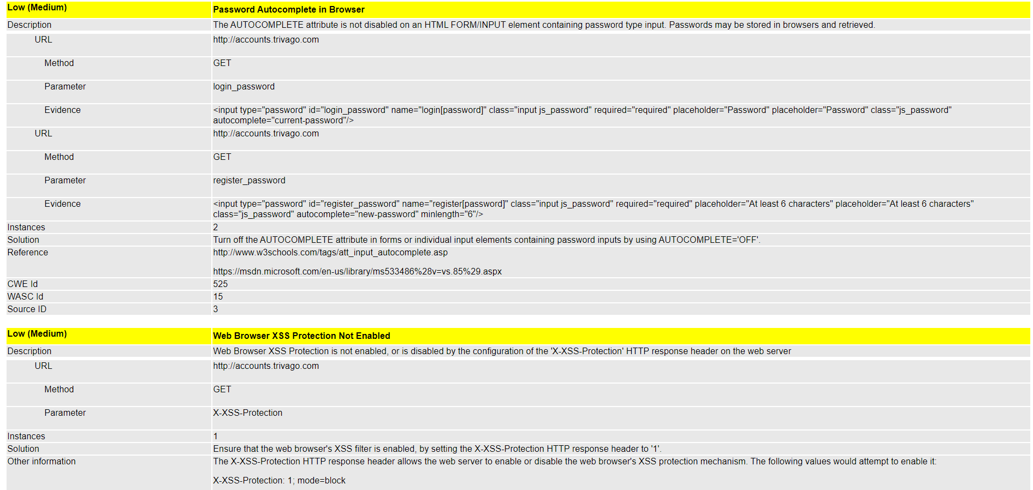

[www.admin.trivago.com](http://www.admin.trivago.com)

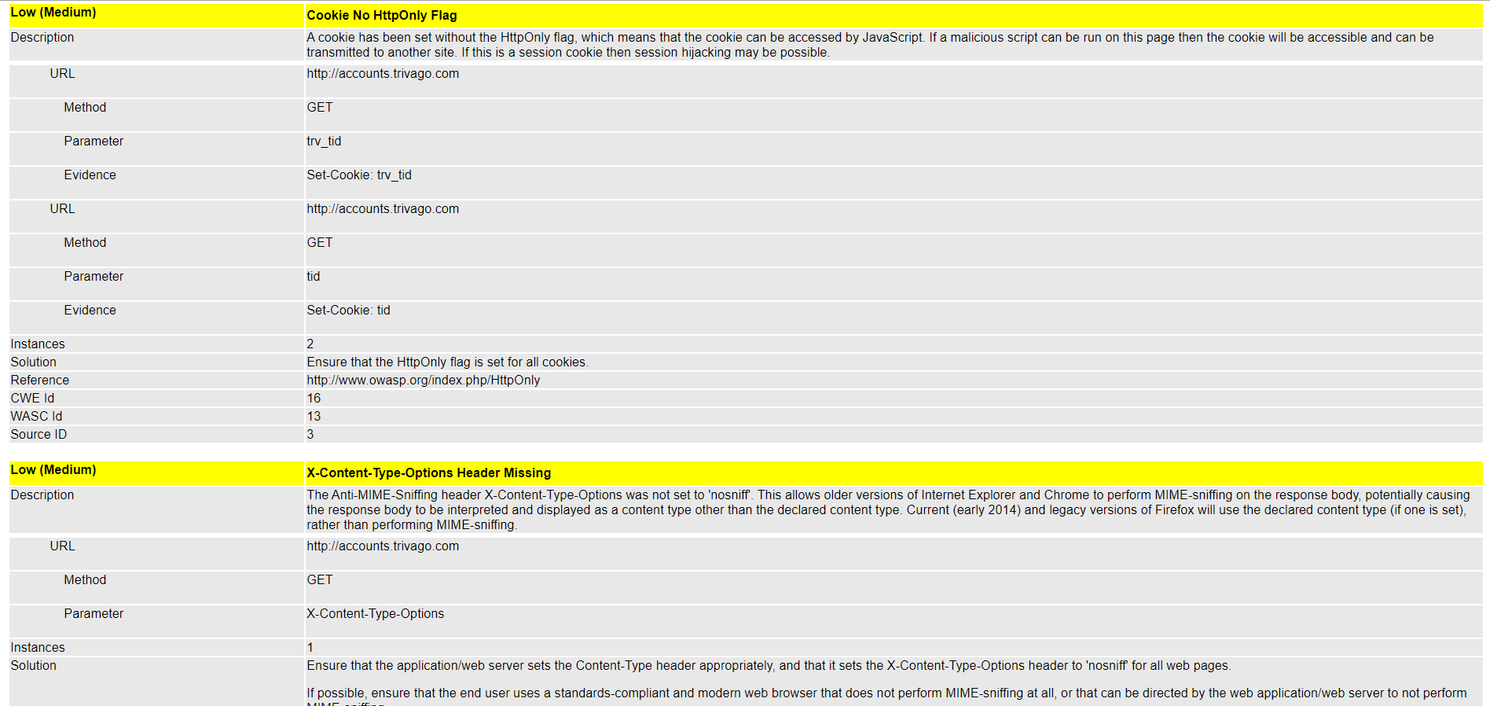

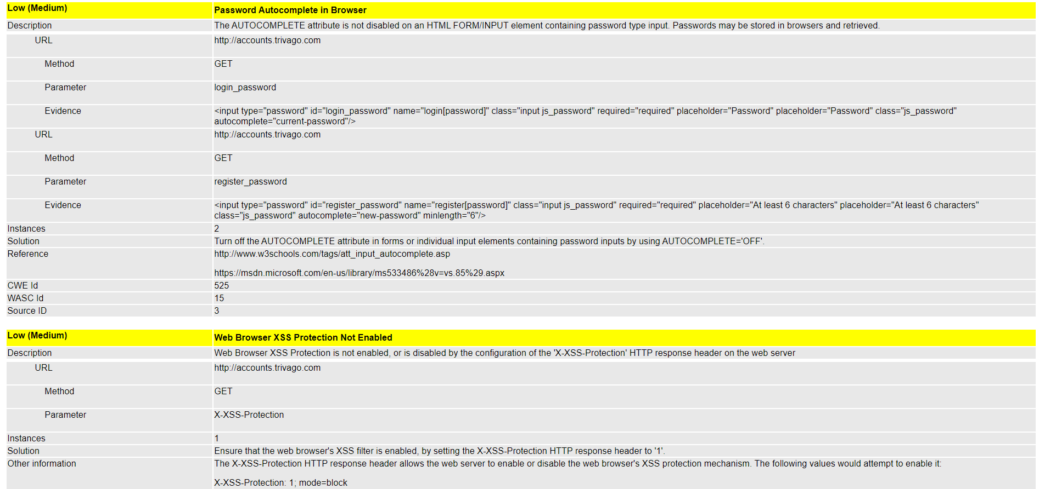

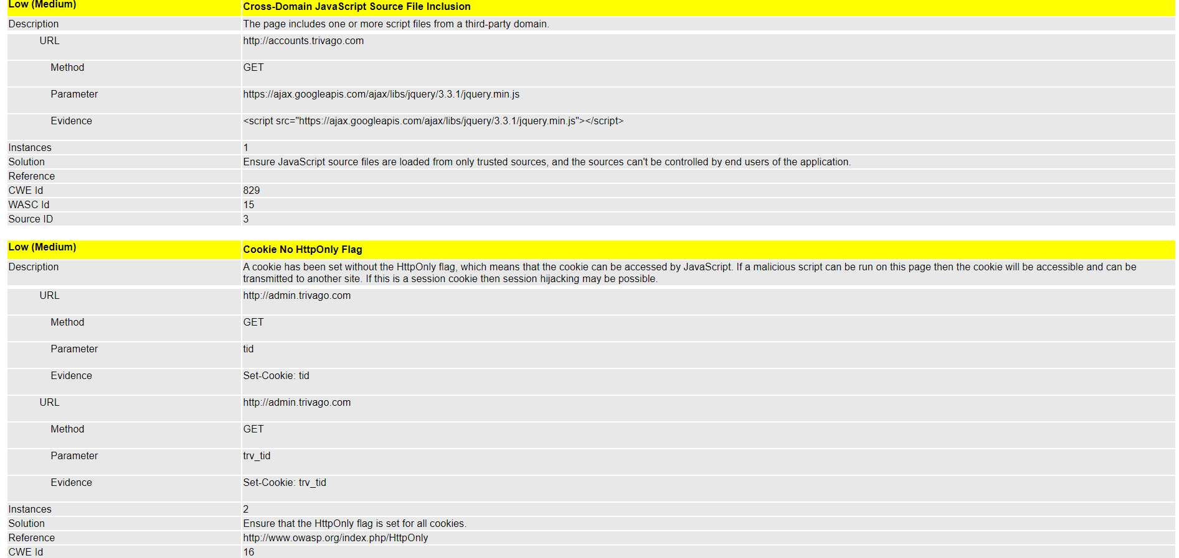

[www.ar.trivago.com](http://www.ar.trivago.com)

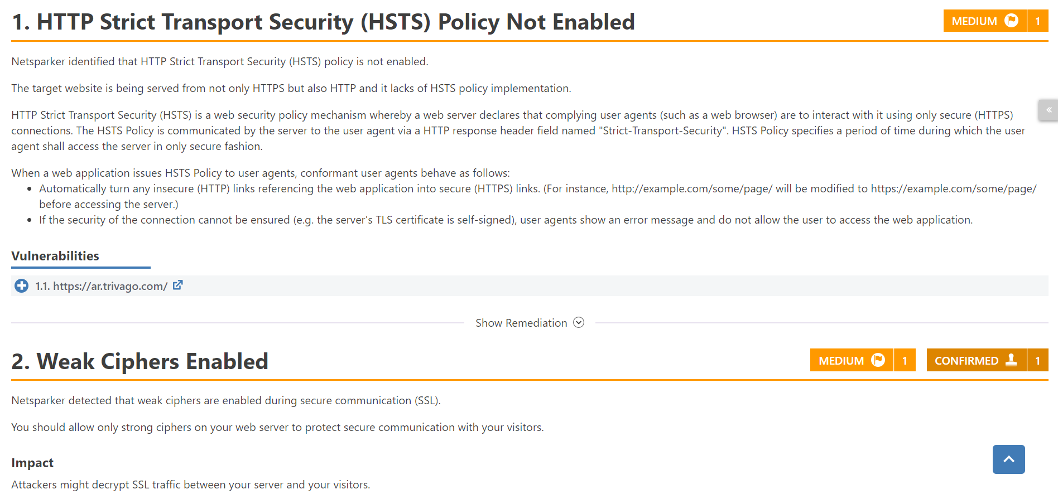

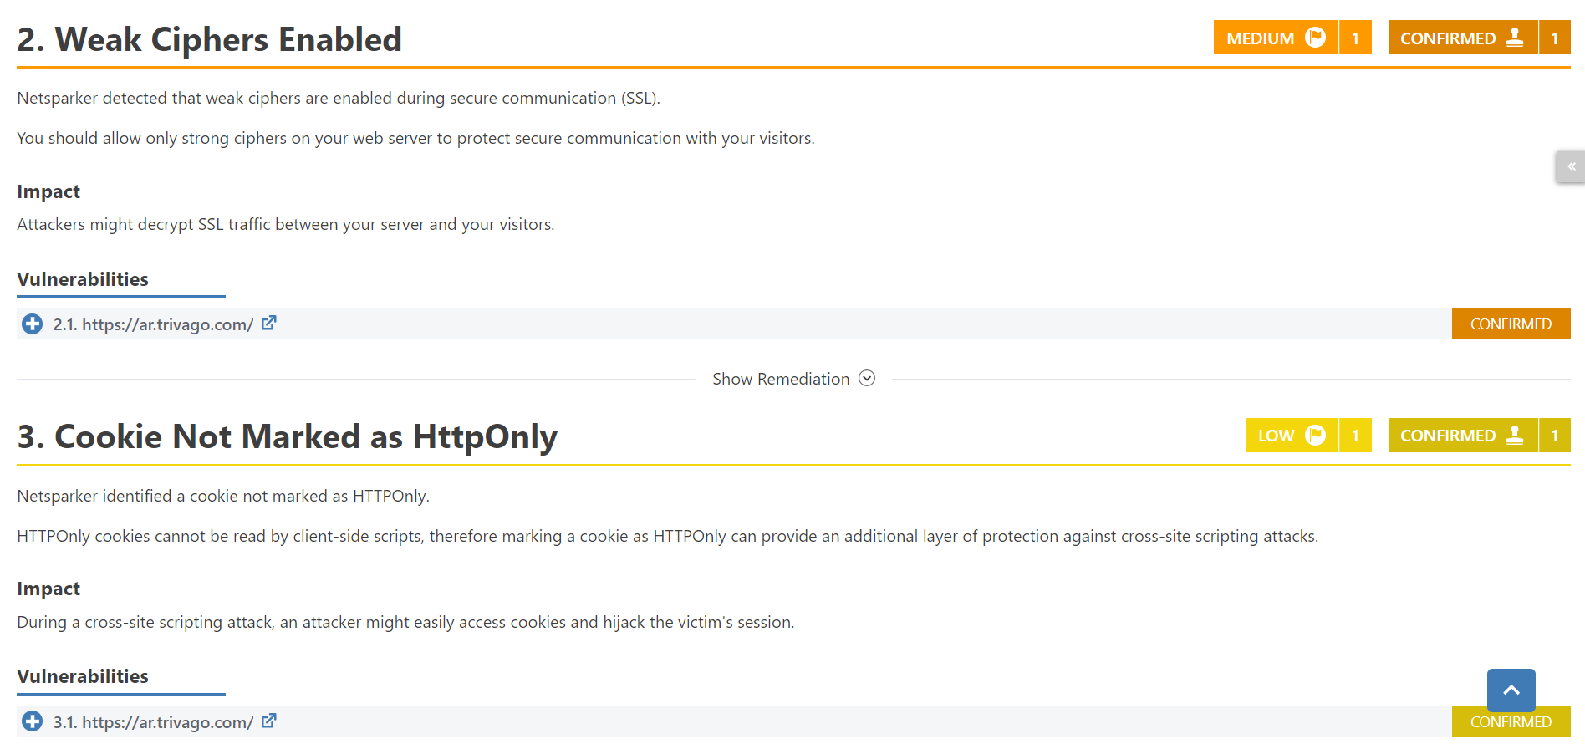

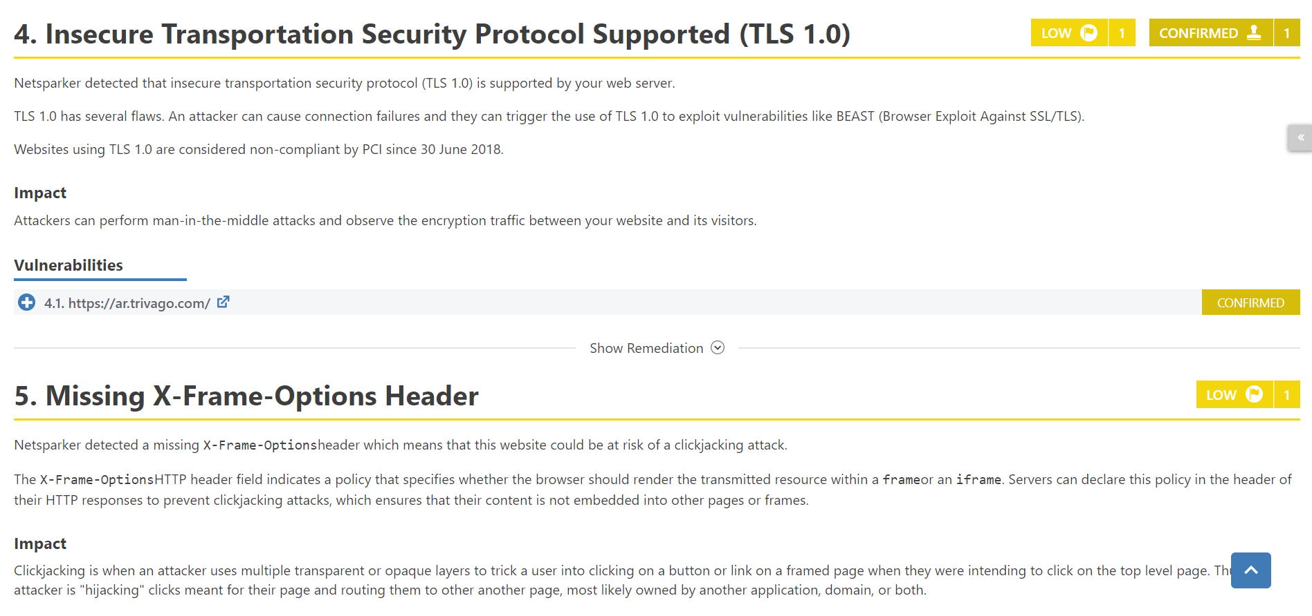

[www.captain-compliance.trivago.com](http://www.captain-compliance.trivago.com)

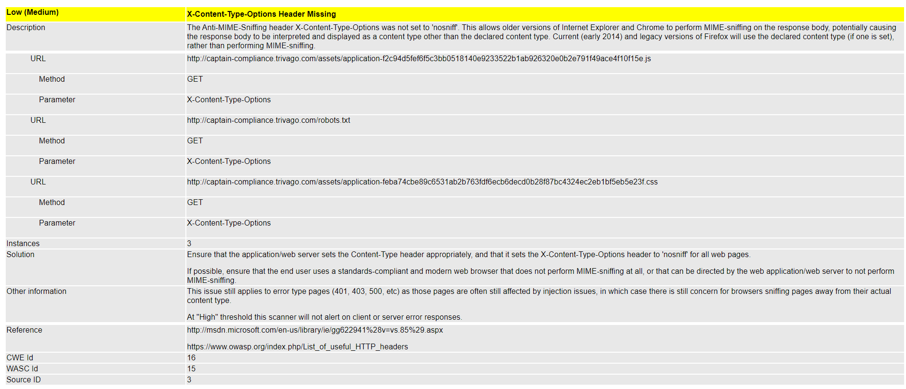

[www.compare.trivago.com](http://www.compare.trivago.com)

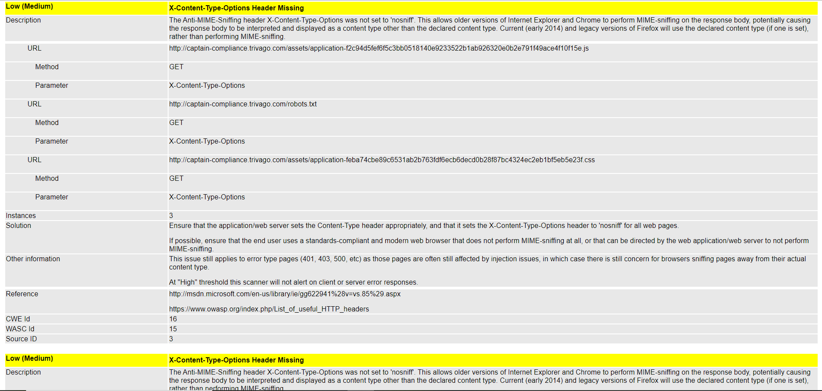

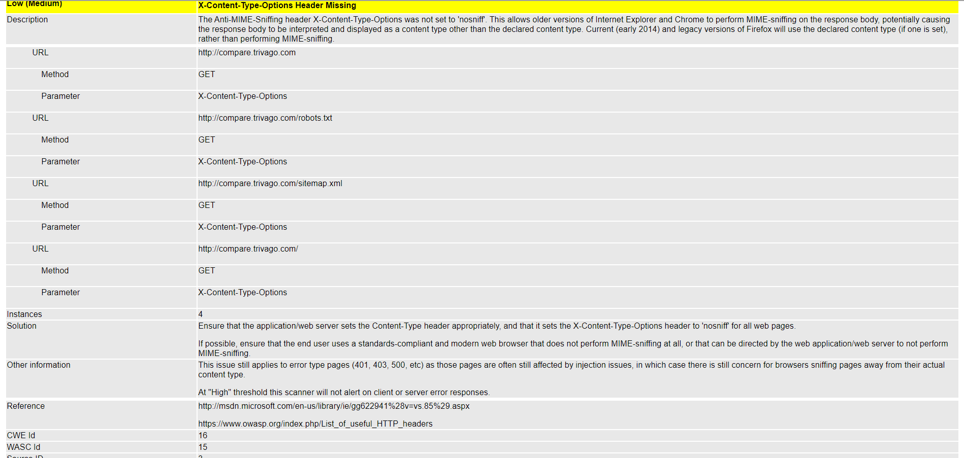

[www.discussions.engage.trivago.com](http://www.discussions.engage.trivago.com)

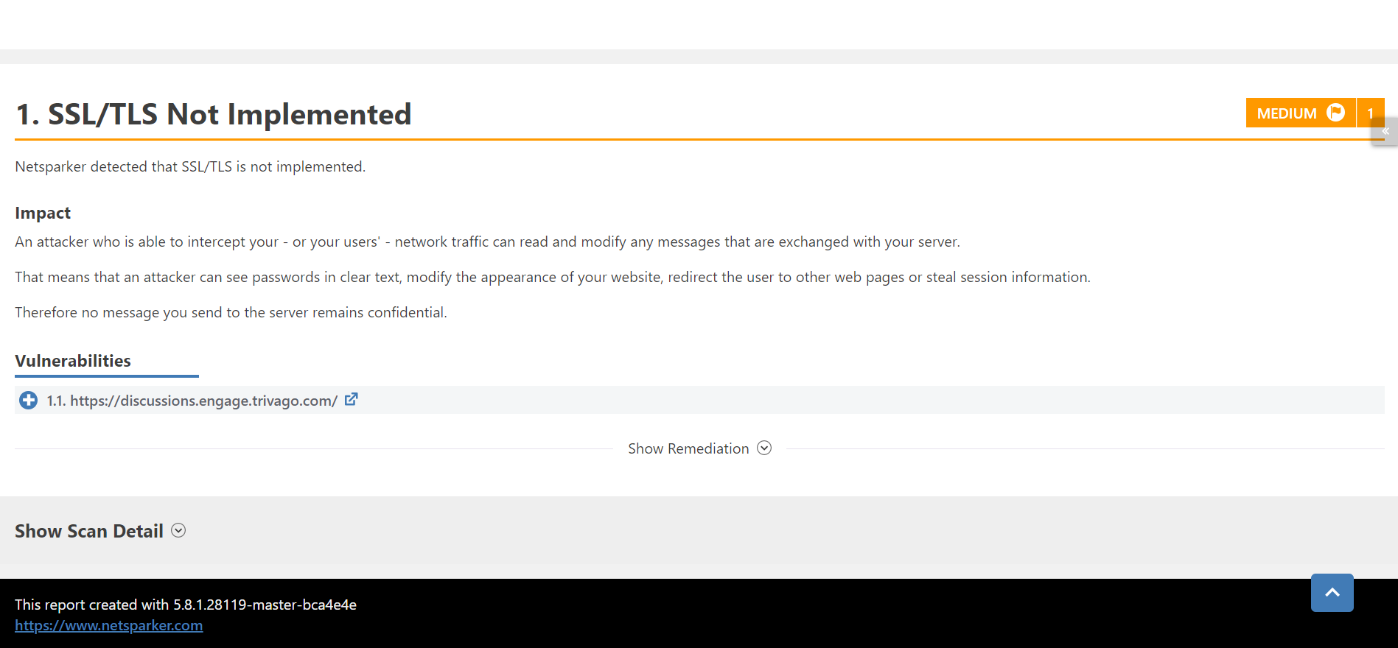

[www.help.trivago.com](http://www.help.trivago.com)

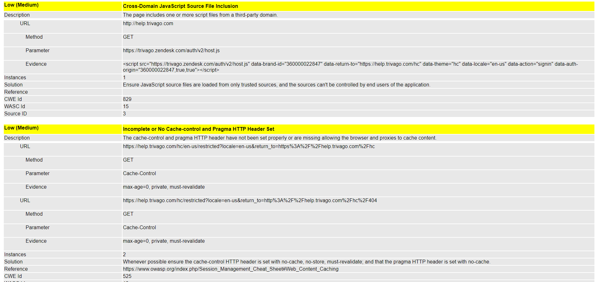

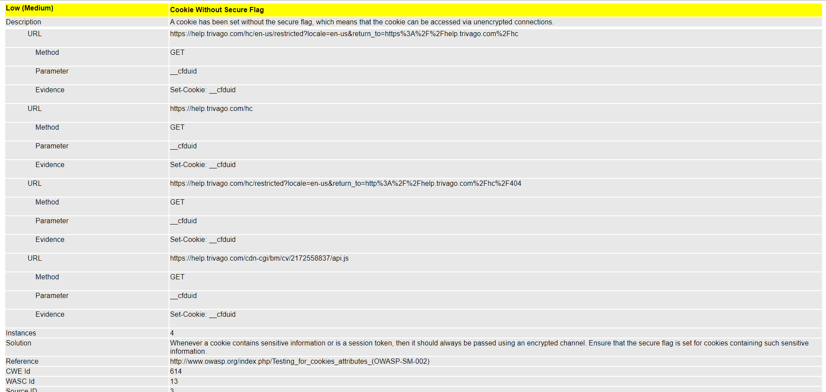

[www.media-magazine.trivago.com](http://www.media-magazine.trivago.com)

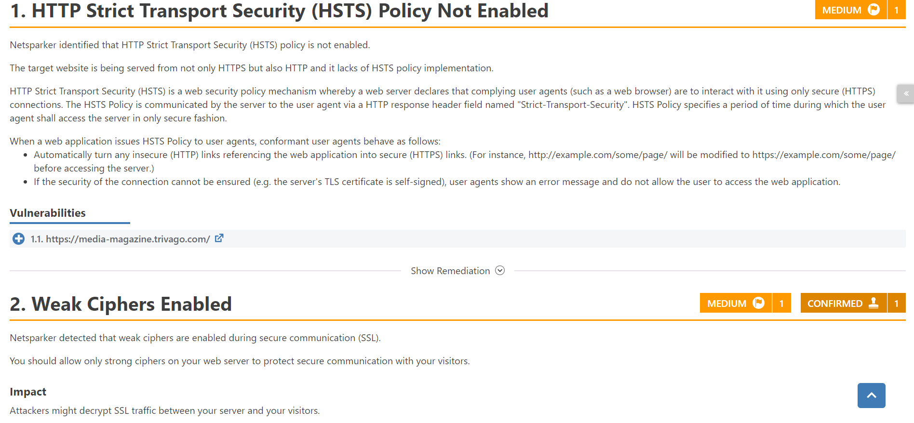

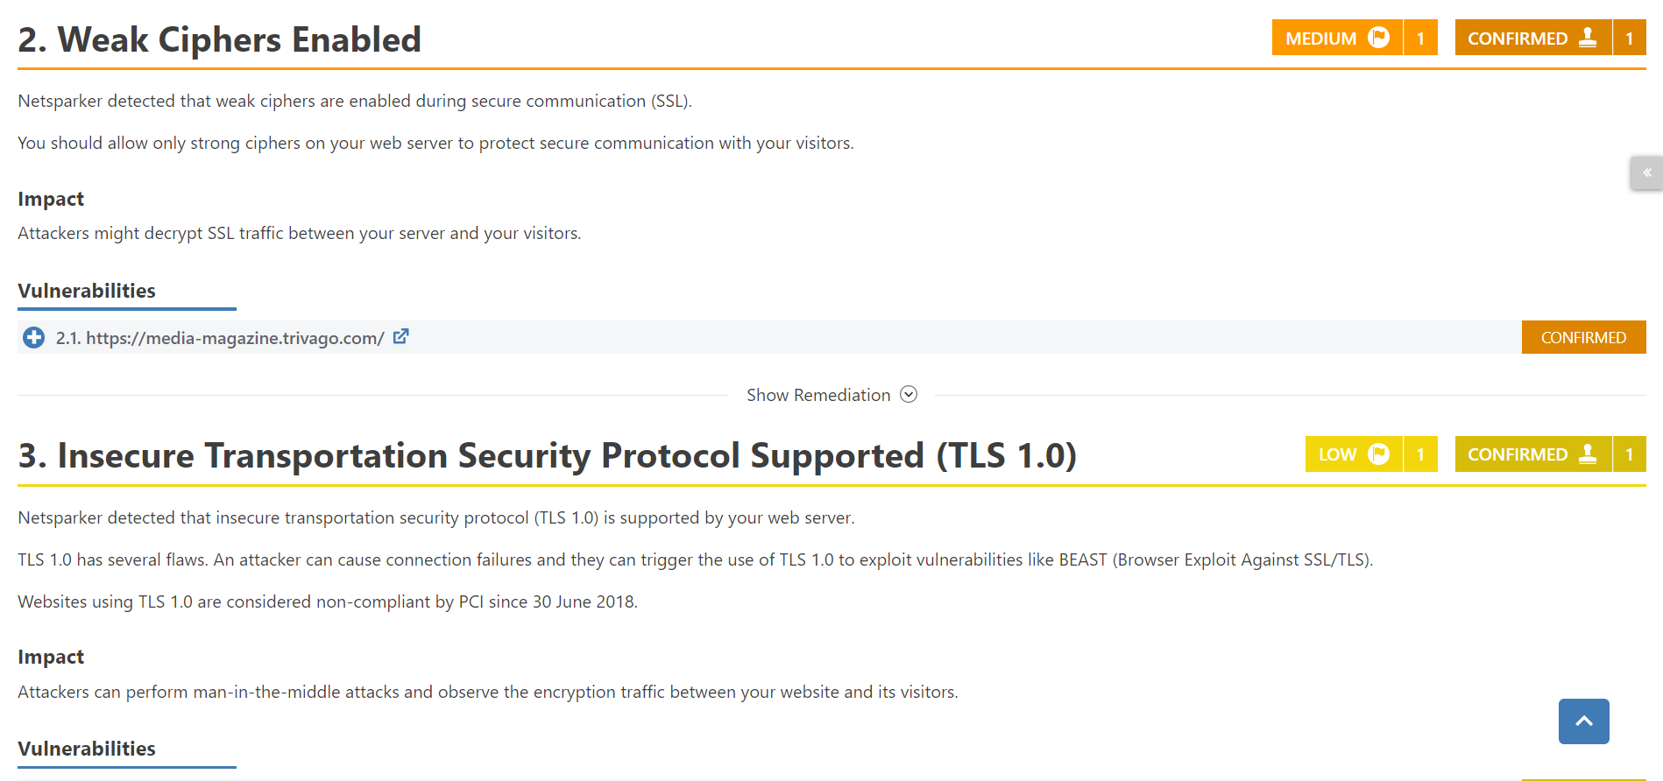

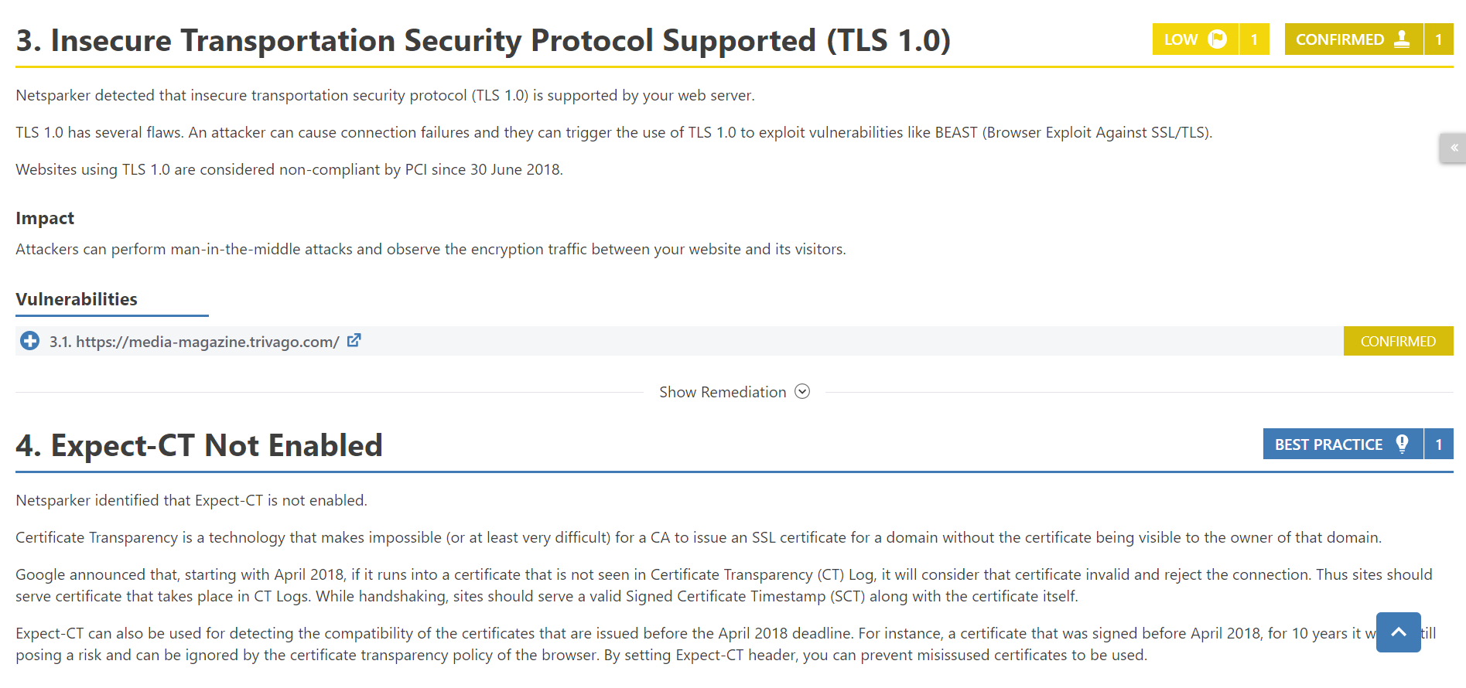

[www.mta.email.trivago.com](http://www.mta.email.trivago.com)

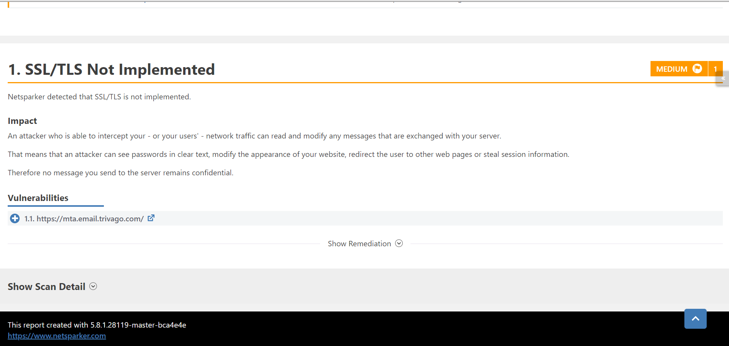

[www.press.trivago.com](http://www.press.trivago.com)

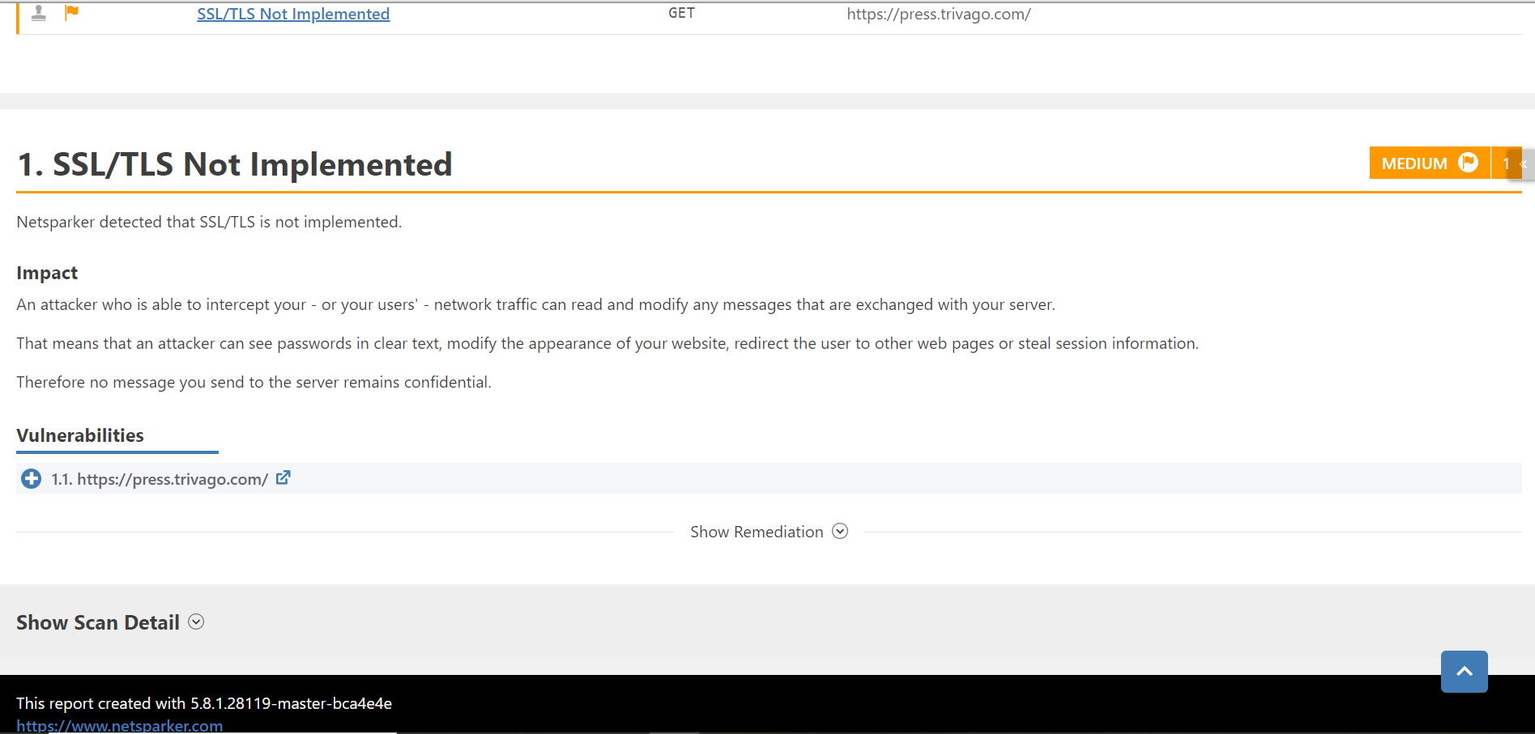

[www.room5.trivago.com](http://www.room5.trivago.com)

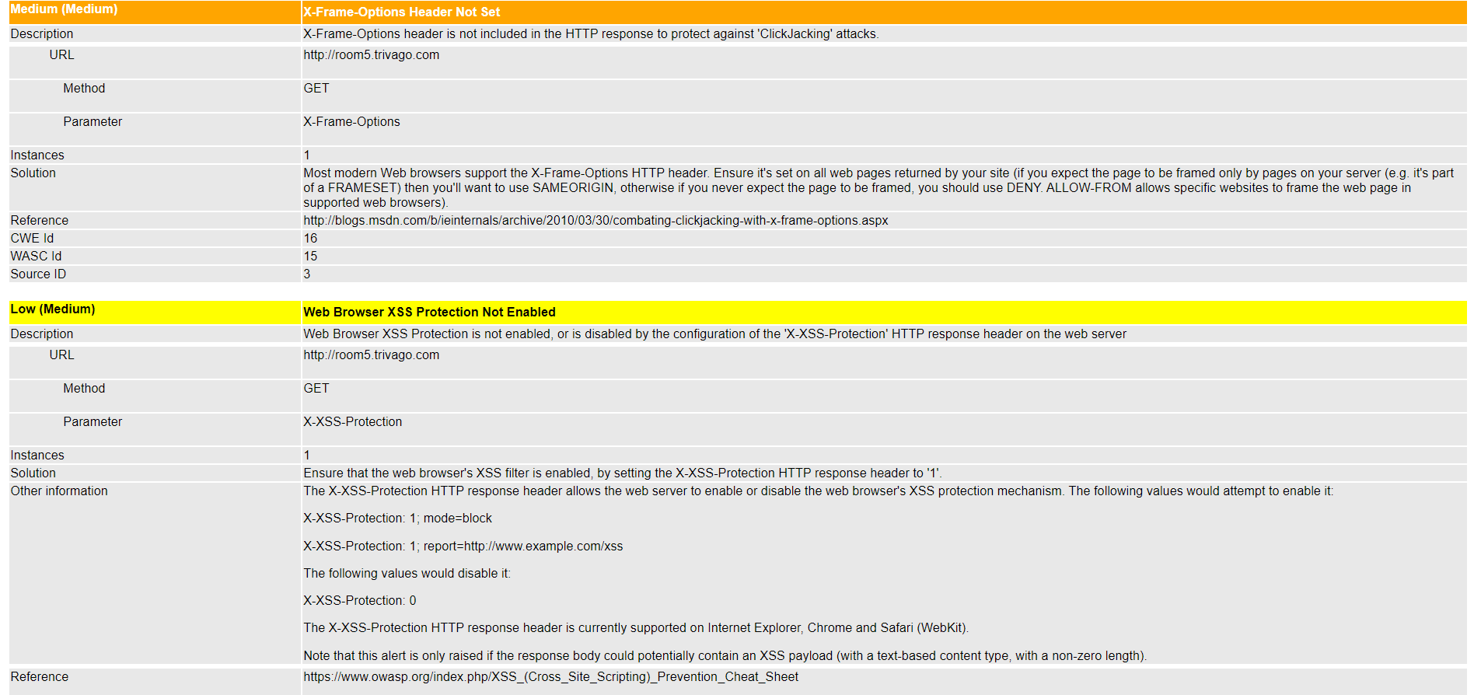

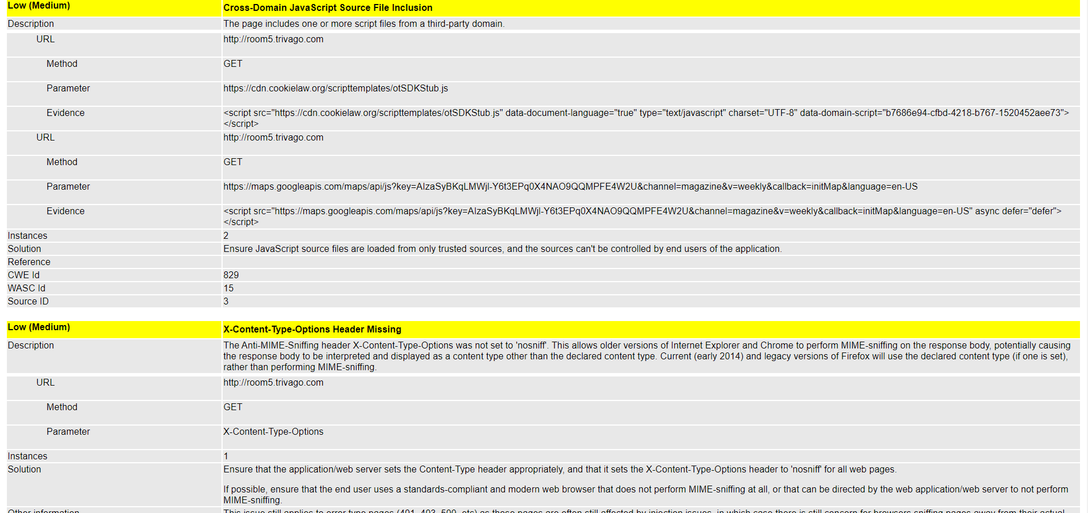

[www.click.hotelmanager.trivago.com](http://www.click.hotelmanager.trivago.com)

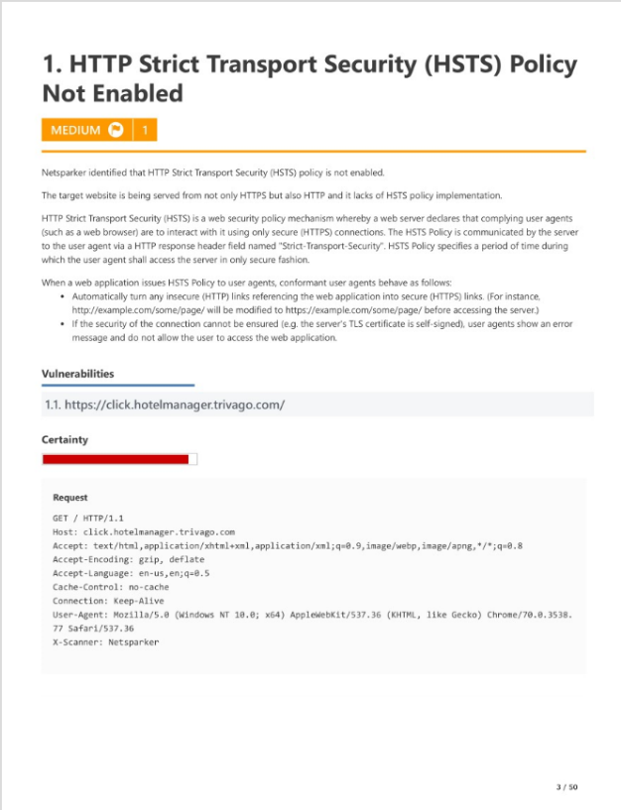

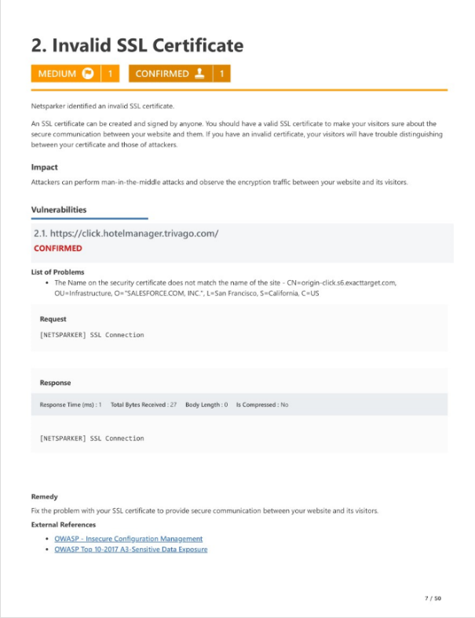

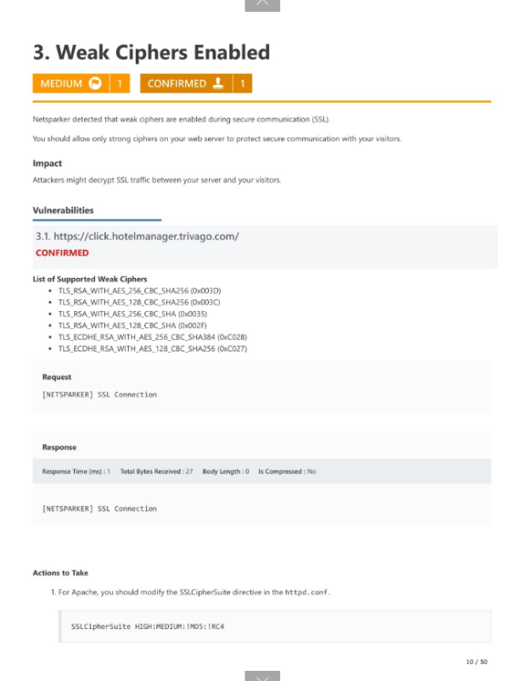

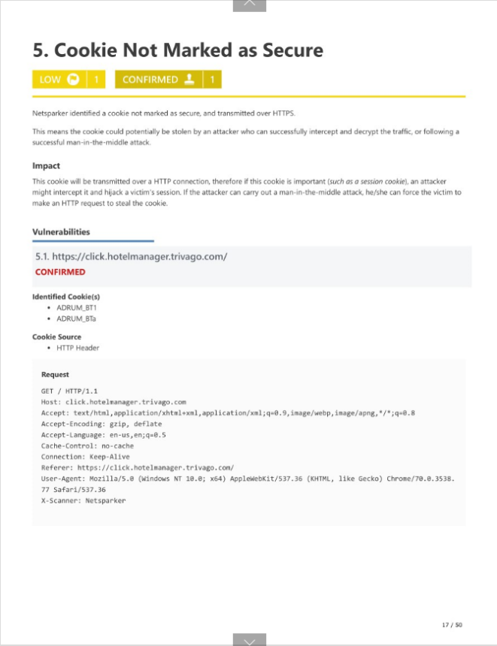

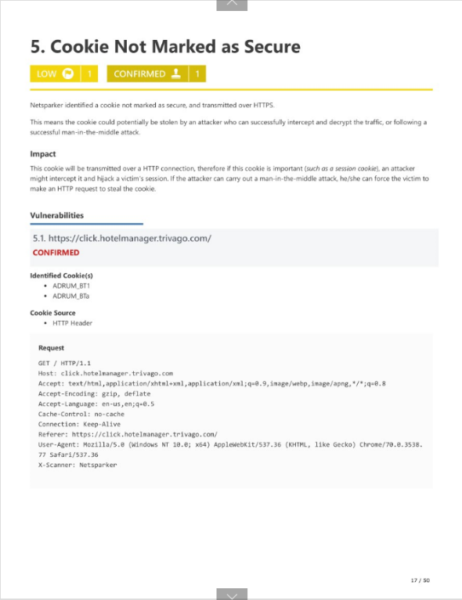

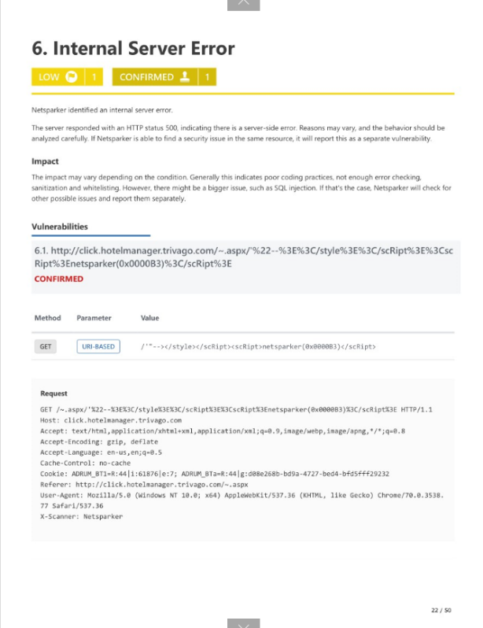

[www.discussions.engage.trivago.com](http://www.discussions.engage.trivago.com)

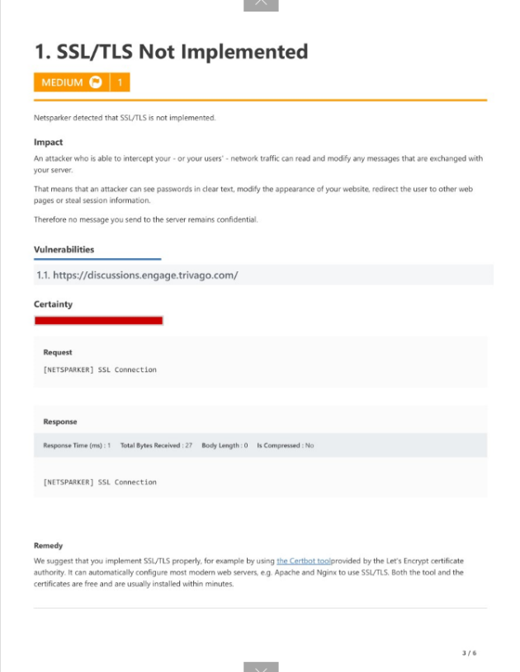

www.image.email.trivago.com

